
MOUNT CARMEL UNIVERSITY
(Deemed to be University)
Bengaluru
Department of Computer Science
A Project Report on
CHIRON
Camera-Based Personal Movement Analysis System
Submitted in partial fulfilment of the requirements for the award of the degree of
Bachelor of Computer Applications (BCA)
Submitted by
1. Nitish Amritraj B MS244469
2. Dominic Kennith MS244519
Under the guidance of
Mrs. Catherine
Fifth Semester | 2026 – 2027
MOUNT CARMEL UNIVERSITY
(Deemed to be University)
Bengaluru
Department of Computer Science
A Project Report on
CHIRON
Camera-Based Personal Movement Analysis System
Submitted in partial fulfilment of the requirements for the award of the degree of
Bachelor of Computer Applications (BCA)
Submitted by
1. Nitish Amritraj B MS244469
2. Dominic Kennith MS244519
Under the guidance of
Mrs. Catherine
Fifth Semester | 2026 – 2027
MOUNT CARMEL UNIVERSITY
(Deemed to be University), Bengaluru
Department of Computer Science
CERTIFICATE
This is to certify that the project work entitled Chiron – Camera-Based Personal Movement Analysis System has been carried out by Nitish Amritraj B and Dominic Kennith in the Fifth Semester, Department of Computer Science, under our supervision and guidance, in partial fulfilment of the requirements for the award of the degree of Bachelor of Computer Applications (BCA) at Mount Carmel University (Deemed to be University), Bengaluru, during the academic year 2026 – 2027.
Register Numbers:
1. MS244469
2. MS244519
Project Guide  Mrs. Catherine | Head of the Department  Dr. Vijayalakshmi N

Examiners:
1. ____________________________
2. ____________________________
Date of Examination: 17-10-2026
ACKNOWLEDGEMENT
We express our sincere gratitude to the management of Mount Carmel University (Deemed to be University), Bengaluru, for giving us the opportunity to undertake this project, Chiron – Camera-Based Personal Movement Analysis System, as part of our Bachelor of Computer Applications programme.
We are grateful to Dr. Vijayalakshmi N, Head of the Department of Computer Science, for her continuous support and encouragement throughout our studies and the course of this project.
We express our deep gratitude to our project guide, Mrs. Catherine, for her valuable guidance, constructive suggestions and constant motivation, which were essential to the successful completion of this project.
We thank all the faculty members and staff of the Department of Computer Science for their help and support whenever we needed it.
We also acknowledge the open-source communities and public resources that made this work possible, including Google MediaPipe, the Kotlin and Android developer tools, Firebase, and the authors of the MM-Fit dataset, which we used to evaluate our system.
Finally, we are deeply thankful to our families and friends for their encouragement, patience and support throughout this journey.

Nitish Amritraj B (MS244469)
Dominic Kennith (MS244519)
TABLE OF CONTENTS
S.NO | CONTENT | PAGE NO.
1. | INTRODUCTION  1.1 Abstract  1.2 Existing System  1.3 Problem Overview  1.4 Objectives  1.5 Proposed System  1.6 Software and Hardware Requirements  1.7 List of Modules  1.8 Summary | 01  01  02  02  03  04  05  06  06
2. | FEASIBILITY STUDY  2.1 Introduction  2.2 Feasibility Analysis  2.3 Vision Document  2.4 Summary | 07  07  07  09  10
3. | SYSTEM REQUIREMENTS SPECIFICATION  3.1 Introduction  3.2 Modules Description  3.3 Module Specification  3.4 UML Use Case  3.5 Summary | 11  11  12  14  17  19
4. | SOFTWARE ANALYSIS AND DESIGN  4.1 Methodology  4.2 Data Flow Diagram  4.3 Class Diagram  4.4 Architecture Diagram  4.5 Database Diagram  4.6 Database Design  4.7 Table Design  4.8 Sequence Diagram  4.9 E-R Diagram  4.10 Deployment Diagram  4.11 Activity Diagram  4.12 Algorithm Design  4.13 Summary | 20  20  20  23  24  25  26  27  29  30  31  32  34  35
5. | CODING | 36
6. | SOFTWARE TESTING  6.1 Introduction  6.2 Types of Testing  6.3 Levels of Testing  6.4 Summary | 63  63  63  64  68
7. | SAMPLE INPUTS AND OUTPUTS | 69
8. | CONCLUSION | 81
9. | SCOPE AND ENHANCEMENT | 82
10. | APPENDIX  10.1 Abbreviations and Glossary  10.2 List of Screenshots | 83  83  83
11. | BIBLIOGRAPHY | 85

1. INTRODUCTION

1.1 Abstract
Regular strength training is one of the most effective habits a person can build, yet most people who train at home or in a college gym do so without anyone watching how they move. They cannot easily tell whether a repetition went through its full range, whether they rushed it, whether one side of the body is doing less work than the other, or whether a set was really twelve repetitions or ten. Personal trainers and motion-capture laboratories answer these questions, but they are expensive and not available every day.
Chiron is an Android application that turns the camera of an ordinary smartphone into a personal movement-analysis tool. The user places the phone so that their whole body is visible, chooses an exercise and starts a set. Every camera frame is passed through Google MediaPipe Pose, which finds 33 body landmarks on the device itself. A shared analysis engine, written once in Kotlin Multiplatform, turns those landmarks into joint angles for the left and the right side of the body separately, filters them, and drives a small state machine that recognises each repetition: leaving the start position, reaching the far position and returning. Isometric holds such as the plank are timed by a separate hold analyser.
Each completed attempt receives a verdict. A full repetition is counted and the skeleton on screen flashes with a "+1"; an attempt that was too fast, did not reach full range or was produced by tracking loss is shown in red with the reason and is not counted. Six technique rules taken from published exercise guidelines mark a repetition red with a short explanation, such as "Upper arm moved forward". After the set, a summary shows every repetition's range of motion, lifting speed per side and form notes, and the user can compare these with a personal calibration of their own usual movement.
The application supports 17 library entries: 15 exercise profiles across three tiers and two analysis modes, plus 2 variants that share a parent profile. All of them run on one shared analysis engine – a single repetition state machine and a single hold analyser – and each profile is a configuration of that engine: the joint it follows, its thresholds, its camera view and its posture. Sessions are saved on the phone first and work entirely offline; with an account, they are copied to Firebase so they survive changing phones. No video, photograph or camera frame ever leaves the device. The counting engine was evaluated on MM-Fit, a public multi-person exercise dataset, using people who were never used during development: it counted 163 of 163 bicep curls and 146 of 150 lateral raises, and with a personal calibration of the starting position it counted 107 of 141 push-ups (84 without it). In no accepted change did it ever count more repetitions than were performed.

1.2 Existing System
People who want feedback on their exercise today choose between the following options. Each solves part of the problem, but none of them gives everyday, private, measured feedback on how a person moves.
- Personal trainers and coaches. A trainer watches the movement and corrects it. This is the most complete form of feedback, but it is costly, available only during booked sessions, and depends on one person's judgement. The trainer's observations are rarely recorded, so progress over weeks cannot be compared objectively.
- Mirrors and self-observation. Many people train in front of a mirror. A mirror shows only one view, and while concentrating on a heavy repetition it is hard to judge range of motion, speed or the difference between the left and right side.
- Manual counting and paper or note logs. Repetitions are counted in the head and written down afterwards. Counts drift when tired, partial repetitions are counted as full ones, and nothing about the quality of the movement is recorded.
- Wearable fitness trackers. Wrist bands count steps and estimate calories and heart rate. A single wrist sensor cannot see the knee in a squat or the trunk in a sit-up, and it does not distinguish the two sides of the body.
- Laboratory motion capture. Marker-based systems measure joint angles precisely, but they need special cameras, a laboratory and trained staff, and are used in research and clinical settings rather than for daily training.
- General fitness apps. Most popular apps play videos and timers or ask the user to enter their own repetitions. Some camera apps count repetitions, but they usually send video to a server, give a single combined count for both arms, and say nothing about why an attempt did or did not count.

1.3 Problem Overview
- No objective measurement at home. A person training alone cannot measure range of motion, tempo or symmetry, so they do not know whether their movement is improving, stable or getting worse.
- Counting is unreliable. Manual counts include half repetitions and rushed repetitions, and miss repetitions when the person is tired or distracted.
- Left and right are mixed together. Existing tools that measure at all usually report one number for both sides of the body, hiding the asymmetry that matters most after an injury or when one side is weaker.
- No explanation of what went wrong. When a repetition "does not count", the user is rarely told why: too fast, not deep enough, or poor technique.
- Privacy concerns. Camera-based tools that upload video put sensitive images of the user's body and home on a server.
- No personal reference. Population thresholds ignore the fact that every person moves differently. A useful system should compare a person with their own usual movement.

1.4 Objectives
The objectives of the project are:
- Measure on the phone. To measure a person's movement from an ordinary smartphone camera, entirely on the phone, without uploading any video.
- Explainable counting. To count repetitions and time holds with rules that can be explained, and to give every attempt a verdict that says why it was or was not counted.
- Left and right kept apart. To keep left and right measurements separate everywhere, so that an asymmetry is never hidden by averaging.
- Personal reference. To calibrate against the user's own normal movement, from 10 to 15 valid repetitions a side, instead of a population threshold.
- Honest claims. To say only what each result can support: a measurement, a deviation from the user's own baseline, or a technique note backed by a published source.
- A complete training application. To provide workouts, history, charts, streaks, reminders and optional account sync around the measurements.
- Honest evaluation. To evaluate the counting on a public dataset (MM-Fit) and to report both what was measured and what was not.

1.5 Proposed System
The proposed system, Chiron, is an offline-first Android application with a shared analysis engine. Its main features are:
- Camera-based pose estimation on the phone. MediaPipe Pose finds 33 body landmarks in every frame without sending images anywhere.
- Explainable repetition counting. A state machine per side of the body counts a repetition only when the full cycle is completed, and every attempt receives a verdict: counted, too fast, not a full repetition, or lost tracking.
- Left and right measured separately. Every angle, range of motion and timing is kept per side, so asymmetry is visible rather than averaged away.
- Live feedback. A skeleton is drawn over the camera picture, with an arc and the live angle at the joint being measured, a "+1" flash for every counted repetition and a red banner with the reason for every rejected attempt.
- Technique notes from published guidelines. Six cited rules for the Tier A exercises flag, for example, a curl started with a bent elbow or hips sagging in a push-up.
- Personal calibration. One normal set records how the user usually moves, so later sets are shown beside the person's own numbers. For push-ups it also adapts the start position to the user, because the straight-arm angle seen by the camera differs from person to person.
- Workout builder and guided workouts, progress history, streaks, achievements, reminders and Health Connect activity.
- Private and offline. Sessions are stored on the phone first. With an account they are synced to the user's own Firebase space. No video is ever stored or uploaded.

- Optional exercise check (experimental). A model trained on the MM-Fit dataset can say, after a set, whether the counted repetitions looked like the exercise that was chosen. It covers push-ups, sit-ups, lateral raises and shoulder presses only, is switched off by default, and never changes the exercise or the count.

1.6 Software and Hardware Requirements

Software Requirements
Item | Requirement
Development operating system | Windows 10 or Windows 11 (64-bit)
IDE | Android Studio (with the bundled JetBrains Runtime, Java 21)
Programming language | Kotlin 2.x (Kotlin Multiplatform for the shared core)
Build system | Gradle with Android Gradle Plugin 8.9.1
User interface | Jetpack Compose with Material 3
Camera | AndroidX CameraX 1.4.1
Pose estimation | Google MediaPipe Tasks Vision 0.10.21 (Pose Landmarker, lite model)
Local database | AndroidX Room 2.7.1 on SQLite
Cloud services | Firebase Authentication 23.1.0 and Cloud Firestore 25.1.1
Background work | AndroidX WorkManager 2.10.0 (reminders)
Activity data | Android Health Connect client 1.1.0
Evaluation tools | Python 3, the MM-Fit dataset, MediaPipe for Python
Version control | Git and GitHub
Target platform | Android 7.0 (API 24) and later; built against API 36, targeting API 35

Hardware Requirements
Item | Requirement
Development PC processor | Intel Core i5 / AMD Ryzen 5 or better
Development PC memory | 8 GB RAM minimum, 16 GB recommended for Gradle and the emulator tools
Development PC storage | 256 GB SSD or more (Android SDK, Gradle caches, dataset)
Smartphone | Android 7.0 or later with a working front or rear camera
Device used for testing | Nothing Phone (2a), Android 16
Phone placement | A stand or a stable surface about 2 to 4 metres from the user
Connectivity | Optional: Internet only for sign-in and syncing; training works offline
Cable | USB cable for installing debug builds from the development PC

1.7 List of Modules
Chiron is organised into the following modules:
- User Account and Synchronisation
- Onboarding and Camera Setup
- Exercise Library
- Live Movement Analysis
- Repetition Verdict and Feedback
- Calibration
- Set Summary and Form Notes
- Workout Builder and Guided Training
- Progress and History
- Profile, Settings and Data Export

A detailed description and specification of each module is given in Chapter 3.

1.8 Summary
This chapter introduced the project proposal: the abstract, the limitations of the existing ways people get feedback on exercise, the problem statement, the proposed system, the software and hardware requirements, and the list of modules. The next chapter studies the feasibility of the proposed system.

2. FEASIBILITY STUDY

2.1 Introduction
A feasibility study checks, before and during development, whether the proposed system can be built with the available technology, time and money, and whether its users will be able and willing to use it. For Chiron the questions were: can a phone estimate body pose fast enough to follow a repetition in real time; can repetitions be counted reliably from those estimates; can the application run without a server; and will a person training alone actually use it?

2.2 Feasibility Analysis
Three kinds of feasibility were examined: technical, economic and operational.

Technical Feasibility
The technical feasibility of Chiron rests on three components that already exist and are freely licensed:
- On-device pose estimation. Google MediaPipe Pose Landmarker runs on ordinary Android phones and returns 33 landmarks per frame. On the test phone it delivered about 15 results a second during a set, which is enough to follow a repetition that lasts a second or more.
- A shared analysis engine. Kotlin Multiplatform allows the analysis logic to be written once and compiled for Android, for the Java Virtual Machine and for JavaScript. This made it possible to test the engine on a PC against a public dataset with exactly the same code that runs on the phone.
- A public evaluation dataset. MM-Fit provides synchronised video and labelled repetition counts for several exercises and several people, so counting accuracy could be measured without collecting a private dataset.

The necessary technology exists, the phone has the capacity to store a user's full training history locally (the author's 108 sessions occupy well under one megabyte), and the system can be upgraded: exercise profiles are configuration objects, so new exercises are added without changing the engine.
Question | Answer
Does the necessary technology exist? | Yes: MediaPipe, CameraX, Jetpack Compose, Room and Firebase are mature and documented.
Can the phone process frames in real time? | Yes: the per-frame analysis is constant-time and allocation-free, and pose estimation runs at about 15 results a second.
Can the data be stored on the device? | Yes: a local SQLite database through Room; months of training take less than one megabyte.
Can the system be extended later? | Yes: exercises are profiles, analysis is shared, and the database is versioned with migrations.

Economic Feasibility
Chiron has no recurring cost for the user and almost none for the developers. The libraries used are free to use: AndroidX, Kotlin, MediaPipe and the pose model are open source under the Apache 2.0 licence, and the Firebase Android SDKs are free under Google's Android SDK licence. Android Studio is free, and the MM-Fit dataset is published under a Creative Commons licence. Because all analysis runs on the phone there is no server to rent; the cloud stores only the numeric session records. The only hardware needed is a PC for development and the smartphone the user already owns. The project is therefore economically feasible.

Operational Feasibility
Operational feasibility concerns whether people will use the system. Chiron is designed for a person training alone, at home or in a gym, with only a phone:
- The user needs no equipment other than the phone and something to lean it against.
- The onboarding screens and each exercise's setup card explain where to place the phone, and the live screen advises when the camera view does not suit the exercise.
- Every counted or rejected repetition is explained on screen, so the user can trust or correct their movement immediately.
- Training works offline; sign-in and sync are optional.
- Privacy concerns are addressed directly: the sign-in screen states that no video, photograph or camera frame ever leaves the phone.

Thus the system is technically, economically and operationally feasible.

2.3 Vision Document

Problem Statement
The problem of | People who train alone cannot measure how they move: whether a repetition was full, how fast it was, and whether both sides of the body worked equally.
Affects | Students and adults who exercise at home or in a gym without a trainer.
The impact of which | Miscounted sets, rushed and partial repetitions, unnoticed asymmetry, and no objective record of progress.
A successful solution would be | A phone application that counts repetitions explainably, measures each side separately, gives live feedback, compares the person with their own usual movement, and keeps their data private.

Product Position Statement
For | People who train alone and want measured feedback
Who | Need to know whether their repetitions are full, controlled and symmetrical
The product | Chiron, a camera-based personal movement-analysis app for Android
That | Counts and explains every repetition, measures left and right separately, and shows progress over time
Unlike | Manual logs, wrist trackers and video-uploading apps
Our product | Runs entirely on the phone, works offline, and never uploads video

Stakeholder and User Description
Name | Represents | Role
User | A person training alone | Chooses exercises, performs sets, reads live feedback and summaries, calibrates, follows workouts and tracks progress.
Developers | The project team | Build, test and evaluate the system; maintain exercise profiles and the analysis engine.
Firebase | External cloud service | Authenticates the user and stores a copy of their session records.
Health Connect | External Android service | Provides the day's steps, active calories and heart rate, shown beside training.

2.4 Summary
This chapter showed that Chiron is technically, economically and operationally feasible, and stated the vision of the product: who it is for, the problem it solves, and how it differs from existing solutions. The next chapter specifies the system's requirements module by module.

3. SYSTEM REQUIREMENTS SPECIFICATION

3.1 Introduction
This chapter describes the modules that make up Chiron, specifies each module's purpose, inputs, processing and outputs, and presents the use case diagram of the system. The functional requirements are listed below; the non-functional requirements follow.

Functional Requirements
- The system shall let a user create an account, sign in, sign out and request a password reset email.
- The system shall present a library of 17 exercise entries, each stating its required camera view and posture.
- The system shall estimate the user's body pose from the phone camera in real time, on the device.
- The system shall count repetitions only when the full movement cycle is completed, and time isometric holds.
- The system shall measure every angle, range of motion and timing for the left and the right side separately.
- The system shall give every attempt a verdict and show the reason when an attempt is not counted.
- The system shall show a live skeleton, the angle being measured and a flash for each counted repetition.
- The system shall save every set on the phone, survive the app being closed in the middle of a set, and sync to the user's account when signed in.
- The system shall let the user calibrate an exercise and compare later sets with that calibration.
- The system shall build workouts, guide the user through them, and record streaks, achievements and trends.
- The system shall export the user's data as JSON and CSV.

Non-functional Requirements
- Performance: the per-frame analysis is constant-time and allocates no memory per frame, so it keeps up with the camera.
- Privacy: no video, photograph or camera frame is stored or uploaded; analysis is entirely on-device.
- Availability: recording works with no network; sync is a background retry.
- Correctness: left and right values are never silently averaged; repetitions are never counted above what was performed in any accepted change.
- Portability: the analysis engine runs identically on Android, the JVM and JavaScript, within a tolerance of 1e-9.
- Usability: large live text readable from two metres, colour combined with shape and motion so feedback works for colour-deficient users.
- Maintainability: more than 3,300 automated test executions guard the behaviour of the system.

3.2 Modules Description
No. | Module | Description
1 | User Account and Synchronisation | Creates accounts and signs users in with email and password through Firebase Authentication, sends password reset emails, keeps a separate local database for each account on the phone, and copies finished sessions to the account in Cloud Firestore in the background.
2 | Onboarding and Camera Setup | Introduces the app in three screens ("Movement, measured", "Yours, on your phone", "Place the phone"), and for every exercise shows how to place the phone: side-on or front-on, distance, framing and light.
3 | Exercise Library | Lists the 17 library entries with their tier (A, B or C), analysis mode (repetitions or hold), required camera view and posture, and whether the user has calibrated each one.
4 | Live Movement Analysis | Captures camera frames with CameraX, estimates pose with MediaPipe, converts landmarks to the body's own left and right, computes joint angles per side, filters them and drives the repetition state machine or the hold analyser. Draws the skeleton, angle arc and live count.
5 | Repetition Verdict and Feedback | Gives every completed attempt one verdict: counted, counted with a form note, too fast, not a full repetition, lost tracking, or silent (a wobble, or the far limb seeing the same movement). Shows the reason on screen and turns the skeleton red when the movement is to blame.
6 | Calibration | Records one normal set of an exercise and stores, per side, the median and spread of range of motion, top and far angles, lowering and lifting times and curve shape, as the user's personal baseline.
7 | Set Summary and Form Notes | After each set, shows the count, every attempt with its verdict, range of motion per side, lifting speed per side and its change through the set, values beside the calibration, and form notes with their published sources.
8 | Workout Builder and Guided Training | Builds a workout from time, focus, level and equipment, lets the user shuffle or save it, and guides them through each exercise with rests between sets.
9 | Progress and History | Shows total sessions and repetitions, the training streak with freezes, a calendar, achievements, per-exercise statistics and trend charts, and every past session repetition by repetition.
10 | Profile, Settings and Data Export | Sets the weekly goal, sound, vibration and spoken counts, rest length and reminders; shows calibrations, Health Connect activity and licences; exports all data as JSON and CSV; signs out.

The Exercise Library
The library contains 17 entries: 15 exercise profiles across three tiers and two analysis modes, and 2 variants (Goblet Squat and Reverse Lunge) that share their parent profile and calibration. Tier A exercises are the ones technique rules are written for – Squat, Push-up, Bicep Curl and Lateral Raise carry cited rules; Tier B exercises are measured and counted; Tier C exercises are isometric holds.
No. | Exercise | Tier | Mode | Camera view | Posture
1 | Squat | A | Repetitions | Side-on | Standing
2 | Bicep Curl | A | Repetitions | Side-on | Standing
3 | Push-up | A | Repetitions | Side-on | Face down
4 | Lateral Raise | A | Repetitions | Front-on | Seated
5 | Glute Bridge | A | Repetitions | Side-on | On your back
6 | Goblet Squat (variant of Squat) | A | Repetitions | Side-on | Standing
7 | Lunge | B | Repetitions | Side-on | Standing
8 | Reverse Lunge (variant of Lunge) | B | Repetitions | Side-on | Standing
9 | Standing Hip Abduction | B | Repetitions | Front-on | Standing
10 | Standing Knee Raise | B | Repetitions | Side-on | Standing
11 | Sit-up | B | Repetitions | Side-on | On your back
12 | Lying Leg Raise | B | Repetitions | Side-on | On your back
13 | Shoulder Press | B | Repetitions | Front-on | Seated
14 | Bent-over Row | B | Repetitions | Side-on | Bent over
15 | Plank | C | Hold | Side-on | Face down
16 | Wall Sit | C | Hold | Side-on | Seated
17 | Side Plank | C | Hold | Front-on | On your side

3.3 Module Specification
User Account and Synchronisation
Purpose | To identify the user, keep each user's training separate on a shared phone, and keep a copy of their sessions in their account.
Responsible person | User.
Entry criteria | Opening the app while signed out, or tapping Sign out in Profile.
Input | Email address and password; for a reset, the email address only.
Process | Firebase Authentication verifies or creates the account; the app opens that account's own database; finished sessions are pushed to users/{uid}/sessions in Cloud Firestore in the background.
Output | Signed-in home screen with the user's own history, or a clear message such as "That email and password do not match an account."
Exit criteria | Successful sign-in, or leaving the sign-in screen.

Onboarding and Camera Setup
Purpose | To explain what Chiron does and how to place the phone so that the body can be measured.
Responsible person | User.
Entry criteria | First launch, or Profile > Introduction and camera setup.
Input | Taps on Next, Skip and Get started.
Process | Shows three introduction pages and, for each exercise, its setup card (camera view, distance, framing).
Output | The user knows how to set up; the onboarding is marked complete.
Exit criteria | Tapping Get started or Skip.

Exercise Library
Purpose | To let the user choose an exercise and see how it is analysed.
Responsible person | User.
Entry criteria | Workouts tab, or Train > Choose an exercise.
Input | Filter (All, Repetitions, Holds) and the selected exercise.
Process | Lists the 17 entries with tier, mode, camera view, posture and calibration status.
Output | The exercise page with setup instructions, Start set and Calibrate.
Exit criteria | Back, or starting a set.

Live Movement Analysis
Purpose | To measure the movement in real time and count repetitions or time a hold.
Responsible person | User.
Entry criteria | Tapping Start set on an exercise page or in a guided workout.
Input | Camera frames; the chosen exercise profile.
Process | Pose estimation (33 landmarks) → anatomical left/right → validity and camera-view check → joint angle per side → outlier gate and smoothing → repetition state machine or hold analyser.
Output | Live skeleton with angle arc, repetition count or hold time, movement phase, tracking state and setup advice.
Exit criteria | Tapping End set; the set is saved.

Repetition Verdict and Feedback
Purpose | To decide whether each attempt counts and to tell the user why when it does not.
Responsible person | System (on behalf of the user).
Entry criteria | A repetition record completed by the state machine.
Input | The repetition record (validity, duration, peak and far angle per side) and the exercise profile.
Process | Checks the plausibility floor, the exercise's too-fast limit, the depth reached and the cited technique rules, and silences the far limb seeing the same movement.
Output | "+1" flash and count for a counted repetition; a red banner such as "Too fast – not counted"; a red note for a counted repetition with a form fault.
Exit criteria | The banner clears after two seconds or at the next counted repetition.

Calibration
Purpose | To record the user's own usual movement for an exercise.
Responsible person | User.
Entry criteria | Calibrate or Recalibrate on an exercise page.
Input | One normal set of 5 to 8 valid repetitions per side.
Process | Computes robust statistics (median and interquartile range) per side for range, top, far end, lowering time, lifting time and curve spread.
Output | A stored baseline, shown on the exercise page and in Profile. For push-ups it also sets the user's personal start position, used for every later push-up set.
Exit criteria | The baseline is saved, or the set is discarded if it had too few valid repetitions.

Set Summary and Form Notes
Purpose | To show what happened in the set just finished.
Responsible person | User.
Entry criteria | Ending a set.
Input | The saved set, its verdicts and the calibration, if any.
Process | Judges every record, groups technique findings into form notes, and compares each value with the calibration.
Output | Count of N attempts, each attempt with its verdict, range per side, lifting speed per side, personal records, form notes and a rest timer.
Exit criteria | Tapping Done.

Workout Builder and Guided Training
Purpose | To plan a short workout and lead the user through it.
Responsible person | User.
Entry criteria | Build a workout on the Workouts or Train tab.
Input | Time (10, 20 or 30 min), focus, level and equipment.
Process | Chooses exercises that the app can follow, sets and targets, and orders them with rests.
Output | A plan such as "About 9 min – Full body – Beginner", which can be shuffled, saved and started.
Exit criteria | Finishing or leaving the guided workout.

Progress and History
Purpose | To show progress over days and weeks.
Responsible person | User.
Entry criteria | Progress tab, or Home.
Input | All saved sessions of the signed-in account.
Process | Counts sessions and counted repetitions, computes the streak and freezes, builds the calendar, achievements, per-exercise statistics and trends.
Output | Dashboard, calendar, achievements, per-exercise statistics and session details.
Exit criteria | Leaving the tab.

Profile, Settings and Data Export
Purpose | To manage the account, preferences and the user's own data.
Responsible person | User.
Entry criteria | Profile tab.
Input | Weekly goal, cue switches, rest length, reminder time and days, Export my data.
Process | Stores preferences, schedules reminders with WorkManager, reads Health Connect, writes JSON and CSV export files.
Output | Updated settings, a reminder notification at the chosen time, exported files.
Exit criteria | Leaving the tab, or Sign out.

3.4 UML Use Case
The use case diagram below shows the user and the two external services, Firebase and Health Connect, and the use cases of the system. Performing a live set always includes live feedback, and may be extended by syncing the finished session.
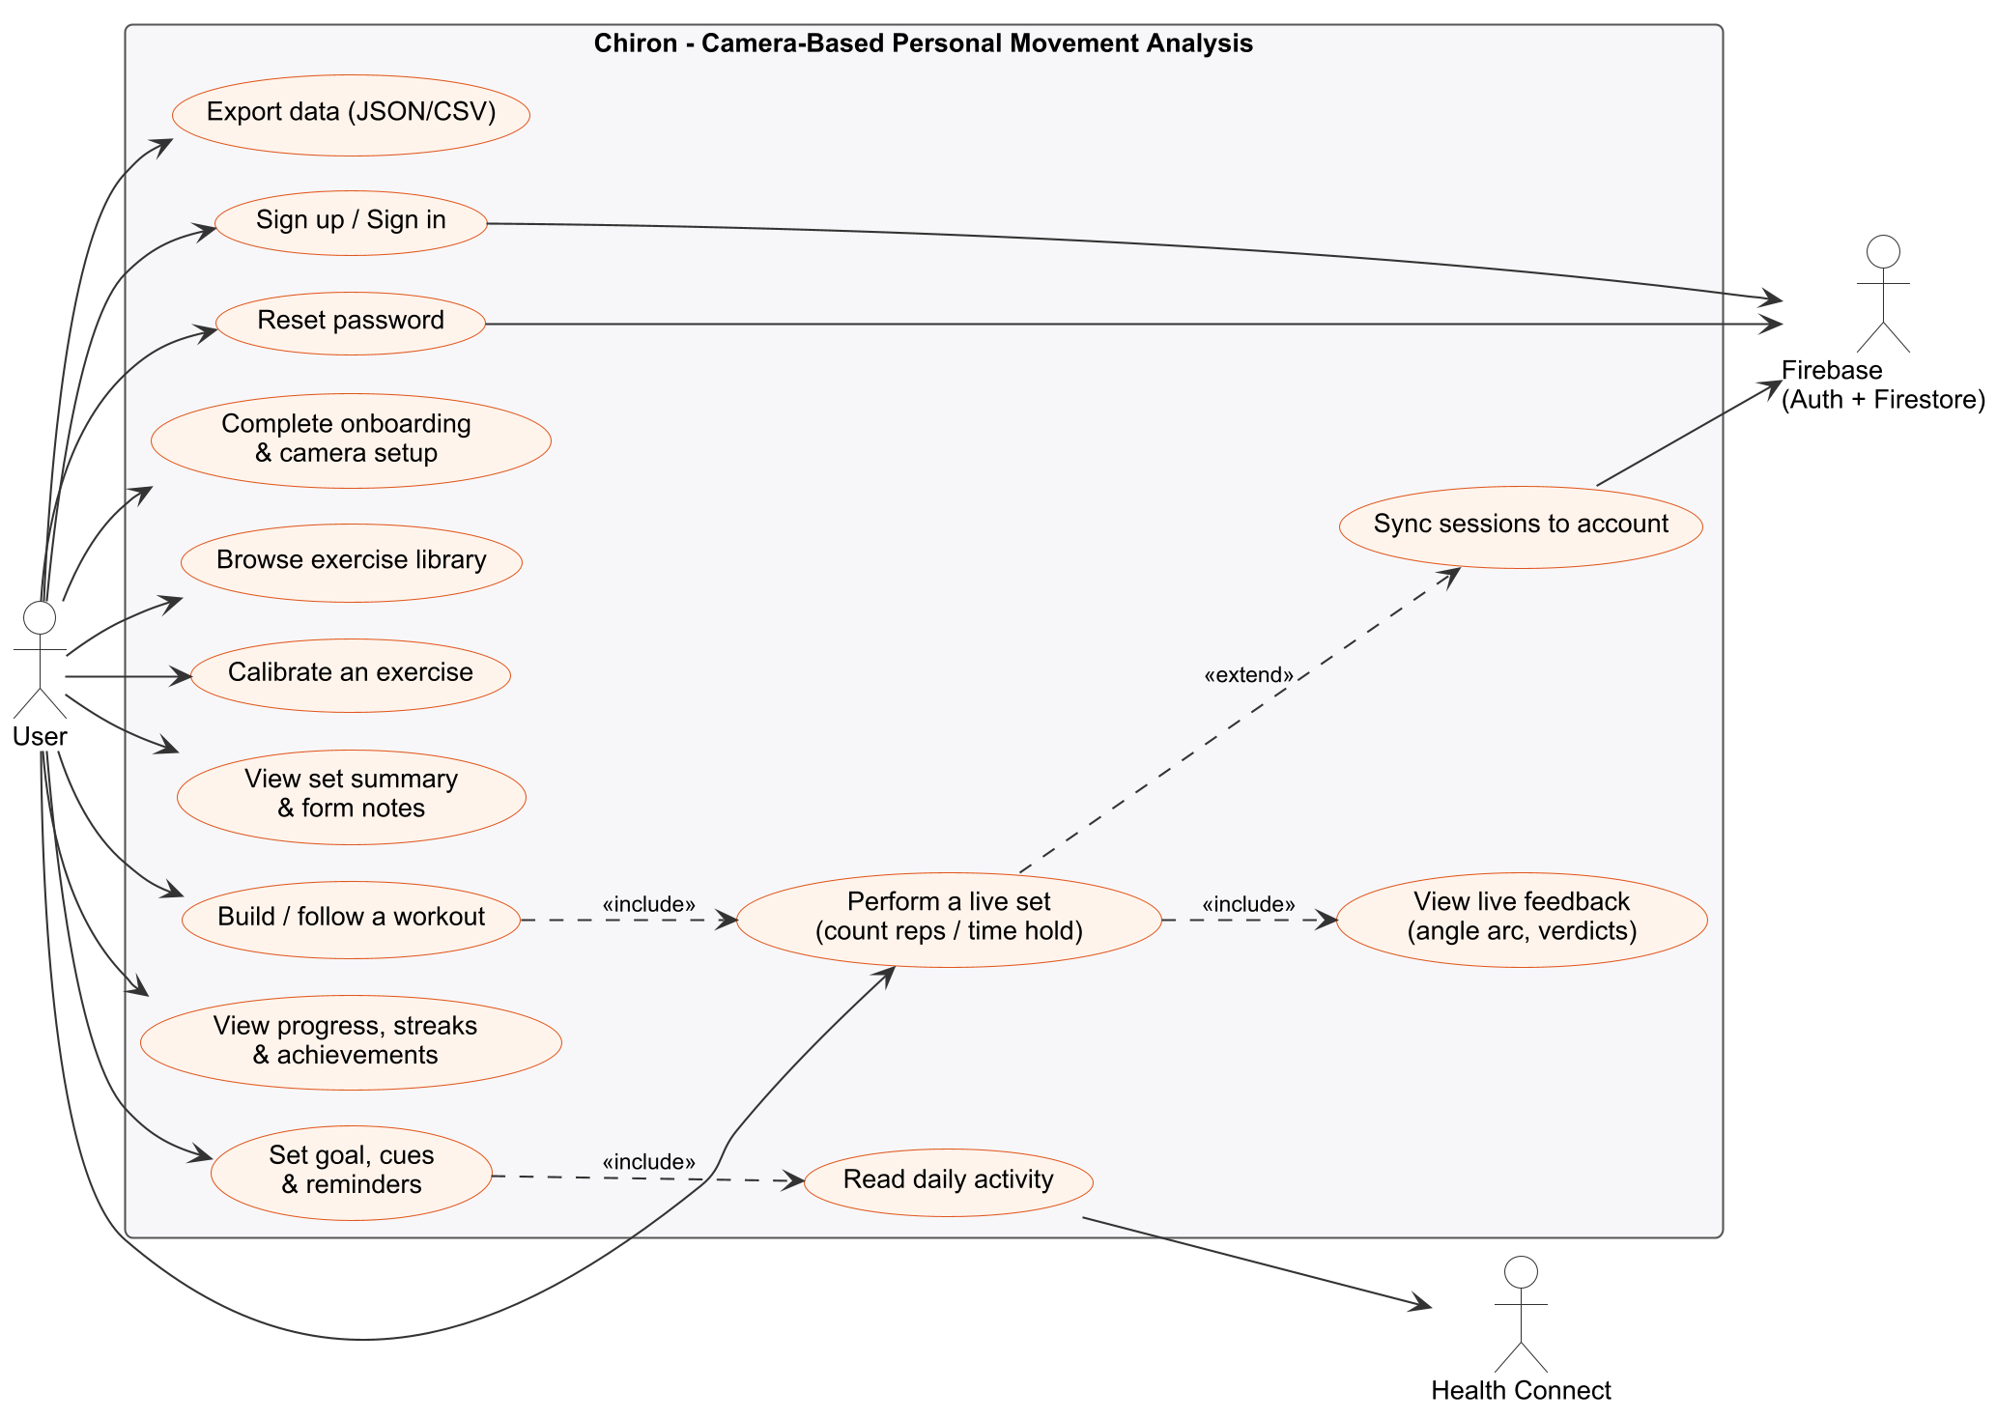
Fig 3.1: Use case diagram of Chiron
Use case | Description
Sign up / Sign in | The user creates an account or signs in with email and password.
Reset password | The user requests a password reset email from the sign-in screen.
Complete onboarding and camera setup | The user reads the introduction and how to place the phone.
Browse exercise library | The user views the 17 entries and chooses one.
Calibrate an exercise | The user records a normal set as their personal baseline.
Perform a live set | The user exercises in front of the camera; repetitions are counted or the hold is timed.
View live feedback | The user sees the skeleton, angle arc, count and verdict banner.
View set summary and form notes | The user reviews each attempt, range, speed and notes.
Build / follow a workout | The user plans a workout and is guided through it.
View progress, streaks and achievements | The user reviews history, calendar and statistics.
Set goal, cues and reminders | The user sets preferences and reminder notifications.
Export data | The user exports all sessions and calibrations as JSON and CSV.
Sync sessions to account | Finished sessions are copied to the user's Firebase account.
Read daily activity | Steps, active calories and heart rate are read from Health Connect.

3.5 Summary
This chapter described the functional and non-functional requirements, the ten modules of Chiron with their specifications, and the use case diagram. The next chapter presents the analysis and design of the software.

4. SOFTWARE ANALYSIS AND DESIGN
This chapter presents the design of Chiron through its data flow diagrams, class diagrams, architecture, database design, sequence diagram, entity-relationship diagram, deployment diagram and activity diagram.

4.1 Methodology
The project followed one working method throughout: measure, test, document, and only then claim. In practice this meant the following.
- One shared analysis core. All analysis is written once, in Kotlin Multiplatform common code. The Android application holds only the camera, the display and the storage, so no movement decision is made in user-interface code.
- Tests before profiles. Every exercise profile is guarded by tests written before it. Permanent guard tests protect left and right separation, front-camera mirroring, claim levels, the meaning of a repetition, agreement between platforms and the per-frame time budget.
- Public-data evaluation. Video from the MM-Fit dataset is run through MediaPipe and then through the application's own engine, and the counts are compared set by set with the dataset's published labels. People are kept apart: some for development, six never touched until the final run. No change was accepted if any set was counted above its label.
- A dated decision record. Every design choice and every measured number is recorded with its date and its reason, so that a claim in this report can be traced to the measurement behind it.
- Checks on a real phone. Each build is installed on a real phone after the data on it has been backed up and checked, and what is only built and unit-tested is kept separate from what has been seen on the device.

4.2 Data Flow Diagram
A data flow diagram shows how data moves between external entities, processes and data stores. Level 0 shows the whole system as one process; Level 1 breaks it into its main processes; Level 2 expands the live analysis process.

Level 0 (Context Diagram)
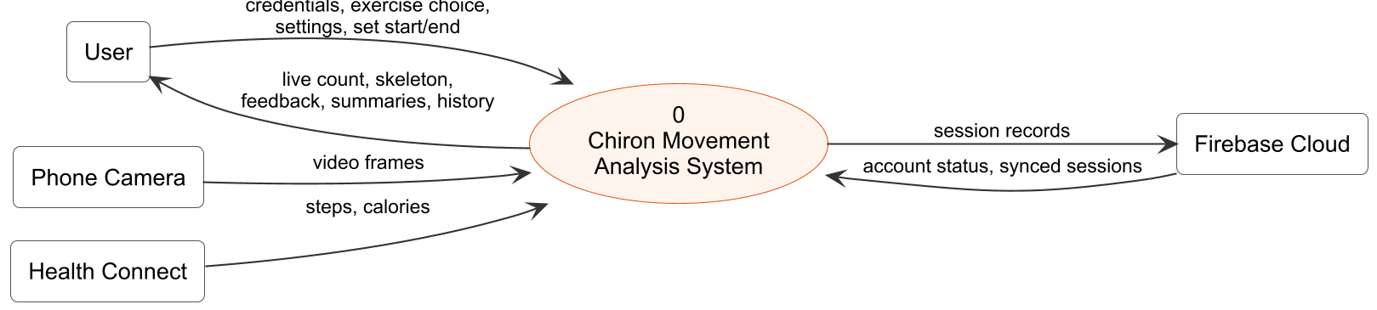
Fig 4.1: Level 0 DFD
The user supplies credentials, exercise choices, settings and the start and end of each set; the camera supplies video frames. Chiron returns the live count, skeleton and feedback, summaries and history. Session records go to Firebase, and Health Connect supplies daily activity.

Level 1
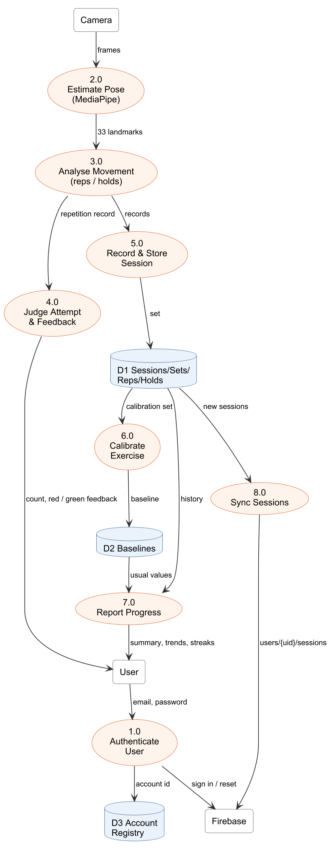
Fig 4.2: Level 1 DFD
Frames are turned into landmarks (2.0), analysed into repetition records (3.0), judged (4.0) and stored (5.0) in the session store D1. Calibration (6.0) builds baselines D2 from a calibration set; Report Progress (7.0) reads D1 and D2; Sync (8.0) copies new sessions to Firebase. Authentication (1.0) records which account owns which database in D3.

Level 2 (Live Movement Analysis)
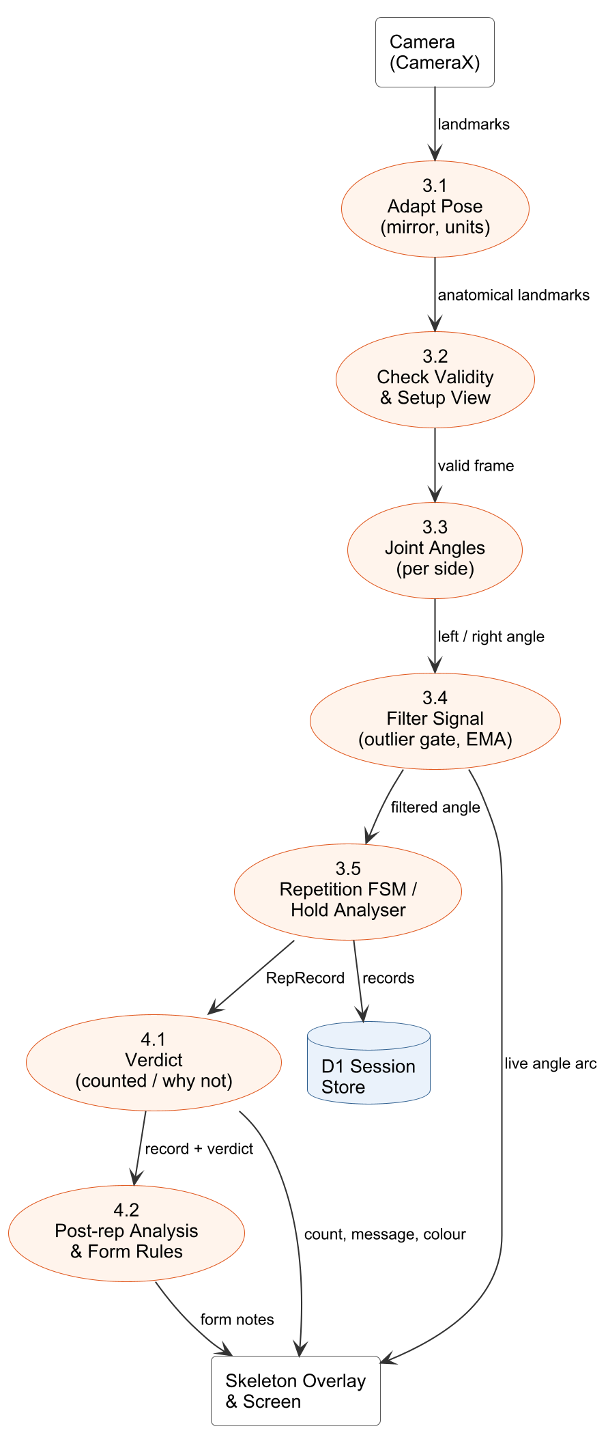
Fig 4.3: Level 2 DFD of live movement analysis

4.3 Class Diagram
The class design is split between the shared analysis core, written once in Kotlin Multiplatform, and the Android application. The core holds all analysis logic; the app holds the camera, the screens and storage.
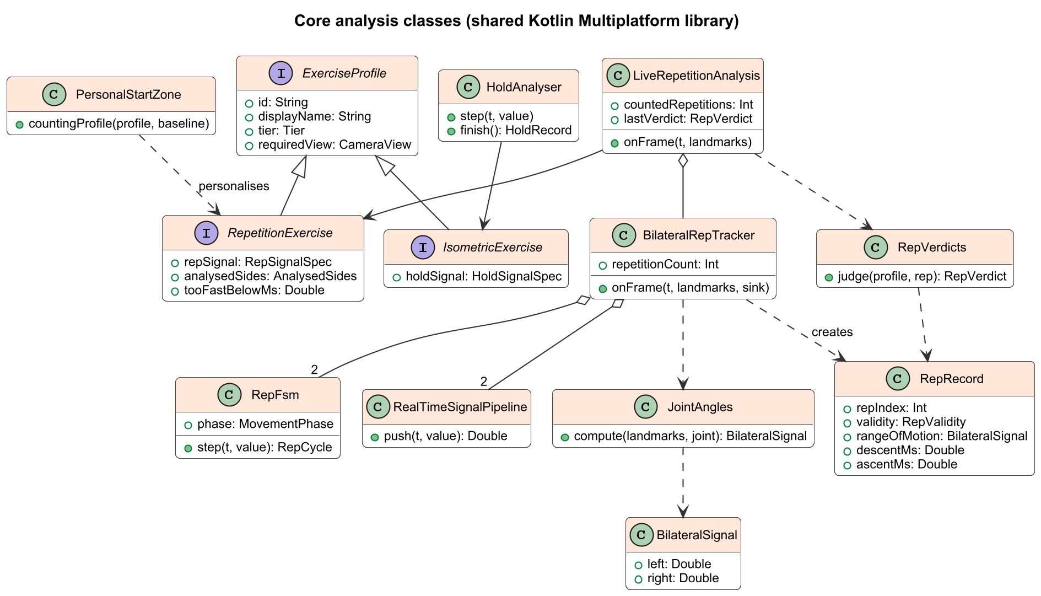
Fig 4.4: Class diagram of the shared analysis core
ExerciseProfile is specialised into RepetitionExercise and IsometricExercise, so a hold can never be passed to the repetition counter. LiveRepetitionAnalysis owns a BilateralRepTracker, which holds one RepFsm and one RealTimeSignalPipeline for each side of the body. JointAngles returns a BilateralSignal, a pair of left and right values that are never averaged. RepVerdicts judges every RepRecord that the tracker creates.
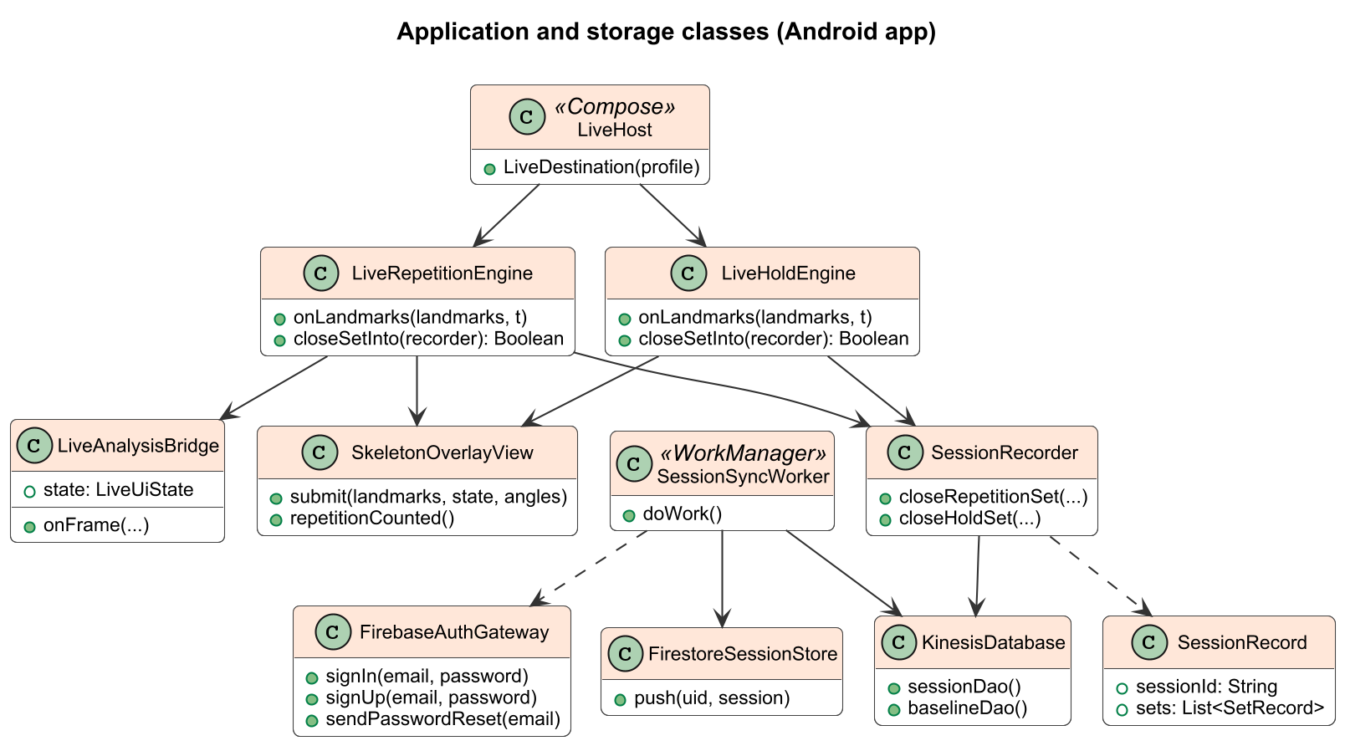
Fig 4.5: Class diagram of the Android application

4.4 Architecture Diagram
Chiron follows a four-layer architecture. The presentation layer contains the Jetpack Compose screens and the live skeleton overlay. The platform layer contains everything specific to Android: camera capture, MediaPipe, the pose adapter that converts camera coordinates to the body's own left and right, the live engines and the session recorder. The shared analysis core contains every analysis decision and is compiled for Android, the JVM and JavaScript. The data layer stores sessions on the phone and copies them to the user's account.
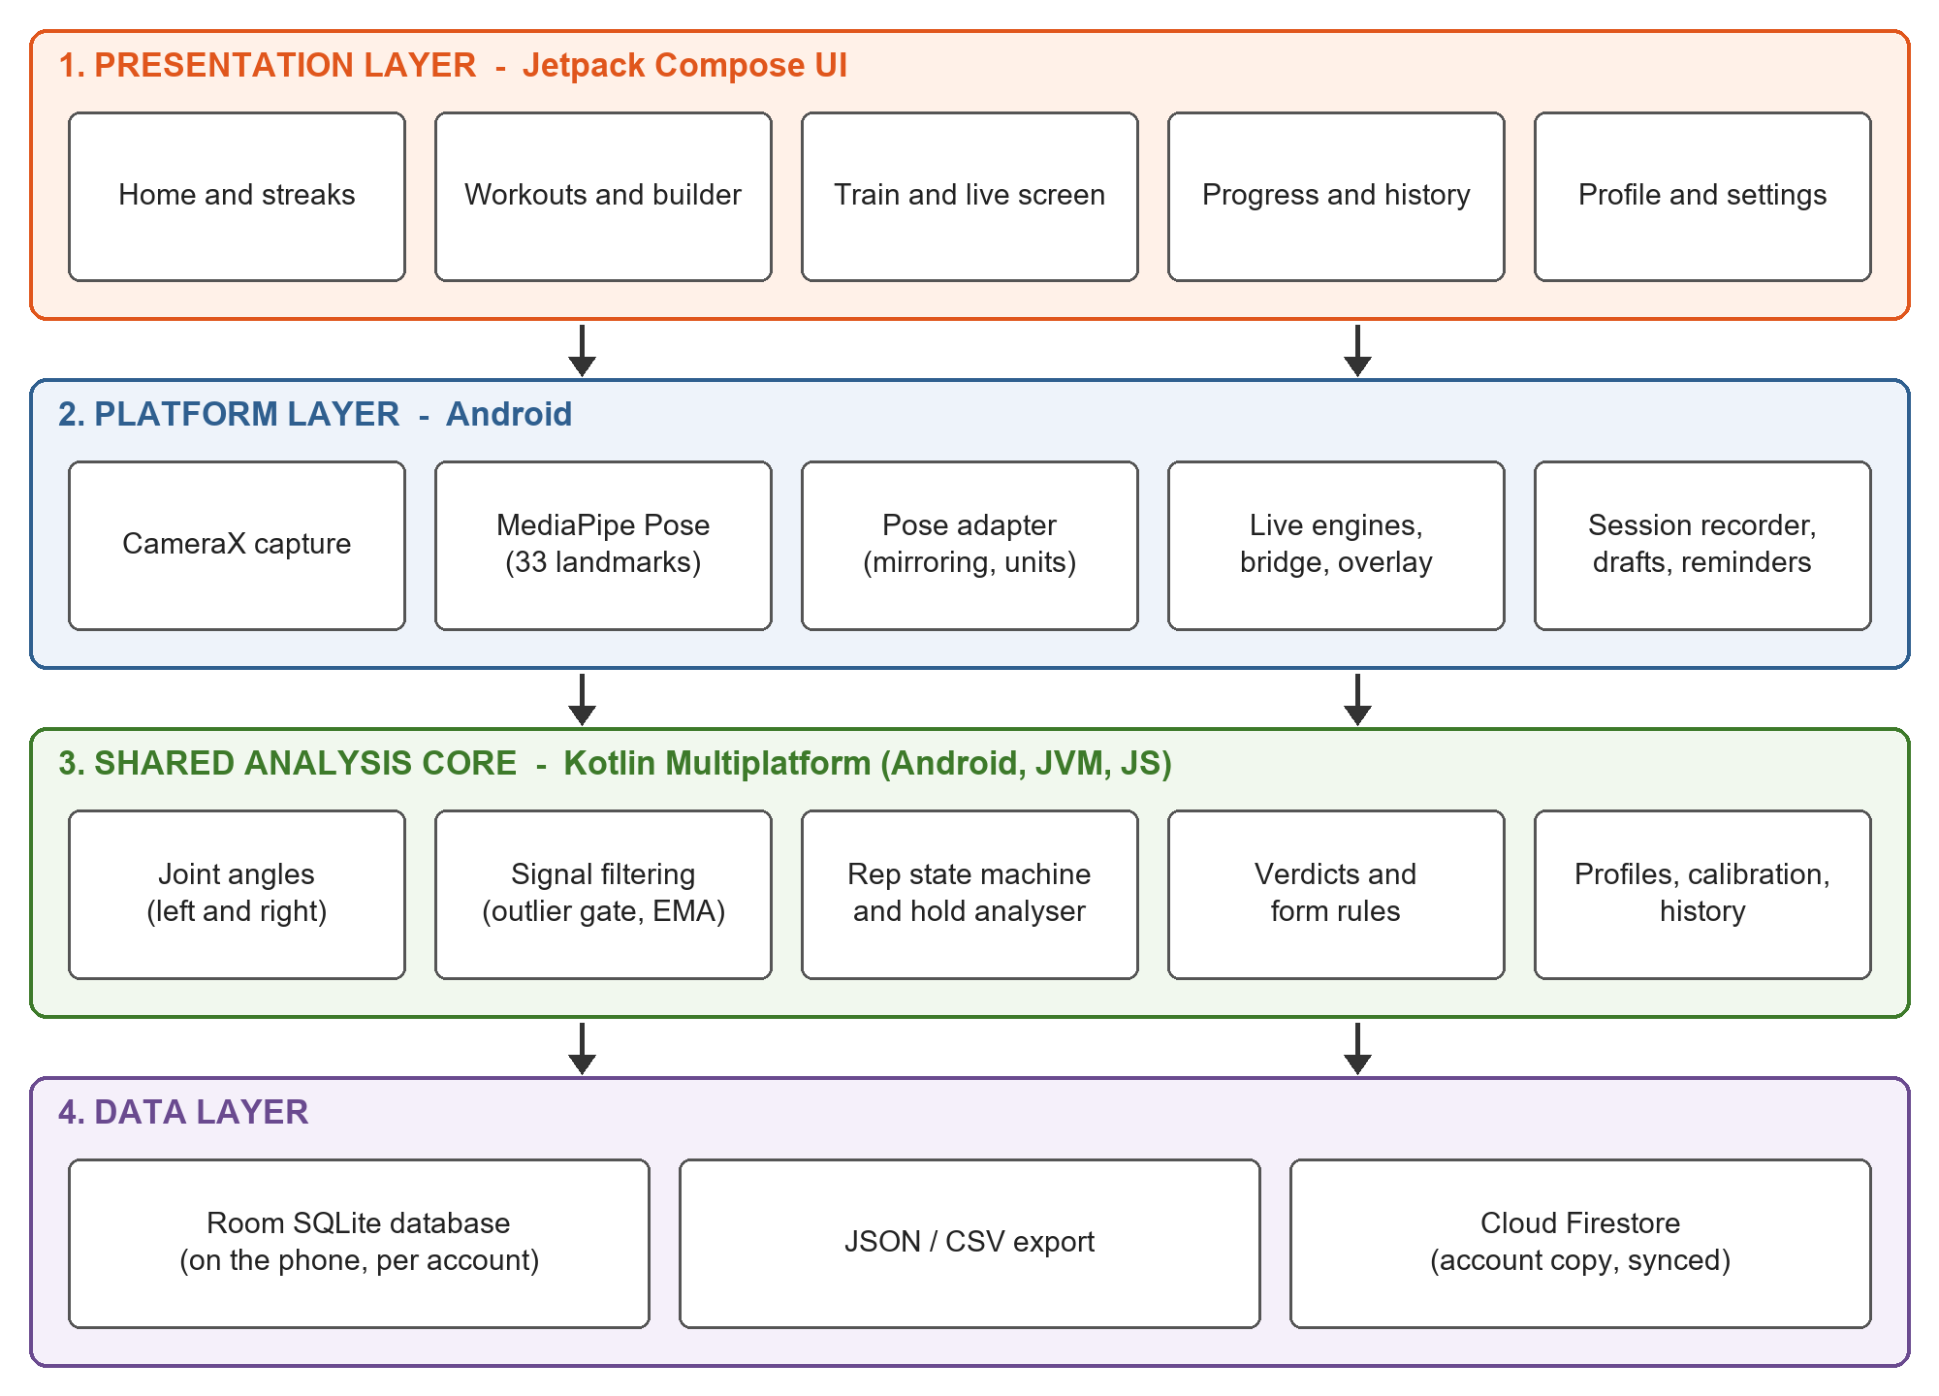
Fig 4.6: Architecture of Chiron
- Real-time path (every frame): landmarks → validity check → joint angles → ring-buffered filter → state machine. This path is constant-time and allocates nothing per frame.
- Post-repetition path (a few times a minute): repetition record → verdict → technique rules → comparison with the calibration → storage.
- Separation of concerns: the screens are never redrawn for every camera frame; only the skeleton view is, on its own canvas.

4.5 Database Diagram
Chiron stores its data in a Room (SQLite) database on the phone, one database file per signed-in account. The diagram shows the five tables and their relationships.
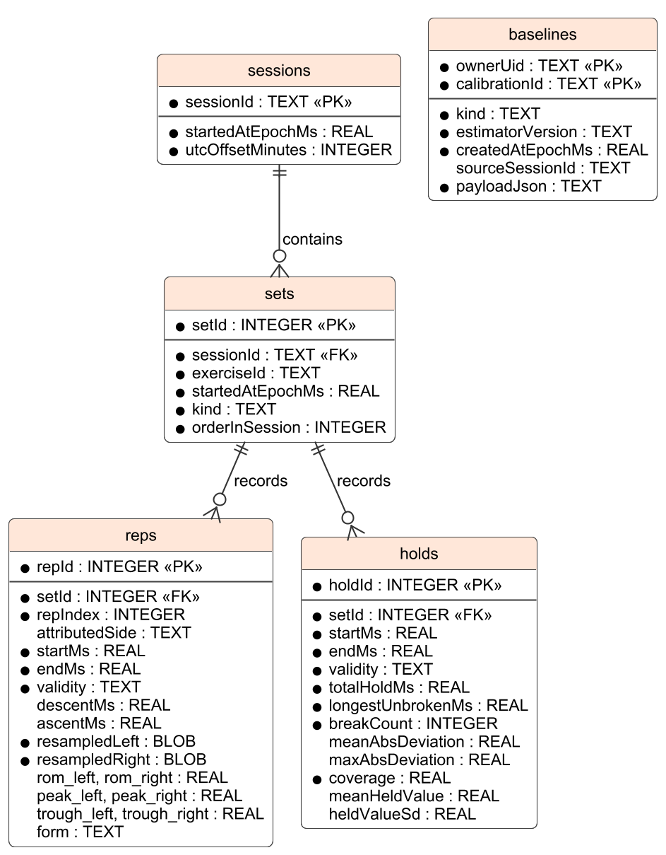
Fig 4.7: Database diagram

4.6 Database Design
The database is designed around the idea that a stored record is a measurement, and every interpretation (verdicts, comparisons with the calibration, form notes) is computed from it whenever it is shown. If a rule changes, old sessions are re-interpreted correctly without rewriting the data.
- sessions – one row per training session.
- sets – one row per set; belongs to a session; kind is REPETITION or HOLD.
- reps – one row per repetition record, with left and right values in separate columns, a 64-point resampled curve per side and the technique measures.
- holds – one row per isometric hold: time held, longest unbroken stretch, breaks, deviation and coverage.
- baselines – one personal calibration per user and exercise, stored as JSON with the version of the estimator that produced it.

Data Integrity
- Primary keys identify every row; sets reference sessions and reps and holds reference sets through foreign keys.
- Left and right are separate columns; a side that was not measured is stored as NULL, never as zero.
- The schema is versioned (version 3) with tested migrations, so an update never loses data.
- Each account has its own database file, so two people sharing a phone never see each other's sessions.
- A set in progress is written to a draft file after every repetition (and about once a second during a hold), so it survives the app being closed.

4.7 Table Design
Table: sessions
Column name | Data type | Key | Description
sessionId | TEXT | Primary key | Unique identifier of the session
startedAtEpochMs | REAL | - | Start time (milliseconds since 1970)
utcOffsetMinutes | INTEGER | - | Time zone offset when it started

Table: sets
Column name | Data type | Key | Description
setId | INTEGER | Primary key | Auto-generated set identifier
sessionId | TEXT | Foreign key | References sessions.sessionId
exerciseId | TEXT | - | Exercise profile, e.g. squat
startedAtEpochMs | REAL | - | Start time of the set
kind | TEXT | - | REPETITION or HOLD
orderInSession | INTEGER | - | Position of the set in the session

Table: reps
Column name | Data type | Key | Description
repId | INTEGER | Primary key | Auto-generated record identifier
setId | INTEGER | Foreign key | References sets.setId
repIndex | INTEGER | - | Position in the set, from 1
attributedSide | TEXT | - | LEFT or RIGHT for one-arm exercises
startMs, endMs | REAL | - | Start and end of the attempt
validity | TEXT | - | VALID, ABORTED, INCOMPLETE or INSUFFICIENT_DATA
descentMs, ascentMs | REAL | - | Lowering and lifting time of the repetition
resampledLeft, resampledRight | BLOB | - | 64-point angle curve per side
rom_left, rom_right | REAL | - | Range of motion per side (degrees)
peak_left, peak_right | REAL | - | Angle at the start position per side
trough_left, trough_right | REAL | - | Angle at the far position per side
form | TEXT | - | Technique measures, e.g. trunk lean

Table: holds
Column name | Data type | Key | Description
holdId | INTEGER | Primary key | Auto-generated hold identifier
setId | INTEGER | Foreign key | References sets.setId
startMs, endMs | REAL | - | Start and end of the hold
validity | TEXT | - | VALID, BROKEN, TOO_SHORT or INSUFFICIENT_DATA
totalHoldMs | REAL | - | Total time in position
longestUnbrokenMs | REAL | - | Longest continuous stretch
breakCount | INTEGER | - | Number of times the position was lost
meanAbsDeviation, maxAbsDeviation | REAL | - | Distance from the target angle
coverage | REAL | - | Share of the hold that was measured
meanHeldValue, heldValueSd | REAL | - | Mean angle held and its sway

Table: baselines
Column name | Data type | Key | Description
ownerUid | TEXT | Primary key (composite) | Account that owns the calibration
calibrationId | TEXT | Primary key (composite) | Exercise calibrated, e.g. bicep_curl
kind | TEXT | - | REPETITION or HOLD
estimatorVersion | TEXT | - | Version of the calibration method
createdAtEpochMs | REAL | - | When the calibration was made
sourceSessionId | TEXT | - | Session the calibration came from
payloadJson | TEXT | - | Per-side medians and spreads as JSON

Cloud copy (Cloud Firestore). Each finished session is stored as one document at users/{uid}/sessions/{sessionId}, containing its sets and records. Calibrations stay on the phone. The project's security rules allow a signed-in user to read and create documents only under their own uid; sessions cannot be edited or deleted, and every other path is closed.

4.8 Sequence Diagram
The sequence diagram shows one live set: from the user starting the set, through the per-frame loop of camera, pose estimation, analysis and drawing, to saving the session and syncing it in the background.
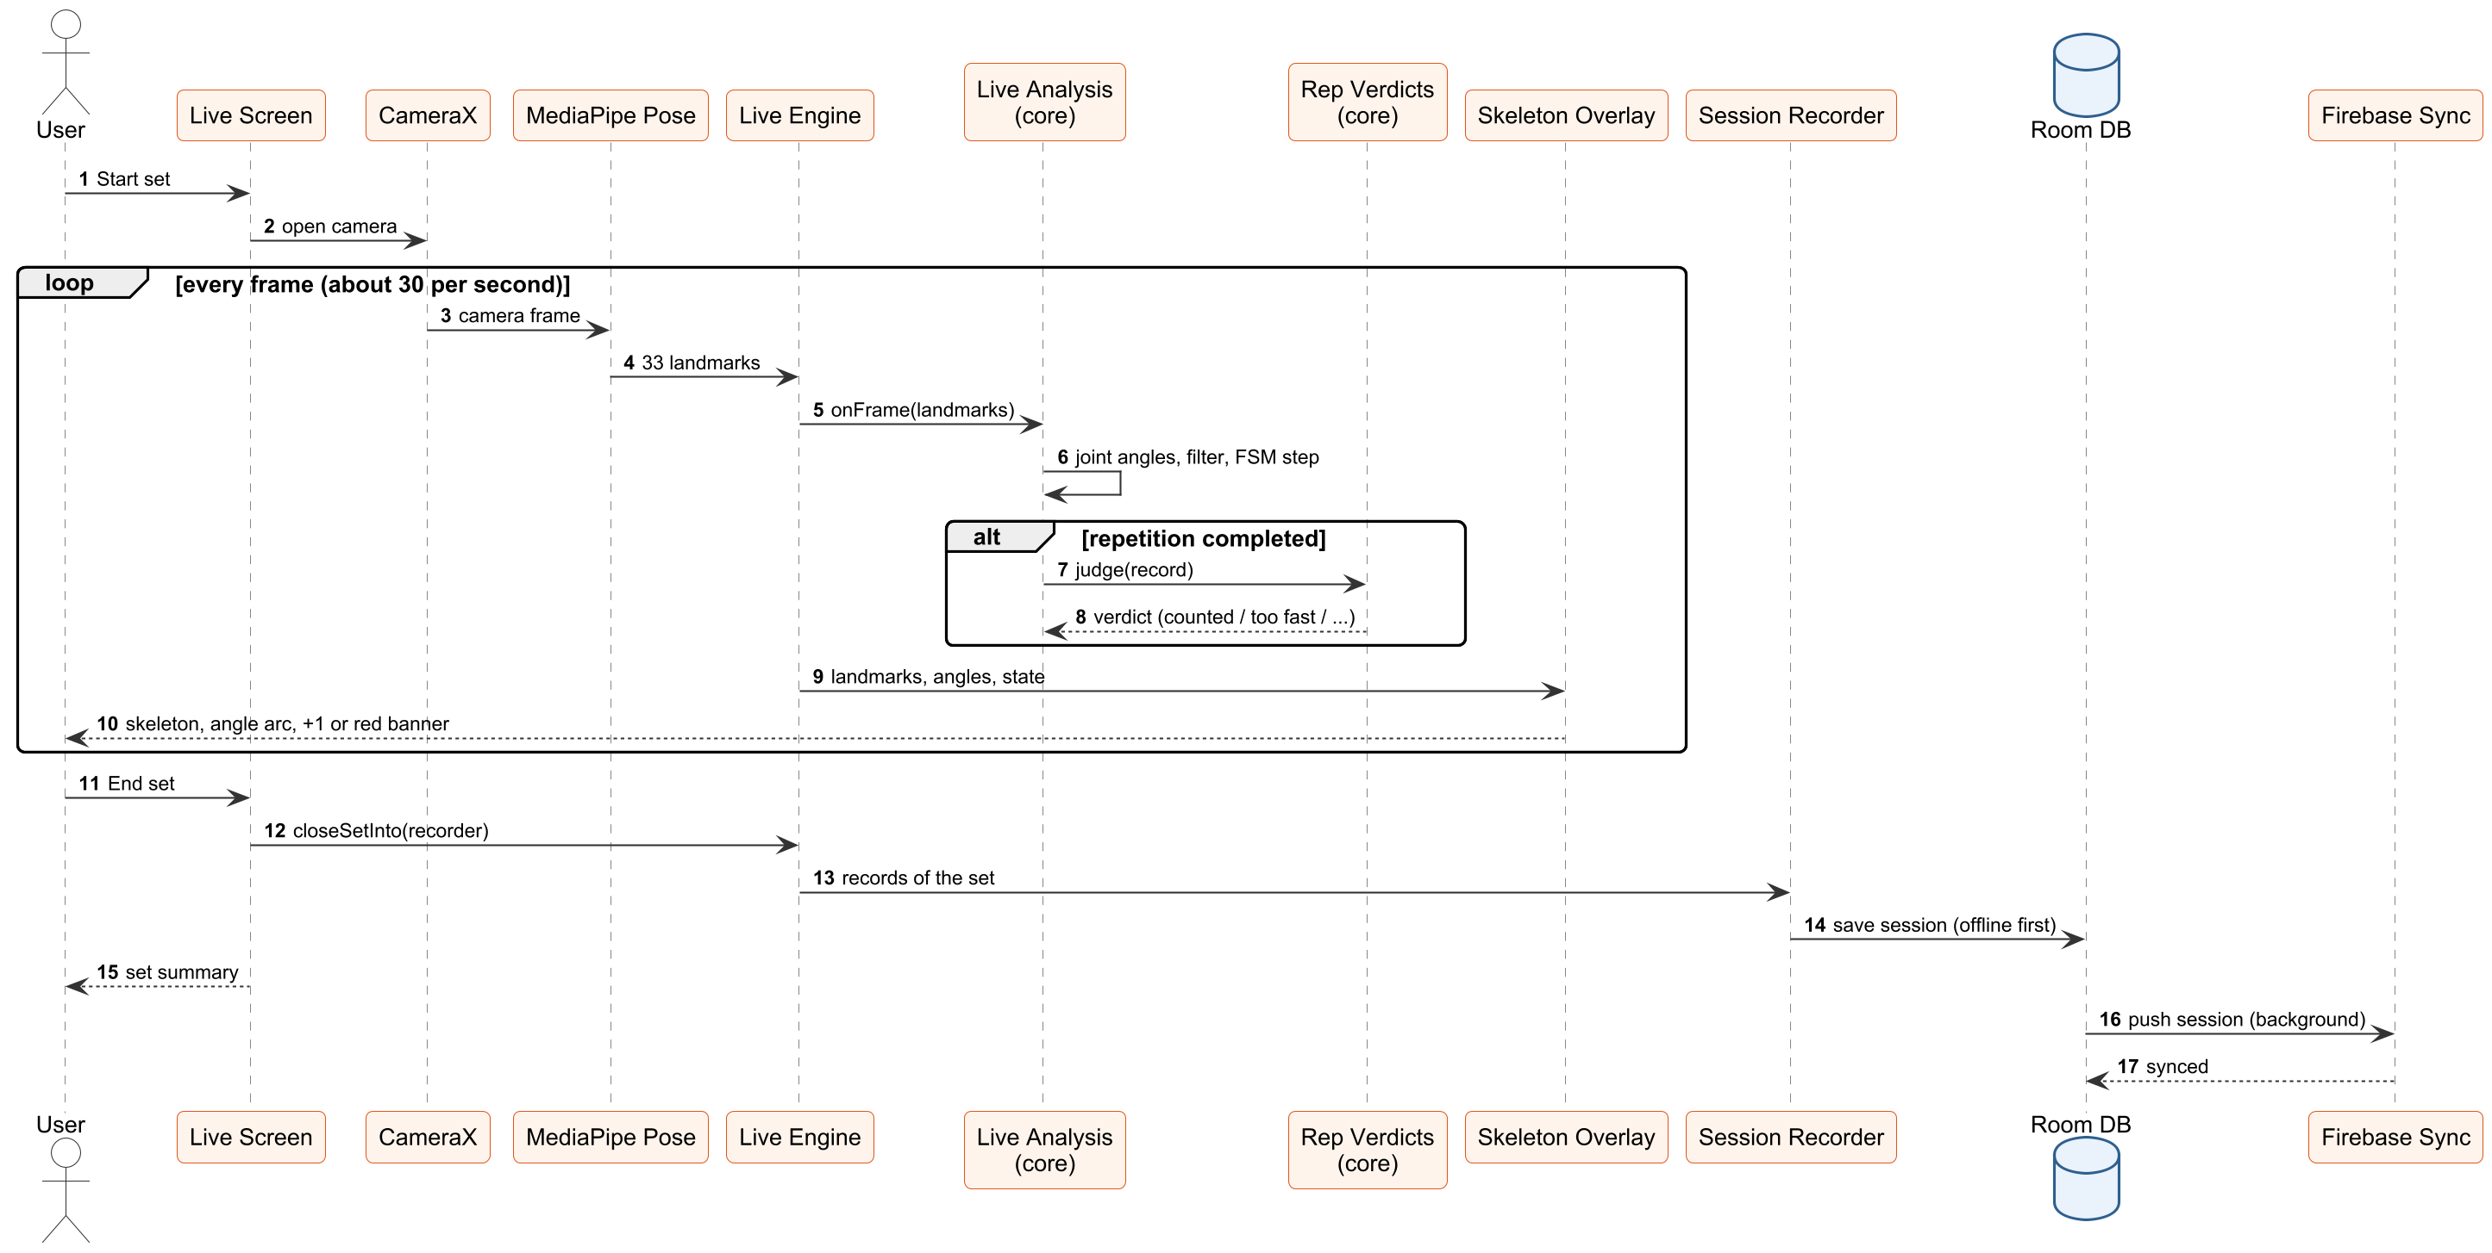
Fig 4.8: Sequence diagram of a live set

4.9 E-R Diagram
The entity-relationship diagram shows the conceptual entities of Chiron and their cardinalities. A user performs many sessions; a session contains many sets; a set records many repetitions or holds and is of one exercise; a user calibrates many baselines. The user is the Firebase account; on the phone, each account's data lives in that account's own database file.
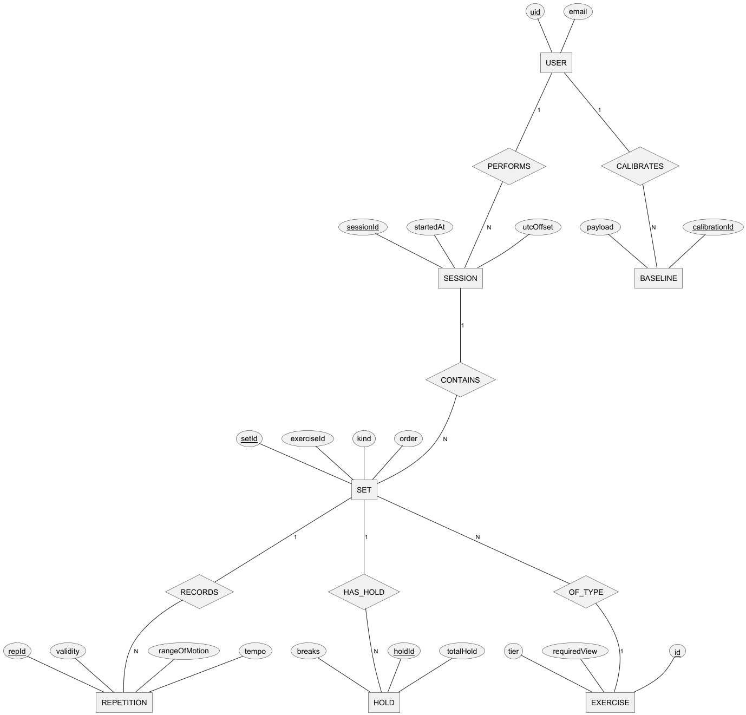
Fig 4.9: E-R diagram

4.10 Deployment Diagram
Chiron is deployed as a single Android application on the user's phone. All analysis runs on the phone; Firebase in the cloud provides authentication and a copy of the session records. The developer PC builds and installs the app and runs the evaluation harness with the same analysis core on the JVM.
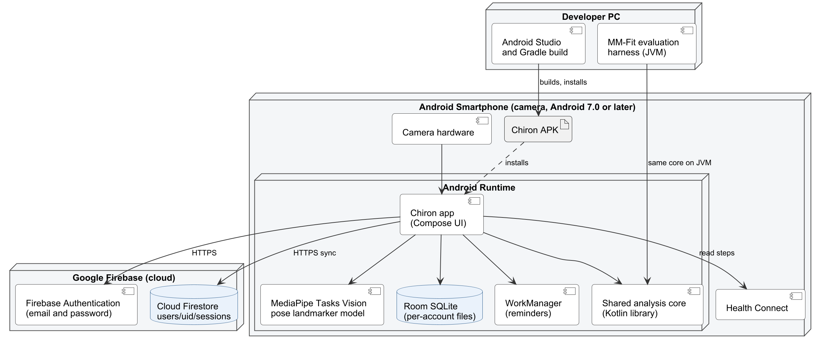
Fig 4.10: Deployment diagram

4.11 Activity Diagram
The activity diagram shows a user's path through one training set, including the per-repetition decision that produces the "+1" flash or the red banner.
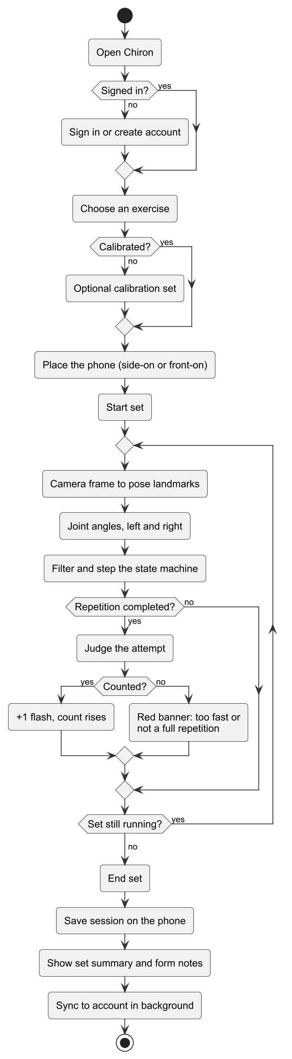
Fig 4.11: Activity diagram of a training set

4.12 Algorithm Design

Repetition Counting
Each side of the body has its own counting machine, which follows one joint angle (for example the knee in a squat or the elbow in a curl). Every exercise profile defines a top threshold (the starting position), a bottom threshold (the far position) and a hysteresis band, so that a signal resting near a threshold does not flicker between phases.
Phase | Meaning | Moves to
IDLE | No start position seen yet | TOP, when the angle is in the start zone
TOP | At the starting position | DESCENDING, when the angle leaves the start zone
DESCENDING | Moving towards the far position | BOTTOM at the far threshold, or back to TOP (turned back)
BOTTOM | At the far position | ASCENDING, when the angle leaves the far zone
ASCENDING | Returning to the start | TOP, which completes the repetition

A completed cycle shorter than the profile's minimum duration is recorded as turned back; one longer than the maximum is treated as abandoned. A short loss of tracking (up to 500 ms) is bridged so that one dropped frame does not end a repetition; a longer one ends it as "insufficient data".

Signal Filtering
- Outlier gate: a new angle that jumps more than 35 degrees from the median of the last 5 samples is held back until 3 samples in a row confirm it, so a single misplaced landmark cannot create a repetition.
- Exponential smoothing: the accepted angle is smoothed with a weight of 0.3 per 33 ms, adjusted to the actual time between results, so the filter behaves the same when the phone is slower.
- Ring buffers: recent samples are kept in fixed-size buffers, so the work per frame never grows with the length of the session.

Verdict Rules
Verdict | Rule | Counted | Shown
Counted | A full cycle within the time limits | Yes | "+1" flash
Form fault | A full cycle on which a cited technique rule fires | Yes | Red, with the rule's reason
Too fast | Faster than the fastest real repetition on record for that exercise | No | Red, "Too fast – not counted"
Not a full repetition | Turned back after passing halfway | No | Red, "Not a full repetition – not counted"
Lost tracking | Tracking lost past halfway, or an impossible angle (knee below 30 degrees) | No | Amber, "Lost tracking – not counted"
Silent | A wobble that never reached halfway, or the far limb seeing the same movement | No | Nothing

Personal Start Position (Push-ups)
At the top of a push-up, the elbow angle seen by a side-on camera varies between people from about 131 to 166 degrees, so one fixed start threshold either misses some people's push-ups or counts other people's half push-ups. Chiron therefore takes the start position from the user's own calibration: the median of their top angles less a margin, never stricter than the profile's 155 degrees and never looser than a floor of 126 degrees. The floor keeps a real minimum range, so a shallow calibration cannot turn half push-ups into counted ones. Calibration sets themselves are counted with the floor.
The too-fast limits were measured on the MM-Fit dataset: each limit is just under the fastest repetition the development participants performed (for example 630 ms for the bicep curl, whose fastest real repetition took 633 ms), so a genuine repetition is never rejected for speed.

4.13 Summary
This chapter described the analysis and design of Chiron: the data flow diagrams, the class diagrams of the core and the app, the four-layer architecture, the database diagram, design and tables, the sequence, E-R, deployment and activity diagrams, and the algorithms that count and judge each repetition. The next chapter describes the testing of the system.

5. CODING
The complete source code contains the shared analysis core (Kotlin Multiplatform), the Android application, and the evaluation tools. The listings below show the central parts of the system. The code uses the package name com.kinesis, the project's working name during development; the application is published as Chiron.
JointAngles.kt - joint angles for each side of the body
package com.kinesis.core.analysis.kinematics

import com.kinesis.core.analysis.geometry.Geometry
import com.kinesis.core.domain.bilateral.BilateralSignal
import com.kinesis.core.domain.landmark.LandmarkId
import com.kinesis.core.domain.landmark.Landmarks
import com.kinesis.core.domain.landmark.VisibilityPolicy
import kotlin.math.PI
import kotlin.math.abs
import kotlin.math.atan2

/**
* Current-frame joint angles, computed from anatomical landmarks.
*
* The first analysis step of CONTRACTS.md section 7's real-time path after
* normalisation and validity. Reads one frame, touches no history, holds no
* state - the same frame gives the same answer at any point in a session.
*
* ### Bilateral by construction
*
* Every function returns a [BilateralSignal]. There is no overload that computes
* one side alone, because that is what made the old prototype's averaging
* possible: it exposed `leftKnee()` and `rightKnee()` as independent scalars,
* and its live detector combined them as `(left + right) / 2f`, falling back to
* `left ?: right` when one side was occluded - so a two-sided measurement and a
* one-sided one were indistinguishable downstream. DECISIONS.md P2-2 has the
* detail.
*
* A side whose landmarks are not visible enough comes back as [Double.NaN] *on
* that side*. The other side keeps its real value, and the absence stays visible
* instead of being averaged away or silently substituted.
*/
object JointAngles {

/**
* The [joint] angle on both sides, in degrees over 0..180.
*
* A side is [Double.NaN] when any of its three landmarks falls below
* [VisibilityPolicy.marginal] or has a `NaN` visibility, or when the
* geometry is degenerate.
*/
fun compute(
landmarks: Landmarks,
joint: JointAngleId,
plane: MeasurementPlane,
policy: VisibilityPolicy,
): BilateralSignal = BilateralSignal(
left = angleFor(
landmarks,
joint.proximal.leftId,
joint.vertex.leftId,
joint.distal.leftId,
plane,
policy,
),
right = angleFor(
landmarks,
joint.proximal.rightId,
joint.vertex.rightId,
joint.distal.rightId,
plane,
policy,
),
)

/**
* The value of whichever [DrivingSignal] a profile names, on both sides - DECISIONS.md P3-45.
* A segment's inclination is always measured in the image plane.
*/
fun compute(
landmarks: Landmarks,
signal: DrivingSignal,
plane: MeasurementPlane,
policy: VisibilityPolicy,
): BilateralSignal = when (signal) {
is JointAngleId -> compute(landmarks, signal, plane, policy)
is SegmentInclination -> BilateralSignal(
left = inclinationFor(landmarks, signal.lower.leftId, signal.upper.leftId, policy),
right = inclinationFor(landmarks, signal.lower.rightId, signal.upper.rightId, policy),
)
}

/**
* The angle above horizontal of the segment from [lower] to [upper], for one side: image y
* runs down the frame (CONTRACTS.md section 4), so [upper] above [lower] is a positive rise.
*/
private fun inclinationFor(
landmarks: Landmarks,
lower: LandmarkId,
upper: LandmarkId,
policy: VisibilityPolicy,
): Double {
if (!policy.isMeasurable(landmarks.visibility(lower))) return Double.NaN
if (!policy.isMeasurable(landmarks.visibility(upper))) return Double.NaN
val across = abs(landmarks.x(upper) - landmarks.x(lower))
val rise = landmarks.y(lower) - landmarks.y(upper)
if (!across.isFinite() || !rise.isFinite()) return Double.NaN
if (across < SEGMENT_EPSILON && abs(rise) < SEGMENT_EPSILON) return Double.NaN
return atan2(rise, across) * 180.0 / PI
}

/** Below this, in image widths, a segment has no direction worth measuring. */
private const val SEGMENT_EPSILON: Double = 1e-6

/**
* The angle at [vertex] between [proximal] and [distal], for one side.
*
* Private on purpose. Exposing a single-sided angle is exactly the API shape
* this file exists to avoid.
*/
private fun angleFor(
landmarks: Landmarks,
proximal: LandmarkId,
vertex: LandmarkId,
distal: LandmarkId,
plane: MeasurementPlane,
policy: VisibilityPolicy,
): Double {
if (!policy.isMeasurable(landmarks.visibility(proximal))) return Double.NaN
if (!policy.isMeasurable(landmarks.visibility(vertex))) return Double.NaN
if (!policy.isMeasurable(landmarks.visibility(distal))) return Double.NaN

return when (plane) {
MeasurementPlane.IMAGE_2D -> Geometry.angleAtVertex2dDegrees(
landmarks.x(proximal), landmarks.y(proximal),
landmarks.x(vertex), landmarks.y(vertex),
landmarks.x(distal), landmarks.y(distal),
)

MeasurementPlane.SPATIAL_3D -> Geometry.angleAtVertex3dDegrees(
landmarks.x(proximal), landmarks.y(proximal), landmarks.z(proximal),
landmarks.x(vertex), landmarks.y(vertex), landmarks.z(vertex),
landmarks.x(distal), landmarks.y(distal), landmarks.z(distal),
)
}
}
}

/** True when both sides of this signal are real measurements. */
fun BilateralSignal.bothSidesMeasured(): Boolean =
Geometry.isMeasured(left) && Geometry.isMeasured(right)

/** True when neither side of this signal was measurable. */
fun BilateralSignal.neitherSideMeasured(): Boolean =
!Geometry.isMeasured(left) && !Geometry.isMeasured(right)
RealTimeSignalPipeline.kt - per-frame filtering
package com.kinesis.core.analysis.temporal

/**
* The per-frame half of CONTRACTS.md section 7, assembled: one scalar signal
* goes in per frame, a filtered value comes out, and a bounded window of recent
* history is kept for whatever reads it next.
*
* raw sample -> outlier gate -> EMA -> ring buffer
*
* The EMA is weighted by the time since the last sample, in intervals of
* [TemporalConfig.smoothingIntervalMs], not per sample - DECISIONS.md P3-33.
*
* ### Why this order, and why it is not the prototype's order
*
* The old prototype ran outlier removal, then gap interpolation, then smoothing,
* then resampling, and it documented why: outliers first so a spike cannot
* pollute the smoother or the interpolator, and interpolation before smoothing
* so a short gap does not jerk the filter state. Both reasons are sound and both
* are kept.
*
* What changed is where the chain is cut. Interpolation and resampling need to
* see both sides of a gap, so neither can run on a live stream - they belong to
* the post-rep path, over a repetition that has finished. See [GapInterpolator]
* and [SignalResampler]. What remains here is the part that is genuinely causal.
*
* The prototype ran its whole chain over the entire session on every frame.
* DECISIONS.md P2-2 records why that is not ported; RealTimeBudgetTest and
* PerFrameAllocationTest keep it from returning.
*
* ### One signal per pipeline
*
* A pipeline filters a single scalar - one joint angle on one side, say. A
* bilateral measurement needs two, which is deliberate: it keeps the left and
* right filter states genuinely independent, so an occlusion on one side cannot
* perturb the other.
*/
class RealTimeSignalPipeline(
val config: TemporalConfig,
bufferCapacity: Int,
) {

/** Recent filtered history, bounded. What the P3 repetition FSM will read. */
val buffer: DoubleRingBuffer = DoubleRingBuffer(bufferCapacity)

private val outlierGate = MedianOutlierGate(
windowSamples = config.outlierWindowSamples,
threshold = config.outlierThreshold,
readmitSamples = config.outlierReadmitSamples,
)

private val smoother = EmaSmoother(config.smoothingAlpha)

/** When the last sample was pushed, measured or not; [Double.NaN] before the first. */
private var lastPushMs: Double = Double.NaN

/**
* Samples examined by the last [push]. Instrumentation, not behaviour:
* "this frame did no work proportional to the session" is the invariant
* CLAUDE.md section 6 turns on, and without a counter there is no way for a
* test to check it. One integer per frame is a fair price for making the
* rule enforceable rather than aspirational.
*/
var lastPushSamplesVisited: Int = 0
private set

/** How many samples the outlier gate has rejected. Diagnostic. */
val rejectedSampleCount: Long get() = outlierGate.rejectedCount

/** The most recent filtered value, or [Double.NaN]. */
val current: Double get() = smoother.current

/**
* Feeds one frame through the chain and records the result.
*
* @param rawValue the measurement for this frame, or [Double.NaN] if it could
* not be measured. An unmeasurable sample is buffered as [Double.NaN]
* rather than dropped, so the gap keeps its place in time and the post-rep
* path can see how long it lasted.
* @return the filtered value, or [Double.NaN].
*/
fun push(timestampMs: Double, rawValue: Double): Double {
val gated = outlierGate.accept(rawValue)
// After a NaN the smoother starts afresh, so only the time since a measured
// sample ever weighs anything.
val smoothed = smoother.update(gated, (timestampMs - lastPushMs) / config.smoothingIntervalMs)
lastPushMs = timestampMs
buffer.push(timestampMs, smoothed)
lastPushSamplesVisited = outlierGate.lastCallSamplesVisited
return smoothed
}

/** Returns the pipeline to its initial state. Storage is kept and reused. */
fun reset() {
outlierGate.reset()
smoother.reset()
lastPushMs = Double.NaN
buffer.clear()
lastPushSamplesVisited = 0
}
}
RepFsm.kt - the repetition state machine
package com.kinesis.core.analysis.rep

import com.kinesis.core.analysis.profile.RepSignalSpec
import com.kinesis.core.analysis.temporal.DoubleRingBuffer
import com.kinesis.core.analysis.temporal.SignalResampler
import com.kinesis.core.domain.rep.MovementPhase
import com.kinesis.core.domain.rep.RepValidity

/**
* One completed cycle of a single signal, before it is attributed to a side.
*
* Side-agnostic on purpose: an [RepFsm] tracks one scalar and does not know
* whether it is watching a left knee or a right elbow. `BilateralRepTracker`
* pairs two of them and decides what a repetition means.
*/
class RepCycle(
val startMs: Double,
val endMs: Double,
val validity: RepValidity,

/** Signal value at the starting position. */
val peakValue: Double,

/** Signal value at the far position. */
val troughValue: Double,

val descentMs: Double,
val ascentMs: Double,

/** The cycle resampled to a fixed length - CLAUDE.md section 15. */
val resampled: DoubleArray,
) {
val durationMs: Double get() = endMs - startMs

/** Peak-to-peak excursion. Always non-negative, whichever way the signal ran. */
val rangeOfMotion: Double
get() = if (peakValue.isNaN() || troughValue.isNaN()) {
Double.NaN
} else if (peakValue >= troughValue) {
peakValue - troughValue
} else {
troughValue - peakValue
}
}

/**
* Counts repetitions in one scalar signal, one frame at a time.
*
* ### Incremental, which is the whole point
*
* [step] consumes a single frame and returns either nothing or the repetition
* that frame completed. The machine holds its own state between calls: a phase,
* two extremes, three timestamps and a bounded buffer. It never looks at the
* session.
*
* The old prototype's `RepEngine` took the whole signal and replayed it from
* IDLE, and its live adapter called that once per frame over a list that grew
* for the length of the set. Its state machine was sound and is the basis for
* this one; the way it was driven is what DECISIONS.md P2-2 records as not
* ported. The P2 per-frame budget guards enforce the difference.
*
* ### Direction-agnostic
*
* Nothing assumes the signal falls during the working phase. A squat's knee
* angle decreases from standing; a bicep curl's elbow angle also decreases; a
* lateral raise's shoulder angle increases. [RepSignalSpec.topIsGreater] settles
* it once, and the comparisons below read the same either way.
*
* ### Hysteresis
*
* A threshold is a band, not a line. A signal resting exactly on one jitters
* across it every frame, and without the band the phase would oscillate and
* manufacture repetitions out of estimator noise.
*/
class RepFsm(
val spec: RepSignalSpec,
bufferCapacity: Int,
private val resampleLength: Int = DEFAULT_RESAMPLE_LENGTH,
/**
* How long a repetition in progress may go unmeasured and carry on -
* DECISIONS.md P3-23. Zero abandons it on the first unmeasurable frame, as
* before.
*/
private val maxBridgedGapMs: Double = 0.0,
) {

init {
require(bufferCapacity >= resampleLength) {
"the cycle buffer (" + bufferCapacity + ") must hold at least as many samples as " +
"the resampled output (" + resampleLength + ")"
}
require(resampleLength >= 2) { "resampleLength must be at least 2" }
}

/**
* Samples of the repetition currently in progress.
*
* Bounded, so a movement that never finishes cannot grow without limit. If a
* repetition overruns the buffer its oldest samples fall out, which is
* detected through [RepSignalSpec.maxRepDurationMs] rather than by letting
* the memory grow.
*/
private val cycle = DoubleRingBuffer(bufferCapacity)

var phase: MovementPhase = MovementPhase.IDLE
private set

var completedReps: Int = 0
private set

private var repStartMs: Double = Double.NaN
private var descentStartMs: Double = Double.NaN
private var ascentStartMs: Double = Double.NaN
private var descentMs: Double = Double.NaN
private var peakValue: Double = Double.NaN
private var troughValue: Double = Double.NaN

/** When this repetition was last measured. A bridged gap is measured from here. */
private var lastMeasuredMs: Double = Double.NaN

/**
* Feeds one frame to the machine.
*
* @param value the driving signal for this frame, or [Double.NaN] if it could
* not be measured.
* @return the repetition this frame completed, or `null` - which is the
* answer on the overwhelming majority of frames.
*/
fun step(timestampMs: Double, value: Double): RepCycle? {
if (value.isNaN()) return onUnmeasurableFrame(timestampMs)
// The result before this one: a crossing of the whole zone happened after it.
val previousMeasuredMs = lastMeasuredMs
lastMeasuredMs = timestampMs

if (phase != MovementPhase.IDLE) {
cycle.push(timestampMs, value)
recordExtremes(value)
// Only a repetition actually under way can overrun. Someone standing
// at the top between sets is not a slow repetition, and timing them
// out would emit a phantom record every maxRepDurationMs.
if (phase != MovementPhase.TOP &&
!repStartMs.isNaN() &&
timestampMs - repStartMs > spec.maxRepDurationMs
) {
return abandon(timestampMs, RepValidity.INCOMPLETE)
}
}

return when (phase) {
MovementPhase.IDLE -> {
// Only a subject already at the starting position begins a
// repetition. Entering mid-movement would count a partial one.
if (isAtTop(value)) {
phase = MovementPhase.TOP
beginRepetition(timestampMs, value)
}
null
}

MovementPhase.TOP -> {
if (isAtTop(value)) {
rebaseAtTop(timestampMs, value)
} else if (isAtBottom(value)) {
// DECISIONS.md P3-32: the whole way down between two results - a
// throttled frame rate, or a fast start the gate held back. It
// reached depth, so it is at the bottom; taking it as the start of
// a descent recorded a full repetition as turned back (P3-31). The
// descent is timed from the last result at the start, the most it
// can have taken.
phase = MovementPhase.BOTTOM
descentStartMs = previousMeasuredMs
descentMs = timestampMs - previousMeasuredMs
ascentStartMs = timestampMs
} else {
phase = MovementPhase.DESCENDING
descentStartMs = timestampMs
}
null
}

MovementPhase.DESCENDING -> {
if (isAtBottom(value)) {
phase = MovementPhase.BOTTOM
descentMs = timestampMs - descentStartMs
ascentStartMs = timestampMs
} else if (isAtTop(value)) {
// Turned back without reaching depth.
val aborted = emit(timestampMs, RepValidity.ABORTED)
phase = MovementPhase.TOP
beginRepetition(timestampMs, value)
return aborted
}
null
}

MovementPhase.BOTTOM -> {
if (isAtTop(value)) {
// DECISIONS.md P3-32: the whole way back between two results. It
// is at the start, so the repetition is complete; the ascent is
// timed from the last result in the far zone.
ascentStartMs = previousMeasuredMs
return completeAtTop(timestampMs, value)
}
if (!isAtBottom(value)) {
phase = MovementPhase.ASCENDING
ascentStartMs = timestampMs
}
null
}

MovementPhase.ASCENDING -> {
if (isAtTop(value)) completeAtTop(timestampMs, value) else null
}
}
}

/** The repetition has returned to the start: valid if it took long enough, turned back if not. */
private fun completeAtTop(timestampMs: Double, value: Double): RepCycle {
val duration = timestampMs - repStartMs
val validity = if (duration < spec.minRepDurationMs) {
RepValidity.ABORTED
} else {
RepValidity.VALID
}
val completed = emit(timestampMs, validity)
if (validity == RepValidity.VALID) completedReps++
phase = MovementPhase.TOP
beginRepetition(timestampMs, value)
return completed
}

fun reset() {
phase = MovementPhase.IDLE
completedReps = 0
cycle.clear()
repStartMs = Double.NaN
descentStartMs = Double.NaN
ascentStartMs = Double.NaN
descentMs = Double.NaN
peakValue = Double.NaN
troughValue = Double.NaN
lastMeasuredMs = Double.NaN
}

/**
* Ends any repetition in progress, for the end of a set.
*
* @return the unfinished repetition, marked [RepValidity.INCOMPLETE], or
* `null` if nothing was in progress.
*/
fun finish(timestampMs: Double): RepCycle? {
if (phase == MovementPhase.IDLE || phase == MovementPhase.TOP) return null
return abandon(timestampMs, RepValidity.INCOMPLETE)
}

// --- Internals ---------------------------------------------------------------

/**
* Tracking was lost for a frame.
*
* A repetition in progress carries on across a short gap - up to
* [maxBridgedGapMs] since it was last measured - and continues from the next
* measured frame. Nothing is filled in: the phase changes only on measured
* values, so a gap can never count a repetition by itself, and the resampled
* curve interpolates between the samples either side as it always has.
* DECISIONS.md P3-23: on the phone one unmeasurable frame, or one sample the
* outlier gate rejected, threw away almost every repetition.
*
* Past the limit the repetition becomes INSUFFICIENT_DATA rather than being
* completed on guesswork or dropped without trace, ending at the last frame
* that was actually measured.
*
* ### At the start position - DECISIONS.md P3-28
*
* The same bridge applies at [MovementPhase.TOP]. It used to drop to IDLE on
* the first unmeasured frame, and P7 found that lost every fast repetition in
* MM-Fit: the outlier gate rejects the first fast-moving samples, which are
* far from the median of the resting ones, so the machine got NaN while still
* at TOP, fell to IDLE, and IDLE waits for the top again - the repetition
* vanished without a record. Now TOP holds across a gap up to the limit, and
* the next measured value, once the gate admits it, starts the descent.
* Nothing is filled in: a count still needs measured values reaching the far
* zone and coming back. Past the limit, TOP drops to IDLE as before.
*/
private fun onUnmeasurableFrame(timestampMs: Double): RepCycle? {
if (phase == MovementPhase.IDLE) return null
val bridged = !lastMeasuredMs.isNaN() && timestampMs - lastMeasuredMs <= maxBridgedGapMs
if (phase == MovementPhase.TOP) {
if (!bridged) phase = MovementPhase.IDLE
return null
}
if (bridged) return null
return abandon(if (lastMeasuredMs.isNaN()) timestampMs else lastMeasuredMs, RepValidity.INSUFFICIENT_DATA)
}

private fun abandon(timestampMs: Double, validity: RepValidity): RepCycle {
val record = emit(timestampMs, validity)
phase = MovementPhase.IDLE
repStartMs = Double.NaN
return record
}

private fun beginRepetition(timestampMs: Double, value: Double) {
cycle.clear()
cycle.push(timestampMs, value)
repStartMs = timestampMs
descentStartMs = Double.NaN
ascentStartMs = Double.NaN
descentMs = Double.NaN
peakValue = value
troughValue = value
}

/**
* Restarts the clock and the cycle buffer while the subject waits at the
* starting position, so a pause between repetitions belongs to neither the
* one before nor the one after.
*
* It also keeps resampled repetitions comparable. If the dwell accumulated,
* a fixed pause would be a large fraction of a fast repetition and a small
* fraction of a slow one, and the two would stop lining up point for point -
* which is the whole purpose of resampling to a fixed length.
*
* The peak is **not** reset to the current value, only widened. Hysteresis
* means the first part of the descent is still counted as "at top", so
* taking the latest in-band value as the peak would shave the width of the
* band off every range-of-motion measurement - here, reporting a 100-degree
* squat as 87. Range of motion is a Level 1 measurement; the hysteresis band
* is a detection device and has no business altering it.
*/
private fun rebaseAtTop(timestampMs: Double, value: Double) {
cycle.clear()
cycle.push(timestampMs, value)
repStartMs = timestampMs
descentStartMs = Double.NaN
ascentStartMs = Double.NaN
descentMs = Double.NaN
if (peakValue.isNaN()) peakValue = value else recordExtremes(value)
troughValue = value
}

private fun recordExtremes(value: Double) {
if (spec.topIsGreater) {
if (peakValue.isNaN() || value > peakValue) peakValue = value
if (troughValue.isNaN() || value < troughValue) troughValue = value
} else {
if (peakValue.isNaN() || value < peakValue) peakValue = value
if (troughValue.isNaN() || value > troughValue) troughValue = value
}
}

private fun emit(endMs: Double, validity: RepValidity): RepCycle {
val ascent = if (ascentStartMs.isNaN()) Double.NaN else endMs - ascentStartMs
return RepCycle(
startMs = repStartMs,
endMs = endMs,
validity = validity,
peakValue = peakValue,
troughValue = troughValue,
descentMs = descentMs,
ascentMs = ascent,
resampled = resampleCycle(),
)
}

/**
* Resamples the repetition just finished to a fixed length.
*
* Post-rep work, running about once every few seconds, so it may allocate -
* CONTRACTS.md section 7. A cycle too short to resample honestly comes back
* as all [Double.NaN] rather than as an interpolation of two points.
*/
private fun resampleCycle(): DoubleArray {
val held = cycle.size
if (held < 2) return DoubleArray(resampleLength) { Double.NaN }

val timestamps = DoubleArray(held)
val values = DoubleArray(held)
cycle.copyTimestampsInto(timestamps)
cycle.copyValuesInto(values)
if (!(timestamps[held - 1] > timestamps[0])) {
return DoubleArray(resampleLength) { Double.NaN }
}

return SignalResampler.resampleToFixedLength(
timestampsMs = timestamps,
values = values,
length = resampleLength,
// The cycle is already one repetition, so any internal gap is
// bridgeable; the gate against fabricating data across a long
// occlusion is INSUFFICIENT_DATA, applied above.
maxGapMs = spec.maxRepDurationMs,
)
}

private fun isAtTop(value: Double): Boolean = if (spec.topIsGreater) {
value >= spec.topThreshold - spec.hysteresis
} else {
value <= spec.topThreshold + spec.hysteresis
}

private fun isAtBottom(value: Double): Boolean = if (spec.topIsGreater) {
value <= spec.bottomThreshold + spec.hysteresis
} else {
value >= spec.bottomThreshold - spec.hysteresis
}

companion object {
/** CONTRACTS.md section 7 names 64 points for a completed repetition. */
const val DEFAULT_RESAMPLE_LENGTH: Int = 64
}
}
LiveRepetitionAnalysis.kt - the live real-time path
package com.kinesis.core.analysis.live

import com.kinesis.core.analysis.fps.FrameRateHealth
import com.kinesis.core.analysis.fps.FrameRateMonitor
import com.kinesis.core.analysis.landmark.LandmarkNormalizer
import com.kinesis.core.analysis.landmark.ValidityGate
import com.kinesis.core.analysis.profile.RepetitionExercise
import com.kinesis.core.analysis.rep.BilateralPhase
import com.kinesis.core.analysis.rep.BilateralRepTracker
import com.kinesis.core.analysis.rep.RepSink
import com.kinesis.core.analysis.setup.SetupGate
import com.kinesis.core.analysis.temporal.TemporalConfig
import com.kinesis.core.analysis.verdict.RepVerdict
import com.kinesis.core.analysis.verdict.RepVerdicts
import com.kinesis.core.analysis.verdict.SetJudge
import com.kinesis.core.domain.bilateral.Side
import com.kinesis.core.domain.landmark.FrameValidity
import com.kinesis.core.domain.landmark.Landmarks
import com.kinesis.core.domain.landmark.VisibilityPolicy
import com.kinesis.core.domain.rep.MovementPhase
import com.kinesis.core.domain.rep.RepValidity

/**
* CONTRACTS.md section 7's real-time path for a repetition exercise, run one
* frame at a time - DECISIONS.md P3-15.
*
* landmarks -> normalise -> validity -> kinematics -> buffer -> FSM -> phase + count
*
* In the shared core because deciding what a frame's validity is, and which
* repetition was "last", is analysis - CLAUDE.md section 2. The platform feeds
* it frames and reads four values back; it computes none of them.
*
* ### Validity is reported, not used to gate the tracker
*
* Every frame reaches [BilateralRepTracker], including `INVALID` ones. The
* tracker already refuses to measure a side whose landmarks fall below
* `policy.marginal` - that side's angle is `NaN` and a repetition in progress on
* it ends as `INSUFFICIENT_DATA` - and it does so **per side**. Withholding the
* whole frame instead would let an occluded right wrist abandon a left-arm curl
* that was being measured perfectly well, which is exactly the coupling
* DECISIONS.md P3-2 built two independent machines to prevent. For every
* archetype the required landmarks are the joint chain itself, so an `INVALID`
* frame and a `NaN` side coincide.
*
* ### Normalisation, and what consumes it
*
* Nothing on the real-time path consumes normalised coordinates yet: joint
* angles are invariant to translation and uniform scale and are computed from
* the anatomical frame directly. What normalisation contributes here is its
* degenerate-torso check - a frame with no measurable torso has collapsed and is
* `INVALID` whatever its visibility scores say. That check is asked directly,
* through `LandmarkNormalizer.hasMeasurableTorso`, rather than by building a
* normalised frame and discarding it. DECISIONS.md P3-15 and P3-16.
*
* Not thread-safe. The platform must call it from one thread.
*/
class LiveRepetitionAnalysis(
val profile: RepetitionExercise,
val policy: VisibilityPolicy = VisibilityPolicy.PROVISIONAL,
temporalConfig: TemporalConfig = TemporalConfig.PROVISIONAL,
/** Whether a wrong camera view stops scoring. The app blocks; see [SetupEnforcement]. */
val setupEnforcement: SetupEnforcement = SetupEnforcement.REPORT_ONLY,
/**
* Every completed repetition record, as it completes - post-rep path, a few
* times a minute. The platform collects them for the session recorder.
*/
private val onRepetition: RepSink = RepSink { },
) {

private val tracker = BilateralRepTracker(profile, temporalConfig)
private val setupGate = SetupGate(profile, policy, blocks = setupEnforcement == SetupEnforcement.BLOCK_SCORING)
private val fpsMonitor = FrameRateMonitor()

/** The setup line for the screen, or `null` when there is nothing to say. Debounced. */
val setupMessage: String? get() = setupGate.message

/** True while scoring is stopped by the setup gate. Always false when only reporting. */
val isScoringBlocked: Boolean
get() = setupEnforcement == SetupEnforcement.BLOCK_SCORING && setupGate.isScoringBlocked

val frameRateHealth: FrameRateHealth get() = fpsMonitor.health
val currentFps: Double get() = fpsMonitor.currentFps
val fpsWarningMessage: String? get() = fpsMonitor.warningMessage

/** Nothing has been seen before the first frame, so nothing is valid. */
var frameValidity: FrameValidity = FrameValidity.INVALID
private set

/** Validity of the most recent repetition record, or `null` before the first. */
var lastRepValidity: RepValidity? = null
private set

/**
* Records reported so far, valid or not. Lets a display tell a new record
* from the last one repeated - two failures in a row have the same validity.
* DECISIONS.md P3-23.
*/
var recordsReported: Int = 0
private set

/** Each record's verdict, post-rep - DECISIONS.md P3-78. */
private val setJudge = SetJudge(profile)

/** Repetitions the verdict counted: the number the screen shows (P3-78). */
val countedRepetitions: Int get() = setJudge.counted

/** The most recent record's verdict, or `null` before the first. */
var lastVerdict: RepVerdict? = null
private set

/** Verdicts given so far: lets a display tell a new verdict from the last one repeated. */
var verdictsReported: Int = 0
private set

private val sink = RepSink { record ->
lastRepValidity = record.validity
recordsReported++
val verdict = setJudge.judge(record, otherSideMidRepetition(record))
lastVerdict = verdict
verdictsReported++
onRepetition.onRepetition(record)
}

/**
* Whether the side opposite the one [record] was measured on is part-way through a repetition
* now. Read when the record is reported, inside the frame that produced it, after both state
* machines stepped.
*/
private fun otherSideMidRepetition(record: com.kinesis.core.domain.rep.RepRecord): Boolean {
val other = when (RepVerdicts.measuredSide(record)) {
Side.LEFT -> tracker.rightPhase
Side.RIGHT -> tracker.leftPhase
null -> return false
}
return other == MovementPhase.DESCENDING || other == MovementPhase.BOTTOM || other == MovementPhase.ASCENDING
}

/**
* Repetitions the movement counter counted - every VALID record. The evaluated layer (MM-Fit,
* parity); the screen shows [countedRepetitions] since DECISIONS.md P3-78.
*/
val repCount: Int get() = tracker.repetitionCount

/** Each side's phase, separately - the facade reports both. DECISIONS.md P3-19. */
val leftPhase: MovementPhase get() = tracker.leftPhase
val rightPhase: MovementPhase get() = tracker.rightPhase

/** The last frame's unfiltered angle, per side. Diagnostic only - see the tracker. */
val rawAngleLeft: Double get() = tracker.rawAngleLeft
val rawAngleRight: Double get() = tracker.rawAngleRight

/**
* The angle the live skeleton shows, per side: the filtered value each side's repetition
* machine stepped on, never averaged across sides - DECISIONS.md P3-76.
*/
val angleLeft: Double get() = tracker.angleLeft
val angleRight: Double get() = tracker.angleRight

/**
* One phase for the readout, reduced from the two sides by a named rule.
* Display only - see [BilateralPhase] for what this loses and why nothing
* downstream may consume it.
*/
val displayPhase: MovementPhase
get() = BilateralPhase.furthestThroughRepetition(tracker.leftPhase, tracker.rightPhase)

/** One frame of anatomical landmarks, from the platform pose adapter. */
fun onFrame(timestampMs: Double, landmarks: Landmarks) {
fpsMonitor.onFrame(timestampMs)
setupGate.onFrame(landmarks)
frameValidity = if (!LandmarkNormalizer.hasMeasurableTorso(landmarks)) {
FrameValidity.INVALID
} else {
ValidityGate.evaluate(landmarks, profile.requiredLandmarks, policy)
}
// A blocked frame reaches the tracker as one in which nothing was seen, so a repetition
// in progress ends as an occlusion would end it, and nothing counts (P3-59).
tracker.onFrame(timestampMs, if (isScoringBlocked) NOTHING_SEEN else landmarks, policy, sink)
}

/**
* A frame in which the pose estimator found nobody.
*
* Fed to the tracker as a frame in which nothing was seen, so a repetition in
* progress when the user steps out of shot ends as `INSUFFICIENT_DATA` -
* what the tracker already does for an occlusion - rather than being resumed
* later as though no time had passed.
*/
fun onNothingSeen(timestampMs: Double) {
fpsMonitor.onFrame(timestampMs)
setupGate.onNothingSeen()
frameValidity = FrameValidity.INVALID
tracker.onFrame(timestampMs, NOTHING_SEEN, policy, sink)
}

/**
* Ends the set. A repetition still under way is reported `INCOMPLETE` - not
* counted, not dropped - through the same sink as every other record.
*/
fun finish(timestampMs: Double) {
fpsMonitor.reset()
tracker.finish(timestampMs, sink)
}

private companion object {
/**
* Every landmark unseen: zero visibility and no coordinates. Built once.
* Visibility 0 is below any marginal threshold, and `NaN` coordinates keep
* even a zero threshold from producing an angle.
*/
val NOTHING_SEEN: Landmarks = Landmarks.fromPacked(
DoubleArray(Landmarks.PACKED_SIZE) { index ->
if (index % Landmarks.STRIDE == Landmarks.STRIDE - 1) 0.0 else Double.NaN
},
)
}
}

/**
* What the live analyses do with the setup gate - DECISIONS.md P3-59, CLAUDE.md section 10.
*
* - [BLOCK_SCORING] is the app's: while the gate is closed (a wrong camera view, or nobody in
* shot, held for half a second), the tracker and the hold analyser see nothing.
* - [REPORT_ONLY] computes the same message and changes nothing else. It is the default because
* the MM-Fit harness and the JS facade must not block: MM-Fit films its curls front-on, and
* blocking there would erase every result P3-27 to P3-46 recorded.
*/
enum class SetupEnforcement {
REPORT_ONLY,
BLOCK_SCORING,
}
RepVerdicts.kt - the verdict on each attempt
package com.kinesis.core.analysis.verdict

import com.kinesis.core.analysis.deviation.PersonalStartZone
import com.kinesis.core.analysis.profile.AnalysedSides
import com.kinesis.core.analysis.profile.ExerciseVariant
import com.kinesis.core.analysis.profile.RepetitionExercise
import com.kinesis.core.analysis.technique.FormNotes
import com.kinesis.core.analysis.technique.TechniqueRules
import com.kinesis.core.domain.bilateral.Side
import com.kinesis.core.domain.profile.TechniqueAuthority
import com.kinesis.core.domain.profile.TierAProfile
import com.kinesis.core.domain.rep.RepRecord
import com.kinesis.core.domain.rep.RepValidity

/**
* What became of one attempt - DECISIONS.md P3-78.
*
* [counts]: whether it adds to the count the user sees - [COUNTED], and [FORM_FAULT], which the
* owner chose to count once its measured cost was known. [blamesMovement]: the screen says what
* was wrong with the movement, in red; the others are the system's own limits, or nothing at all,
* and must not tell the user they did something wrong.
*/
enum class RepOutcome(val counts: Boolean, val blamesMovement: Boolean) {
COUNTED(true, false),
TOO_FAST(false, true),
NOT_DEEP_ENOUGH(false, true),

/**
* A full repetition one of the cited rules flags: counted, and shown red with the rule's
* reason. The owner first chose "not counted", then, shown that on MM-Fit it would cancel 329
* of 387 lateral raises, chose to count it (P3-78). The rules are unvalidated (CLAUDE.md 12a).
*/
FORM_FAULT(true, true),
LOST_TRACKING(false, false),
DUPLICATE(false, false),
NOISE(false, false),
}

/** One attempt's outcome, the line the screen shows for it (`null`: nothing), and its rule, if one. */
data class RepVerdict(val outcome: RepOutcome, val message: String?, val faultId: String? = null) {
/** Something the user did: everything but a wobble that never got halfway, or the same movement seen twice. */
val isAttempt: Boolean get() = outcome != RepOutcome.NOISE && outcome != RepOutcome.DUPLICATE
}

/** A record with its verdict, as the live analysis keeps them through a set. */
class JudgedRep(val rep: RepRecord, val verdict: RepVerdict)

/**
* Each repetition record's verdict - DECISIONS.md P3-78, from the owner's decisions: an attempt
* that is not a full repetition says so, in red, and does not count; too fast does not count; a
* cited form fault is said in red and counts.
*
* **Interpretation, not measurement** (CLAUDE.md section 15). The record stays as the state
* machine measured it - a form-faulted repetition is stored `VALID` - and the verdict is computed
* from it whenever it is shown, so the live screen, the set summary and history agree, and change
* together if a rule changes. The movement counter, and every MM-Fit figure measured on it, are
* untouched; the count the user sees is that counter's VALID records less the rejections here.
*
* Post-rep path: once per record, a few times a minute.
*/
object RepVerdicts {

const val VERSION: String = "p3-78-1"

const val NOT_COUNTED_SUFFIX: String = " — not counted"
const val TOO_FAST_MESSAGE: String = "Too fast$NOT_COUNTED_SUFFIX"
const val NOT_FULL_MESSAGE: String = "Not a full repetition$NOT_COUNTED_SUFFIX"
const val LOST_TRACKING_MESSAGE: String = "Lost tracking$NOT_COUNTED_SUFFIX"

/** The live line for each rule `FormNotes` shows: short, because it is read mid-set. */
val FORM_SHORT_TEXT: Map<String, String> = mapOf(
TechniqueRules.RAISED_ABOVE_SHOULDER_LEVEL to "Raised above shoulder level",
TechniqueRules.CURL_STARTED_ELBOW_BENT to "Straighten your arm first",
TechniqueRules.CURL_UPPER_ARM_MOVED_FORWARD to "Upper arm moved forward",
TechniqueRules.PUSHUP_ARMS_NOT_EXTENDED to "Arms not straightened",
TechniqueRules.PUSHUP_HIPS_SAGGED to "Hips sagged",
TechniqueRules.PUSHUP_HIPS_RAISED to "Hips raised",
TechniqueRules.SQUAT_TRUNK_AHEAD_OF_SHIN to "Leaned too far forward",
)

/**
* One record's verdict, as it arrives live. [earlier] is the set so far, judged;
* [otherSideMidRepetition] whether the other side's state machine is part-way through a
* repetition right now.
*
* Near-side profiles only: a record that **fails** while the other side is mid-repetition, or
* overlapping a counted repetition on the other side, is that movement seen by the far limb -
* silent, not a red flash. A **counted** record is never taken away for the other side: on
* MM-Fit, real alternating lunges follow each other on the other knee as close as 0.4 s
* (P3-78), so no window separates a second look at one movement from the next repetition.
*/
fun judge(
profile: RepetitionExercise,
rep: RepRecord,
earlier: List<JudgedRep>,
otherSideMidRepetition: Boolean = false,
): RepVerdict {
val base = base(profile, rep)
if (base.outcome.counts || base.outcome == RepOutcome.NOISE || !nearSide(profile)) return base
val side = measuredSide(rep) ?: return base
if (otherSideMidRepetition || countedOnOtherSideOverlapping(earlier, side, rep)) return DUPLICATE
return base
}

/**
* A whole stored set, in the order its records were reported. As live, except that a failed
* record overlapping a counted one on the other side is silent whichever was reported first.
*/
fun judgeSet(profile: RepetitionExercise, reps: List<RepRecord>): List<RepVerdict> {
val judged = ArrayList<JudgedRep>(reps.size)
for (rep in reps) judged += JudgedRep(rep, judge(profile, rep, judged))
if (!nearSide(profile)) return judged.map { it.verdict }
return judged.map { j ->
val side = measuredSide(j.rep)
val failedBesideCounted = !j.verdict.outcome.counts && j.verdict.outcome != RepOutcome.NOISE && side != null &&
countedOnOtherSideOverlapping(judged, side, j.rep)
if (failedBesideCounted) DUPLICATE else j.verdict
}
}

/** How many of [reps] count. */
fun counted(profile: RepetitionExercise, reps: List<RepRecord>): Int =
judgeSet(profile, reps).count { it.outcome.counts }

// --- One record on its own ------------------------------------------------------------------

private fun base(profile: RepetitionExercise, rep: RepRecord): RepVerdict {
if (rep.validity == RepValidity.INCOMPLETE) return NOISE
if (belowFloor(profile, rep)) return LOST_TRACKING
return when (rep.validity) {
RepValidity.VALID -> when {
rep.durationMs < profile.tooFastBelowMs -> TOO_FAST
else -> formFault(profile, rep) ?: COUNTED
}
// Turned back short of the far position, or a full cycle under the state machine's
// minimum. Past halfway, the faster the reason: a very fast curl stops just short of
// the bottom because the smoothing lags, and "too fast" is what helps the user.
RepValidity.ABORTED -> when {
// A full cycle the state machine timed under its minimum. A paired record is also
// ABORTED when one side fell short, so a slow one is not "too fast".
reached(profile, rep, profile.repSignal.bottomThreshold) && rep.durationMs < profile.tooFastBelowMs -> TOO_FAST
reached(profile, rep, profile.repSignal.bottomThreshold) -> NOT_FULL
!reached(profile, rep, halfway(profile)) -> NOISE
rep.durationMs < profile.tooFastBelowMs -> TOO_FAST
else -> NOT_FULL
}
RepValidity.INSUFFICIENT_DATA -> if (reached(profile, rep, halfway(profile))) LOST_TRACKING else NOISE
RepValidity.INCOMPLETE -> NOISE
}
}

/** The first of the shown rules that fires, with its short reason (Tier A and its variants only). */
private fun formFault(profile: RepetitionExercise, rep: RepRecord): RepVerdict? {
val authority = authorityOf(profile) ?: return null
val fault = TechniqueRules.evaluate(authority, profile, rep).firstOrNull { it.faultId in FormNotes.SHOWN } ?: return null
val text = FORM_SHORT_TEXT[fault.faultId] ?: return null
return RepVerdict(RepOutcome.FORM_FAULT, text, fault.faultId)
}

private fun authorityOf(profile: RepetitionExercise): TechniqueAuthority? {
// A personalised push-up is the push-up (P3-82); a variant is judged under its parent.
val unwrapped = PersonalStartZone.baseOf(profile)
val owner = if (unwrapped is ExerciseVariant) unwrapped.parent else unwrapped
return (owner as? TierAProfile)?.techniqueAuthority
}

private fun halfway(profile: RepetitionExercise): Double =
(profile.repSignal.topThreshold + profile.repSignal.bottomThreshold) / 2.0

/** Whether the far direction is downwards: the angle closes towards the far position (squat, curl). */
private fun closes(profile: RepetitionExercise): Boolean =
profile.repSignal.bottomThreshold < profile.repSignal.topThreshold

/**
* Whether either measured side got as far as [target] in the far direction - the furthest-reaching
* side decides, named here as the reduction it is (CLAUDE.md section 3). A side never measured
* reached nothing.
*/
private fun reached(profile: RepetitionExercise, rep: RepRecord, target: Double): Boolean =
if (closes(profile)) {
rep.troughValue.left <= target || rep.troughValue.right <= target
} else {
// RepFsm keeps the far extreme in troughValue whichever way the signal runs; the
// peak is the starting value (a review of P3-78 found the peak read here).
rep.troughValue.left >= target || rep.troughValue.right >= target
}

/**
* Whether either measured side passed the plausibility floor. One side is enough, named here: a
* side past it was not a body, so the record is not a repetition, whatever the other side read.
*/
private fun belowFloor(profile: RepetitionExercise, rep: RepRecord): Boolean {
val floor = profile.trackingFloorDeg
if (floor.isNaN()) return false
return if (closes(profile)) {
rep.troughValue.left < floor || rep.troughValue.right < floor
} else {
rep.troughValue.left > floor || rep.troughValue.right > floor
}
}

// --- The other side -------------------------------------------------------------------------

private fun nearSide(profile: RepetitionExercise): Boolean = profile.analysedSides == AnalysedSides.NEAR_SIDE_ONLY

private fun countedOnOtherSideOverlapping(judged: List<JudgedRep>, side: Side, rep: RepRecord): Boolean {
val other = side.other()
for (j in judged) {
if (j.rep !== rep && j.verdict.outcome.counts && measuredSide(j.rep) == other && overlap(j.rep, rep)) return true
}
return false
}

/** The side a record was measured on alone, or `null` for one measured on both or neither. */
fun measuredSide(rep: RepRecord): Side? {
rep.attributedSide?.let { return it }
val left = !rep.rangeOfMotion.left.isNaN()
val right = !rep.rangeOfMotion.right.isNaN()
return when {
left && !right -> Side.LEFT
right && !left -> Side.RIGHT
else -> null
}
}

private fun Side.other(): Side = if (this == Side.LEFT) Side.RIGHT else Side.LEFT

/** The two records share some time. */
private fun overlap(a: RepRecord, b: RepRecord): Boolean = b.startMs < a.endMs && a.startMs < b.endMs

private val NOISE = RepVerdict(RepOutcome.NOISE, null)
private val DUPLICATE = RepVerdict(RepOutcome.DUPLICATE, null)
private val COUNTED = RepVerdict(RepOutcome.COUNTED, null)
private val TOO_FAST = RepVerdict(RepOutcome.TOO_FAST, TOO_FAST_MESSAGE)
private val NOT_FULL = RepVerdict(RepOutcome.NOT_DEEP_ENOUGH, NOT_FULL_MESSAGE)
private val LOST_TRACKING = RepVerdict(RepOutcome.LOST_TRACKING, LOST_TRACKING_MESSAGE)
}
CountedRepetitions.kt - what counts in history and summaries
package com.kinesis.core.analysis.verdict

import com.kinesis.core.analysis.profile.ExerciseLibrary
import com.kinesis.core.analysis.profile.RepetitionExercise
import com.kinesis.core.domain.rep.RepRecord
import com.kinesis.core.domain.rep.RepValidity
import com.kinesis.core.domain.session.HoldSetRecord
import com.kinesis.core.domain.session.RepetitionSetRecord
import com.kinesis.core.domain.session.SessionRecord
import com.kinesis.core.domain.session.SetRecord

/**
* "Counted", wherever a stored set is shown - DECISIONS.md P3-78. The set summary, history,
* streaks, the dashboard and trends all ask here, so none of them can disagree with the count the
* live screen showed. `SetRecord.completedUnits` stays the measurement layer's VALID count, which
* calibration, the export and the evaluation use.
*/
object CountedRepetitions {

private val repetitionProfiles: Map<String, RepetitionExercise> =
ExerciseLibrary.all.filterIsInstance<RepetitionExercise>().associateBy { it.id }

/**
* Every record of [set] with its verdict, in order. An exercise the library no longer has is
* shown as its counter recorded it: VALID counted, anything else not an attempt.
*/
fun judged(set: RepetitionSetRecord): List<JudgedRep> {
val profile = repetitionProfiles[set.exerciseId]
?: return set.reps.map { JudgedRep(it, if (it.validity == RepValidity.VALID) KEPT else UNJUDGED) }
val verdicts = RepVerdicts.judgeSet(profile, set.reps)
return set.reps.mapIndexed { i, rep -> JudgedRep(rep, verdicts[i]) }
}

/** The repetitions of [set] that count, in order. */
fun of(set: RepetitionSetRecord): List<RepRecord> = judged(set).filter { it.verdict.outcome.counts }.map { it.rep }

/**
* Attempts the user made: every record but the silent ones - a wobble that never got halfway,
* or the other side seeing the same movement. What a summary's "counted of N attempts" means.
*/
fun attempts(set: RepetitionSetRecord): Int = judged(set).count { it.verdict.isAttempt }

/** Counted repetitions, or completed holds. */
fun units(set: SetRecord): Int = when (set) {
is RepetitionSetRecord -> of(set).size
is HoldSetRecord -> set.completedUnits
}

fun units(session: SessionRecord): Int = session.sets.sumOf { units(it) }

private val KEPT = RepVerdict(RepOutcome.COUNTED, null)
private val UNJUDGED = RepVerdict(RepOutcome.NOISE, null)
}
SessionEntities.kt - Room database tables
package com.kinesis.storage

import androidx.room.ColumnInfo
import androidx.room.Embedded
import androidx.room.Entity
import androidx.room.ForeignKey
import androidx.room.Index
import androidx.room.PrimaryKey
import androidx.room.Relation

/**
* The stored shape of a session - DECISIONS.md P3-12.
*
* ### Two rules this schema exists to keep
*
* **1. Left and right never share a column.** CLAUDE.md section 3 says bilateral
* signals stay separate "everywhere", and storage is part of everywhere. A
* schema with one `rangeOfMotion` column would force a reducer at write time and
* lose the distinction permanently - the prototype's `(left + right) / 2f`
* (P2-2), made durable. Every bilateral measurement is two nullable columns.
*
* **2. `NaN` survives the round trip.** This is the subtle one. `NaN` is
* Kinesis's "not measured" sentinel throughout - an alternating repetition
* records one side and `NaN` on the other, and the near-side-only row (P3-8)
* records `NaN` for the arm the camera cannot see. **SQLite has no way to store
* a `NaN` in a REAL column**: it arrives back as `0.0` or `NULL` depending on the
* driver. Stored naively, every bicep curl in the database would reload claiming
* a real measurement of zero on the idle arm.
*
* So every measured column is `Double?`, `NaN` is written as `NULL`, and `NULL`
* is read back as `NaN`. The mapping is in [SessionMapping] and is guarded by
* test, because nothing about the schema itself makes it obvious.
*/

@Entity(tableName = "sessions")
data class SessionEntity(
@PrimaryKey val sessionId: String,
val startedAtEpochMs: Double,
val utcOffsetMinutes: Int,
)

@Entity(
tableName = "sets",
foreignKeys = [
ForeignKey(
entity = SessionEntity::class,
parentColumns = ["sessionId"],
childColumns = ["sessionId"],
onDelete = ForeignKey.CASCADE,
),
],
indices = [Index("sessionId")],
)
data class SetEntity(
@PrimaryKey(autoGenerate = true) val setId: Long = 0,
val sessionId: String,
val exerciseId: String,
val startedAtEpochMs: Double,

/** `REPETITION` or `HOLD`. The two are never mixed in one set - P3-10. */
val kind: String,

/** Position within the session, so sets reload in the order performed. */
val orderInSession: Int,
)

/** Two columns, never one. See the note at the top of this file. */
data class BilateralColumns(
@ColumnInfo(name = "left") val left: Double?,
@ColumnInfo(name = "right") val right: Double?,
)

@Entity(
tableName = "reps",
foreignKeys = [
ForeignKey(
entity = SetEntity::class,
parentColumns = ["setId"],
childColumns = ["setId"],
onDelete = ForeignKey.CASCADE,
),
],
indices = [Index("setId")],
)
data class RepEntity(
@PrimaryKey(autoGenerate = true) val repId: Long = 0,
val setId: Long,
val repIndex: Int,

/** `LEFT`, `RIGHT`, or null for a simultaneous repetition - P3-1. */
val attributedSide: String?,

val startMs: Double,
val endMs: Double,
val validity: String,

@Embedded(prefix = "rom_") val rangeOfMotion: BilateralColumns,
@Embedded(prefix = "peak_") val peakValue: BilateralColumns,
@Embedded(prefix = "trough_") val troughValue: BilateralColumns,

val descentMs: Double?,
val ascentMs: Double?,

/** 64 doubles each, encoded by [SessionMapping]. `NaN` survives. */
val resampledLeft: ByteArray,
val resampledRight: ByteArray,

/**
* The form summary, encoded by [SessionMapping]; `NULL` when the repetition has none,
* which every repetition stored before version 3 reads as - DECISIONS.md P3-44.
*/
val form: String? = null,
) {
// Room generates equals/hashCode warnings for ByteArray fields; these are
// stored blobs compared by content, and nothing relies on entity equality.
override fun equals(other: Any?): Boolean = this === other
override fun hashCode(): Int = repId.hashCode()
}

@Entity(
tableName = "holds",
foreignKeys = [
ForeignKey(
entity = SetEntity::class,
parentColumns = ["setId"],
childColumns = ["setId"],
onDelete = ForeignKey.CASCADE,
),
],
indices = [Index("setId")],
)
data class HoldEntity(
@PrimaryKey(autoGenerate = true) val holdId: Long = 0,
val setId: Long,
val startMs: Double,
val endMs: Double,
val validity: String,
val totalHoldMs: Double,
val longestUnbrokenMs: Double,
val breakCount: Int,
val meanAbsDeviation: Double?,
val maxAbsDeviation: Double?,
val coverage: Double,

/**
* Where the hold was held and how steadily - DECISIONS.md P3-22, added by
* the version 2 migration. `NULL` for every hold recorded before it, which
* reloads as `NaN`: not measured, never zero.
*/
val meanHeldValue: Double?,
val heldValueSd: Double?,
)

/** A set with whichever children it has. Exactly one list is ever populated. */
data class SetWithChildren(
@Embedded val set: SetEntity,
@Relation(parentColumn = "setId", entityColumn = "setId")
val reps: List<RepEntity>,
@Relation(parentColumn = "setId", entityColumn = "setId")
val holds: List<HoldEntity>,
)

/** A session and its sets, which is the only shape anything reads. */
data class SessionWithSets(
@Embedded val session: SessionEntity,
@Relation(entity = SetEntity::class, parentColumn = "sessionId", entityColumn = "sessionId")
val sets: List<SetWithChildren>,
)
AuthGateway.kt - account and password reset
package com.kinesis.sync

/**
* Account state and sign-in - DECISIONS.md P3-14.
*
* ### Named states, not exceptions
*
* The same discipline P3-11 applied to Health Connect and P3-13 to the pose
* model: everything that can realistically go wrong is a value the caller has to
* handle, not something thrown past them. Authentication fails for mundane
* reasons constantly - a typo, an address already registered, no signal on a gym
* wifi - and none of those should be able to take a screen down.
*/

/** Who is signed in, if anyone. */
sealed interface AuthState {

/** Not yet determined. Firebase restores a session asynchronously on launch. */
data object Unknown : AuthState

data object SignedOut : AuthState

data class SignedIn(val uid: String, val email: String?) : AuthState
}

/** Why an attempt failed. Each is a different sentence to the user. */
enum class AuthFailure {

/** Wrong password, or no account for that address. */
INVALID_CREDENTIALS,

/** Sign-up against an address that already has an account. */
EMAIL_ALREADY_IN_USE,

/** The address is not a valid email. */
MALFORMED_EMAIL,

/** Firebase's own minimum, which the UI does not duplicate or guess at. */
WEAK_PASSWORD,

/**
* No usable network.
*
* Kept distinct from every other failure because it is the one the user can
* do nothing about and the one where retrying later genuinely helps.
*/
NETWORK_UNAVAILABLE,

/** Anything else. Reported honestly rather than guessed at. */
UNKNOWN,
}

/** The outcome of a sign-in or sign-up attempt. */
sealed interface AuthResult {
data class Success(val uid: String) : AuthResult
data class Failed(val reason: AuthFailure) : AuthResult
}

/**
* Sign-in, behind an interface so the screens and the sync logic can be tested
* without Firebase, a network or a device.
*/
interface AuthGateway {

/** The current state. `Unknown` until Firebase has restored any session. */
val state: AuthState

suspend fun signIn(email: String, password: String): AuthResult

suspend fun signUp(email: String, password: String): AuthResult

suspend fun signOut()

/**
* Asks for a password-reset email to [email] - DECISIONS.md P3-80. `null` when the request was
* made, or a reason it could not be. An address with no account is reported as sent, as Firebase
* does, so the screen cannot be used to find out which addresses are registered.
*/
suspend fun sendPasswordReset(email: String): AuthFailure? = AuthFailure.UNKNOWN
}

/** What the sign-in screen says after a reset request - DECISIONS.md P3-80. */
object PasswordReset {

const val SENT: String =
"If an account uses that email, a link to choose a new password is on its way. Check the inbox and spam."

/** The line for an outcome: [SENT] when the request was made, otherwise why not. */
fun messageFor(failure: AuthFailure?): String = when (failure) {
null -> SENT
AuthFailure.MALFORMED_EMAIL -> "Type the email address of your account first, then tap Forgot password."
AuthFailure.NETWORK_UNAVAILABLE -> "No network. Sending a reset link needs one."
else -> "The reset link could not be sent. Try again in a moment."
}

/** An address that cannot be one is refused before anything is sent. */
fun isPlausibleEmail(email: String): Boolean {
val trimmed = email.trim()
val at = trimmed.indexOf('@')
return at > 0 && at == trimmed.lastIndexOf('@') && trimmed.indexOf('.', at) > at + 1 && !trimmed.endsWith(".")
}
}
AngleGauge.kt - the live angle arc
package com.kinesis.ui.live

import kotlin.math.atan2
import kotlin.math.cos
import kotlin.math.hypot
import kotlin.math.min
import kotlin.math.roundToInt
import kotlin.math.sin

/**
* One angle arc, written in place so drawing it allocates nothing - DECISIONS.md P3-76.
*
* Angles are in Canvas degrees: 0 along +x, increasing clockwise, because screen y runs down.
* [sweepDeg] is signed - Canvas draws a negative sweep anticlockwise - and its size is the angle.
*/
class GaugeArc {
var visible: Boolean = false
var centreX: Float = 0f
var centreY: Float = 0f
var radius: Float = 0f
var startDeg: Float = 0f
var sweepDeg: Float = 0f
var labelX: Float = 0f
var labelY: Float = 0f
}

/**
* Where the live angle arc is drawn - DECISIONS.md P3-76.
*
* Drawing geometry only: it decides nothing about the movement, and the number in the label is
* the core's. Pure, so it is tested on the JVM. The overlay scales both image axes by the same
* factor (P3-16) and every profile measures in the image plane, so the arc swept between the drawn
* bones is the angle the core computed - mirroring reverses the sweep and keeps its size.
*/
object AngleGauge {

/** How far along the shorter bone the arc reaches. */
private const val BONE_FRACTION = 0.4f

/** Below this, in pixels, a bone has no direction worth drawing. */
private const val DEGENERATE_PX = 1e-3f

/**
* The arc at a joint's [vertex][vx], between the bone toward [proximal][px] and the bone toward
* [distal][dx]: always the interior angle, at most 180 degrees.
*/
fun joint(
px: Float, py: Float,
vx: Float, vy: Float,
dx: Float, dy: Float,
maxRadius: Float, minRadius: Float, labelGap: Float,
out: GaugeArc,
) {
val toProximal = hypot(px - vx, py - vy)
val toDistal = hypot(dx - vx, dy - vy)
if (!(toProximal > DEGENERATE_PX && toDistal > DEGENERATE_PX)) {
// NaN fails the comparison too, so an unmeasured point lands here.
out.visible = false
return
}
val start = direction(px - vx, py - vy)
val end = direction(dx - vx, dy - vy)
place(out, vx, vy, start, wrap(end - start), min(toProximal, toDistal), maxRadius, minRadius, labelGap)
}

/**
* The arc for a segment's inclination (P3-45): at its [lower][lx] end, from the image horizontal
* - toward whichever side the [upper][ux] end lies - to the segment. Its size is the inclination.
*/
fun inclination(
lx: Float, ly: Float,
ux: Float, uy: Float,
maxRadius: Float, minRadius: Float, labelGap: Float,
out: GaugeArc,
) {
val length = hypot(ux - lx, uy - ly)
if (!(length > DEGENERATE_PX)) {
out.visible = false
return
}
val horizontal = if (ux >= lx) 0f else 180f
val segment = direction(ux - lx, uy - ly)
place(out, lx, ly, horizontal, wrap(segment - horizontal), length, maxRadius, minRadius, labelGap)
}

/**
* The label for an angle in whole degrees, or `null` for a side that was not measured. Built
* once, so a frame asks for one without allocating a string.
*/
fun label(degrees: Double): String? {
if (degrees.isNaN()) return null
val whole = degrees.roundToInt().coerceIn(-LABEL_RANGE, LABEL_RANGE)
return LABELS[whole + LABEL_RANGE]
}

private const val LABEL_RANGE = 180

/** −180° to 180°: every joint angle (0 to 180) and every inclination (−90 to 90). */
private val LABELS: Array<String> = Array(2 * LABEL_RANGE + 1) { "${it - LABEL_RANGE}°" }

private fun place(
out: GaugeArc,
cx: Float, cy: Float,
start: Float, sweep: Float,
shorterBone: Float,
maxRadius: Float, minRadius: Float, labelGap: Float,
) {
val radius = (shorterBone * BONE_FRACTION).coerceIn(minRadius, maxRadius)
// Inside the angle it reads, on the bisector, like a protractor: the caller's gap includes
// the label's own half-width, so even a narrow angle's label clears both bones. P3-76 first
// put it opposite, on the open side - on the device that put an arm's number on the torso.
val away = Math.toRadians((start + sweep / 2f).toDouble())
out.visible = true
out.centreX = cx
out.centreY = cy
out.radius = radius
out.startDeg = start
out.sweepDeg = sweep
out.labelX = cx + ((radius + labelGap) * cos(away)).toFloat()
out.labelY = cy + ((radius + labelGap) * sin(away)).toFloat()
}

private fun direction(x: Float, y: Float): Float = Math.toDegrees(atan2(y, x).toDouble()).toFloat()

/** Into (−180, 180]: the shorter way round, which is the interior angle. */
private fun wrap(degrees: Float): Float {
var d = degrees % 360f
if (d > 180f) d -= 360f
if (d <= -180f) d += 360f
return d
}
}

/**
* The flash on a counted repetition - DECISIONS.md P3-76: bright at the moment of counting and
* gone within [DURATION_MS]. Pure, so the curve is tested on the JVM.
*/
object RepFlash {

const val DURATION_MS: Long = 500L

/** No repetition counted yet. */
const val NEVER: Long = Long.MIN_VALUE

/** 0 at the moment of counting, 1 once the flash is over (and before any repetition). */
fun progress(nowMs: Long, countedAtMs: Long): Float {
if (countedAtMs == NEVER) return 1f
val elapsed = nowMs - countedAtMs
if (elapsed < 0L) return 1f
return (elapsed.toFloat() / DURATION_MS).coerceAtMost(1f)
}

/** 1 at the moment of counting, easing out to 0. */
fun intensity(nowMs: Long, countedAtMs: Long): Float {
val remaining = 1f - progress(nowMs, countedAtMs)
return remaining * remaining
}
}

6. SOFTWARE TESTING

6.1 Introduction
Testing is the process of evaluating a system to verify that it does what it is supposed to do and to find defects before users do. In Chiron, testing was treated as part of the architecture: every rule in the analysis engine is guarded by automated tests written before the code, and those tests are run on every platform the engine compiles for. In total the project runs 3,447 automated test executions on the JVM, on JavaScript and on Android (debug and release), all passing. To check that the tests themselves can catch mistakes, deliberate faults were inserted into the code ("mutation testing"); every one of them was caught.

6.2 Types of Testing

Manual Testing
Manual tests were carried out on a real Android phone by performing exercises in front of the camera and comparing what the app showed with what was done: counting squats, curls, lunges and planks, checking the live skeleton and verdict banners, closing the app in the middle of a set, creating an account and checking that the history appeared.

Automated Testing
Automated tests are run with Gradle on every build. They include unit tests of individual functions, integration tests of the live engine with the screen bridge and storage, golden-file tests that compare the engine's output on every platform, instrumented tests that render the skeleton on the phone, and an evaluation harness that runs the engine over the MM-Fit public dataset.

Mutation Testing
Mutation testing checks the quality of the tests. A small deliberate fault is placed in the code, for example averaging the left and right angle, or counting a repetition that was too fast, and the tests are run. A test suite that still passes is too weak. For the live feedback, verdict and personal start position features, 31 such faults were inserted and all 31 were caught.

6.3 Levels of Testing
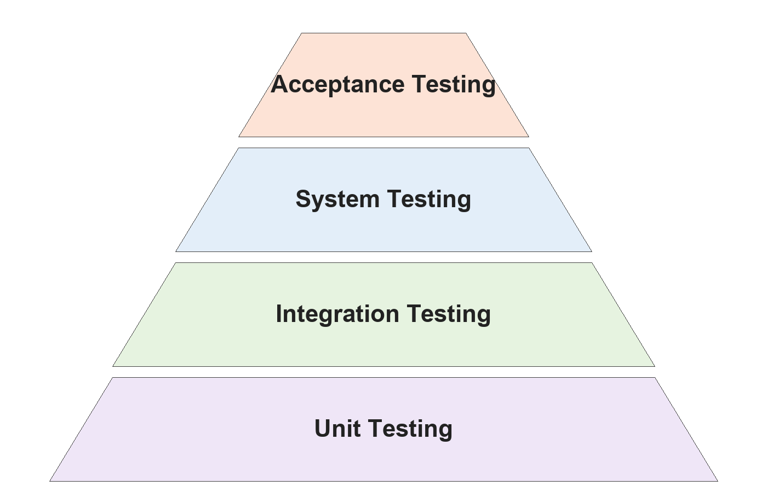
Fig 5.1: Levels of testing

Unit Testing
Unit testing checks individual units of the system on their own. These tests are in KinematicsTest, LiveRepetitionAnalysisTest, LiveRepetitionEngineTest, RepVerdictsTest, LiveHoldAnalysisTest, CalibrationTest, AngleGaugeTest, PasswordResetTest and KinesisPaletteContrastTest.
No. | Module | Test case | Input | Expected output | Status
1 | Kinematics | Joint angle at the elbow | Shoulder above, wrist ahead of the elbow | 90 degrees | Pass
2 | Kinematics | Sides stay separate | Right wrist hidden | Left angle measured, right not measured | Pass
3 | Rep state machine | Count full squats | 3 synthetic squats 170 → 70 → 170 degrees | Count = 3 | Pass
4 | Rep state machine | Ignore a half squat | Squat to 130 degrees and back | Not counted | Pass
5 | Verdict | Too fast | Full curl in 0.6 s | Too fast – not counted | Pass
6 | Verdict | Lost tracking | Knee reading 10.8 degrees | Lost tracking – not counted | Pass
7 | Verdict | Form fault | Curl started with elbow at 140 degrees | Counted, red: Straighten your arm first | Pass
8 | Verdict | Alternating lunges | Left then right lunge 0.4 s apart | Both counted | Pass
9 | Hold analyser | Plank held 5 s | 150 frames at 178 degrees | Valid hold of about 5 s | Pass
10 | Calibration | Baseline from a set | Eight synthetic squats | Median and spread kept per side | Pass
11 | Angle arc | Arc matches the angle | Bones at 90 degrees | Arc sweeps 90 degrees | Pass
12 | Password reset | Invalid email refused | "nitish@" | Ask for a valid address | Pass
13 | Password reset | Reset message reveals no accounts | Reset requested | "If an account uses that email..." | Pass
14 | Theme | Colour readability | All text colours | Contrast of at least 4.5:1 | Pass

Integration Testing
Integration testing checks that modules work together correctly. These tests are in LiveRepetitionEngineTest, LiveHoldEngineTest, SessionRecorderTest, SetDraftsTest, AccountDatabaseNamesTest, SyncOutageTest, SessionExportReadTest and CountedRepetitionsTest.
No. | Modules | Test case | Input | Expected output | Status
1 | Engine + Bridge + Overlay | Counted rep reaches the screen | Squat set of 3 | Count 3, three "+1" flashes | Pass
2 | Engine + Bridge | Screen not redrawn per frame | 900 frames of a steady plank | About 30 updates, not 900 | Pass
3 | Engine + Bridge + Overlay | Rejected attempt shown | Half squat | Red skeleton and banner, no flash | Pass
4 | Recorder + Storage + Dashboard | Set saved and read back | A recorded set | Session stored and shown on the dashboard | Pass
5 | Recorder + Drafts | Crash recovery | App killed mid-set | Set restored on next launch | Pass
6 | Auth + Storage | Separate database per account | Two accounts on one phone | Each account gets its own database file | Pass
7 | Storage + Sync | Upload after the local save | Signed in, session saved | Saved locally first, exactly one upload queued | Pass
8 | Export + Import | Round trip | Export then read back | Identical sessions | Pass
9 | History + Verdict | History counts as the screen did | Set with too-fast reps | Same count in streaks, dashboard and trends | Pass

System Testing
System testing evaluates the complete system. Three system-level tests were run.
1. Cross-platform parity. The same synthetic squat, lunge, lateral raise and plank scenarios were run through the engine on the JVM, on JavaScript and on Android. Counts, phases and validities matched exactly and every continuous value agreed within 1e-9 relative. A deliberate change of 1e-8 to one value made the test fail, as it should.
2. Evaluation on a public dataset (MM-Fit). The app's own engine was run over MM-Fit's videos (RGB video → MediaPipe Pose → Chiron) and its count was compared with MM-Fit's labelled count, on six people who were never used during development.
Exercise | Sets | Counted of labelled | Sets counted exactly | Sets over-counted
Bicep curl | 16 | 163 of 163 | 100% | 0
Lateral raise | 15 | 146 of 150 | 80.0% | 0
Sit-up (trunk angle) | 20 | 146 of 189 | - | 0
Push-up (fixed start position) | 20 | 110 of 201 | 25.0% | 0
Push-up (personal start position)* | 14 | 107 of 141 | - | 0

* Each person's first push-up set was used as their calibration set; the remaining sets were counted with their personal start position. On those same 14 sets the fixed start position counted 84 of 141. On the development people the same method raised push-ups from 52 to 155 of 297, again with no set over-counted. Sit-ups are counted from the angle of the trunk; the sets that remain uncounted belong mostly to one person whose trunk barely lifts from the floor.
In no accepted change did the engine ever count more repetitions than were performed. On MM-Fit's development people, the verdict layer added in the final version kept the count identical to the counter's on every exercise but one lunge, out of 2,518 counted repetitions.
3. Performance. The per-frame path was checked by an allocation test (no memory allocated per frame) and a budget test; on the phone, pose estimation ran at about 15 results a second during sets, which is enough to follow every exercise in the library.

Acceptance Testing
Acceptance testing was carried out by the project owner on their own phone, training normally.
No. | Scenario | Expected | Observed | Status
1 | Five slow side-on squats | Count 5 | Count 5, knee 58 to 65 degrees at the bottom | Pass
2 | Curls done in half a second | Shown "Too fast", not counted | Six attempts of 0.5 to 0.6 s judged too fast and not counted | Pass
3 | Tracking lost on the legs | Not counted | Three phantom lunges (knee 11 to 27 degrees) judged lost tracking | Pass
4 | App force-stopped during a set | Set kept | 3 squats recovered in history | Pass
5 | New account on the same phone | History available | 108 sessions and the calibration present; upload to the account began at once | Pass
6 | Live screen drawing | Angle arc and +1 flash | Drawn on the phone: arc on the measured joint, flash after a counted repetition | Pass

6.4 Summary
This chapter described how Chiron was tested: manual, automated and mutation testing, at the unit, integration, system and acceptance levels, including the evaluation on the MM-Fit public dataset. The next chapter concludes the report.

7. SAMPLE INPUTS AND OUTPUTS

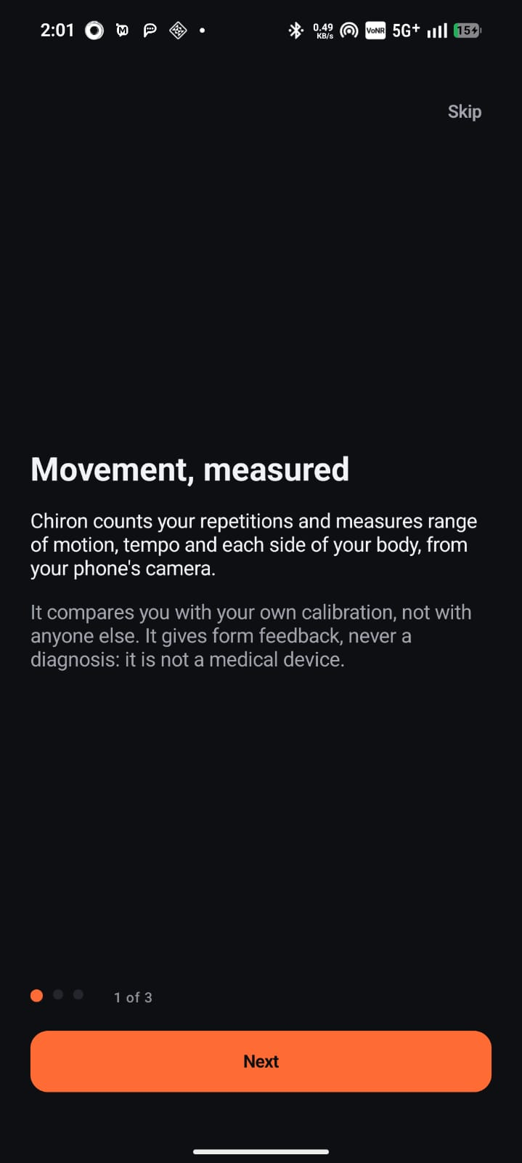  Onboarding: Movement, measured | 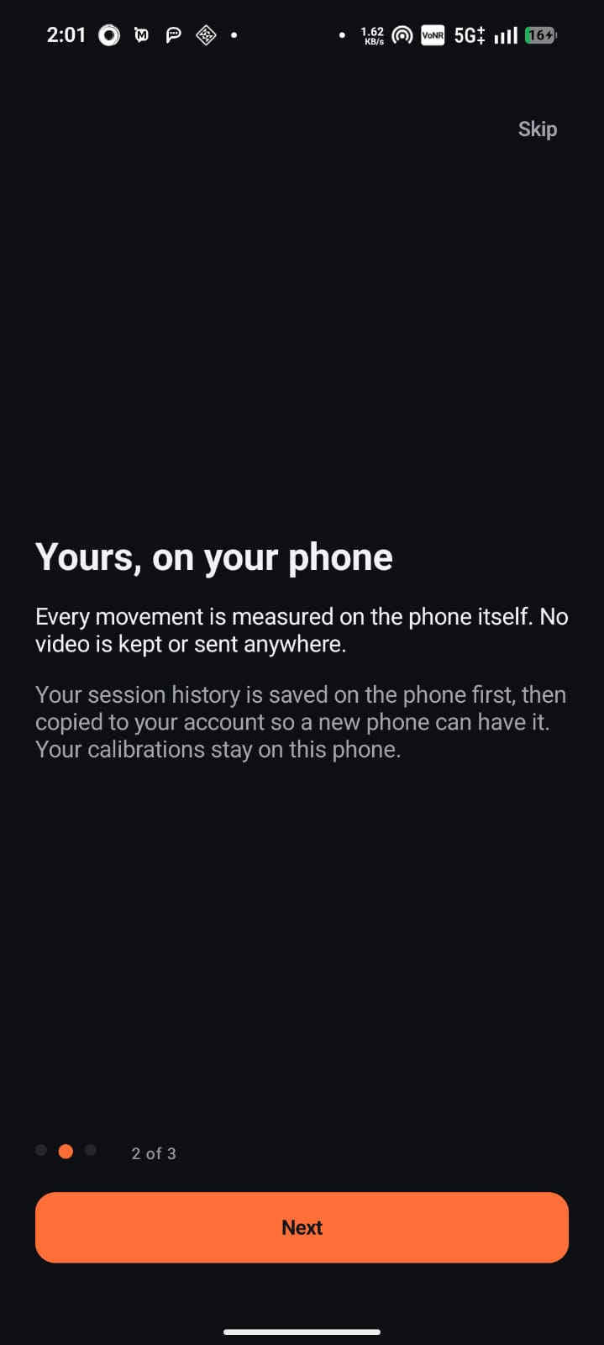  Onboarding: Yours, on your phone
The first two onboarding pages explain what Chiron does – it counts repetitions and measures range of motion, tempo and each side of the body from the phone camera, comparing the user with their own calibration – and that every movement is measured on the phone itself, with no video kept or sent.
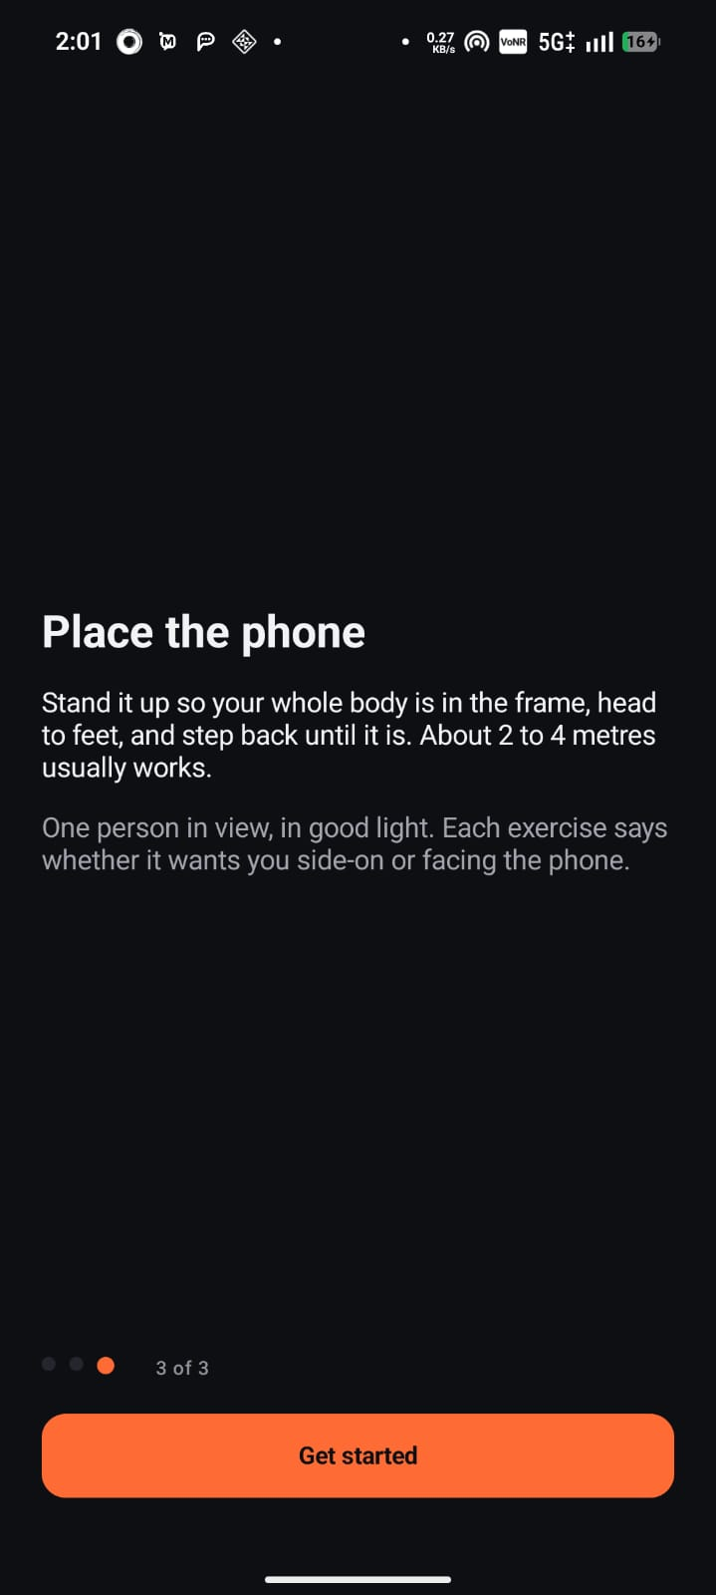  Onboarding: Place the phone | 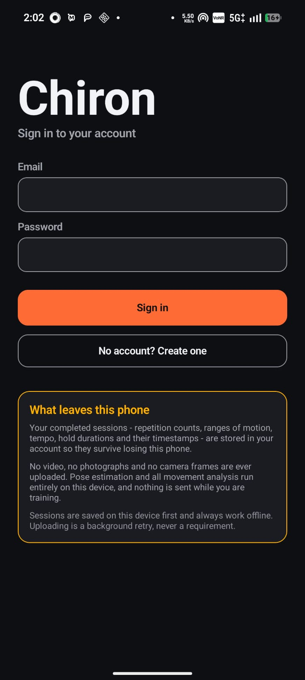  Sign in to your account
The last onboarding page explains how to place the phone. The sign-in screen offers sign-in, account creation and password reset, and states above the buttons exactly what leaves the phone: the numeric session records, never video, photographs or camera frames.
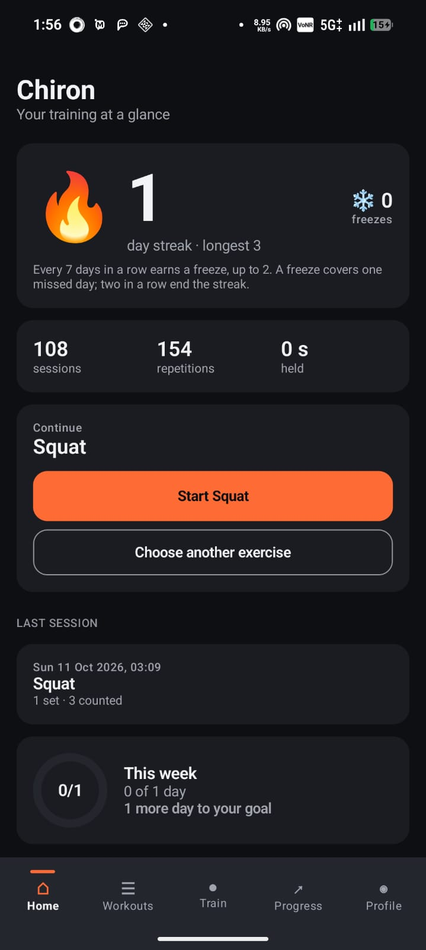  Home: streak, totals, continue and weekly goal | 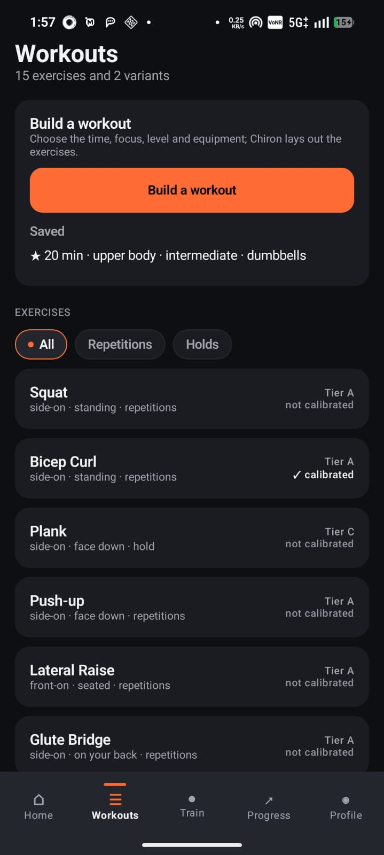  Workouts: library and workout builder
Home shows the training streak with earned freezes, total sessions and repetitions, a shortcut to continue the last exercise, the last session and progress towards the weekly goal. Workouts lists the library with filters and the saved workouts.
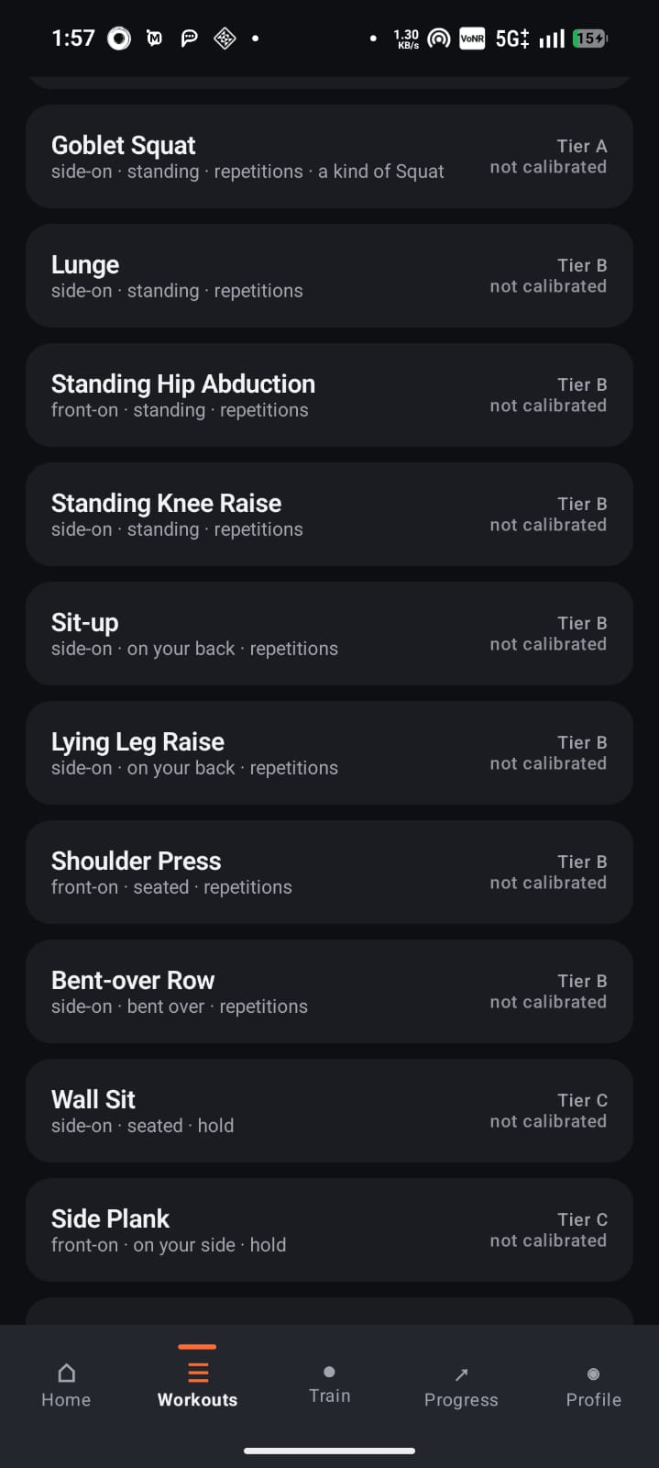  Workouts: exercise library (tiers and views) | 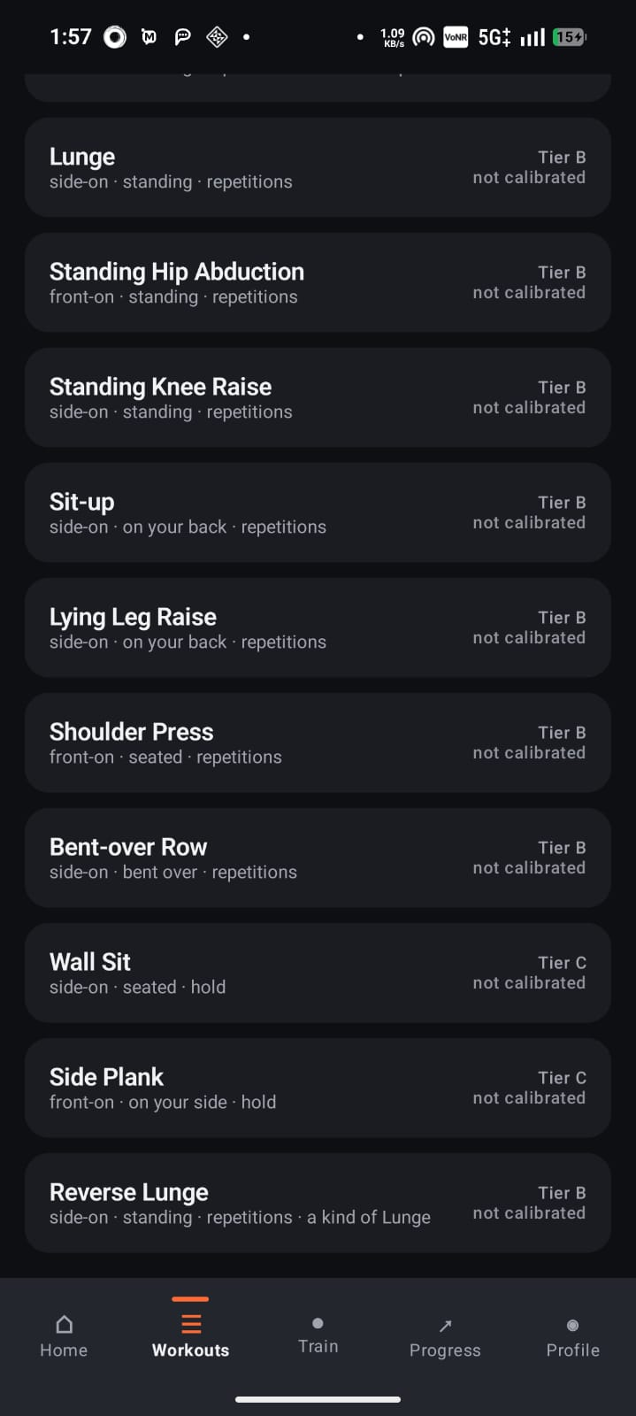  Workouts: library continued
Every library entry states its tier, required camera view, posture and analysis mode, and whether the user has calibrated it. Goblet Squat and Reverse Lunge are variants that share their parent exercise's analysis and calibration.
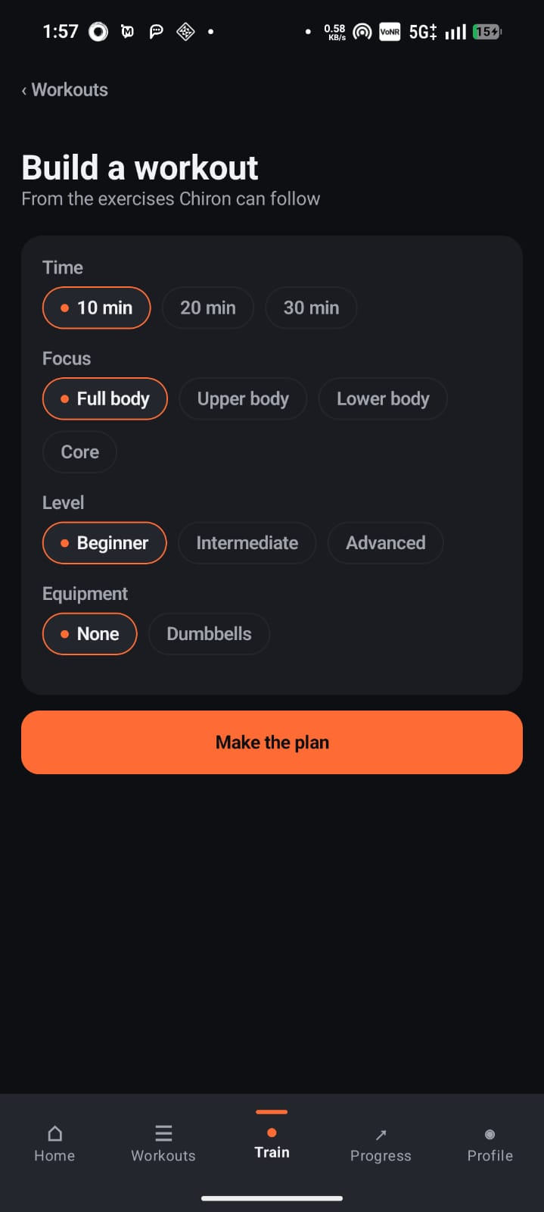  Build a workout: time, focus, level, equipment | 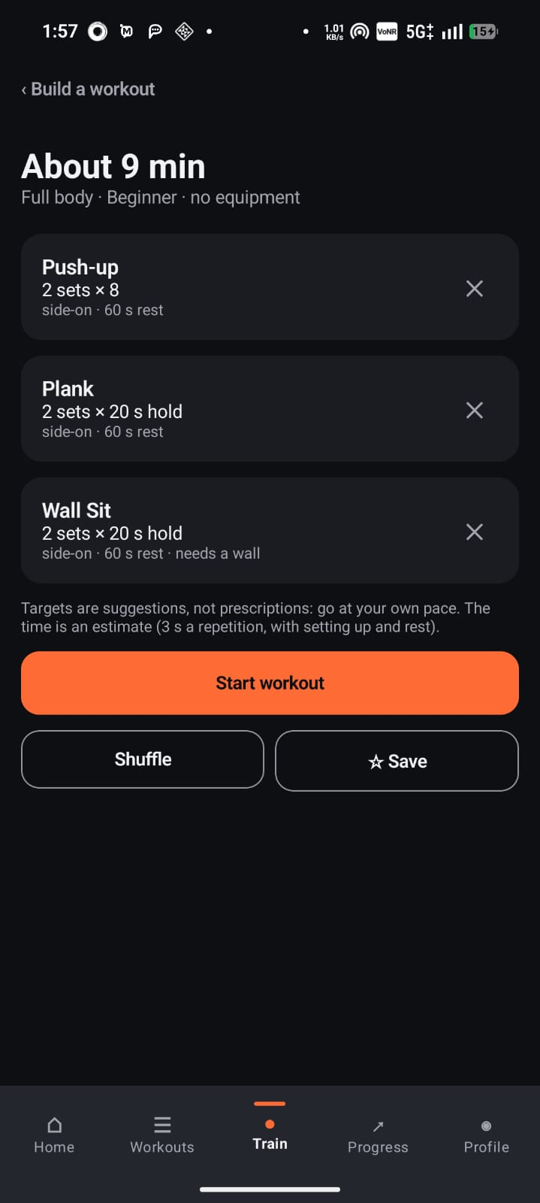  Generated workout plan
The workout builder asks for time, focus, level and equipment and produces a plan of exercises the app can follow, with sets, targets and rests. The plan can be shuffled, saved or started as a guided workout.
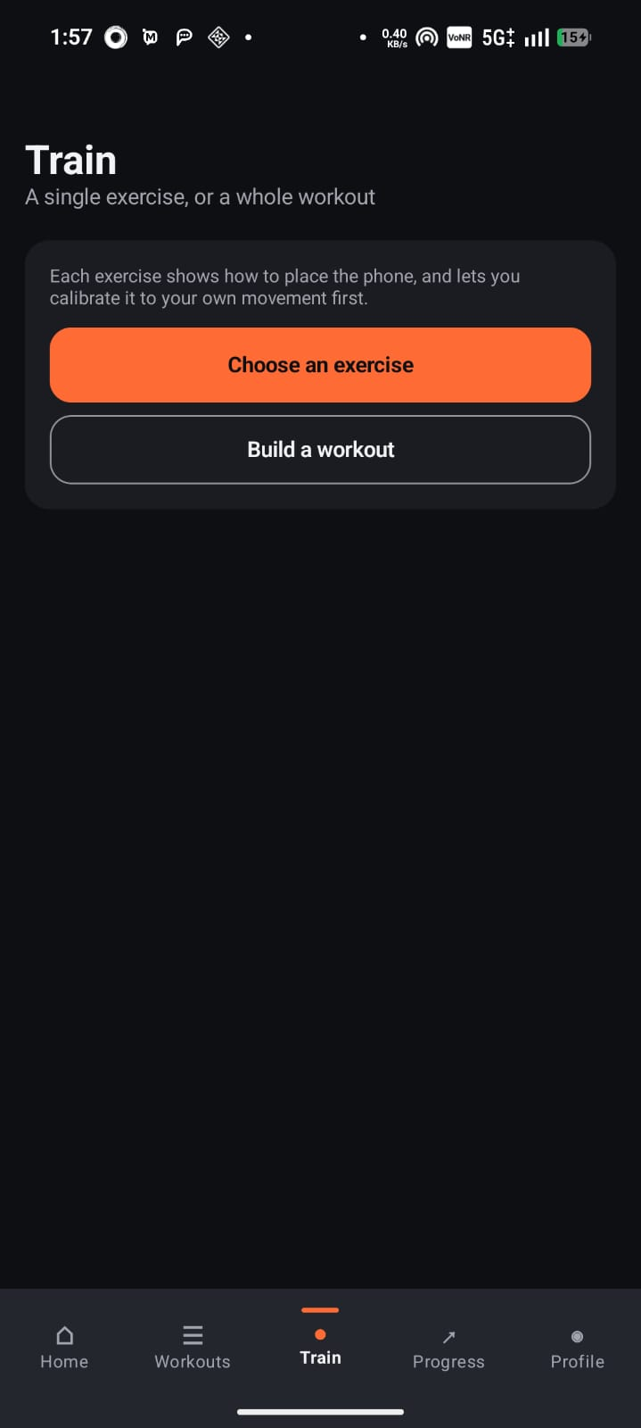  Train tab | 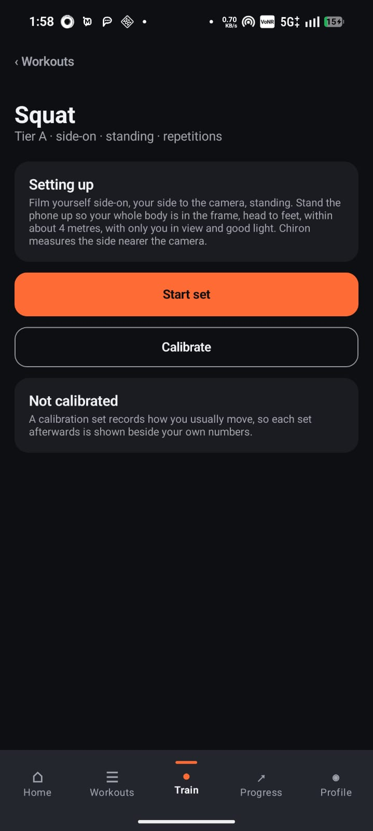  Exercise page: Squat setup
The Train tab starts a single exercise or a workout. Each exercise page explains how to set up the phone for that exercise, and offers Start set and Calibrate.
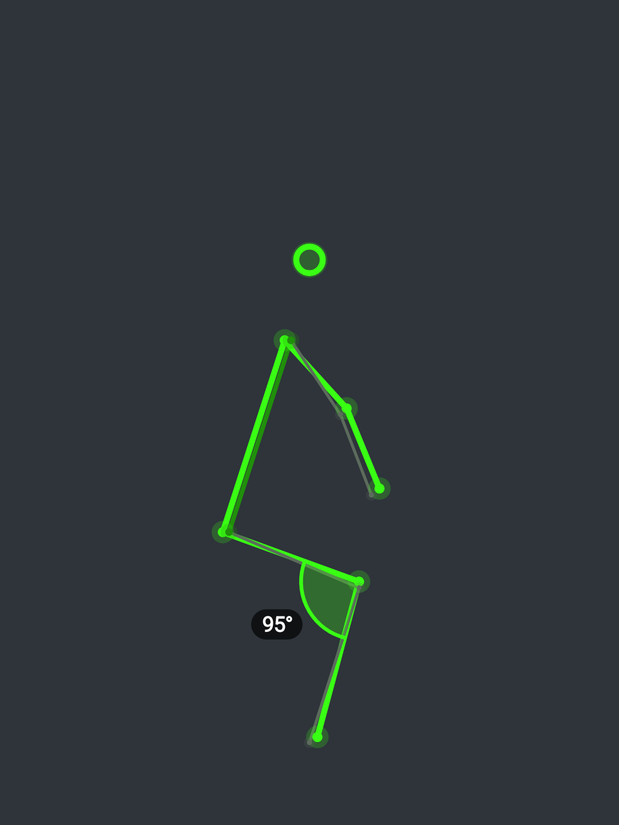  Squat side-on: knee angle arc | 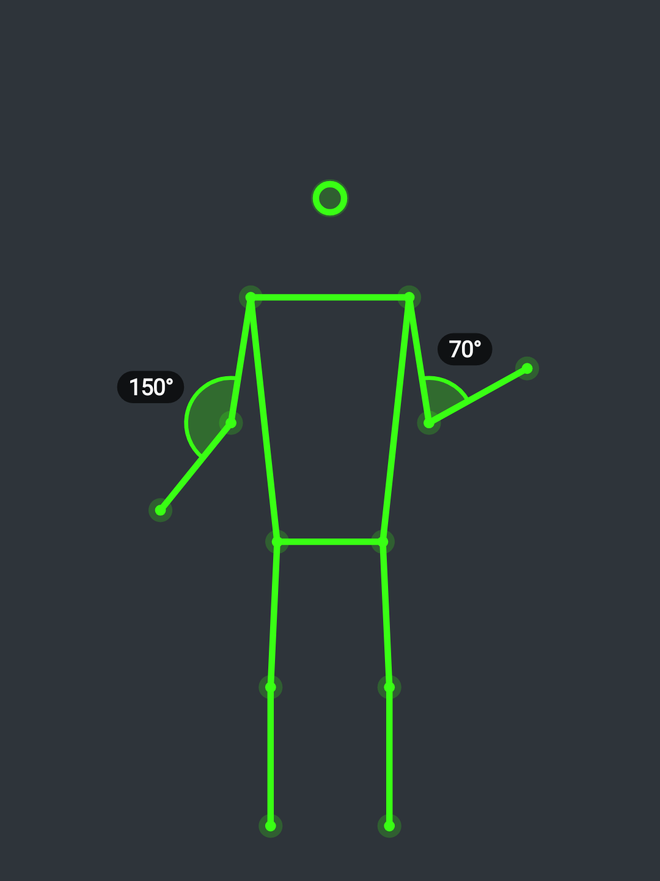  Curl: each elbow measured separately | 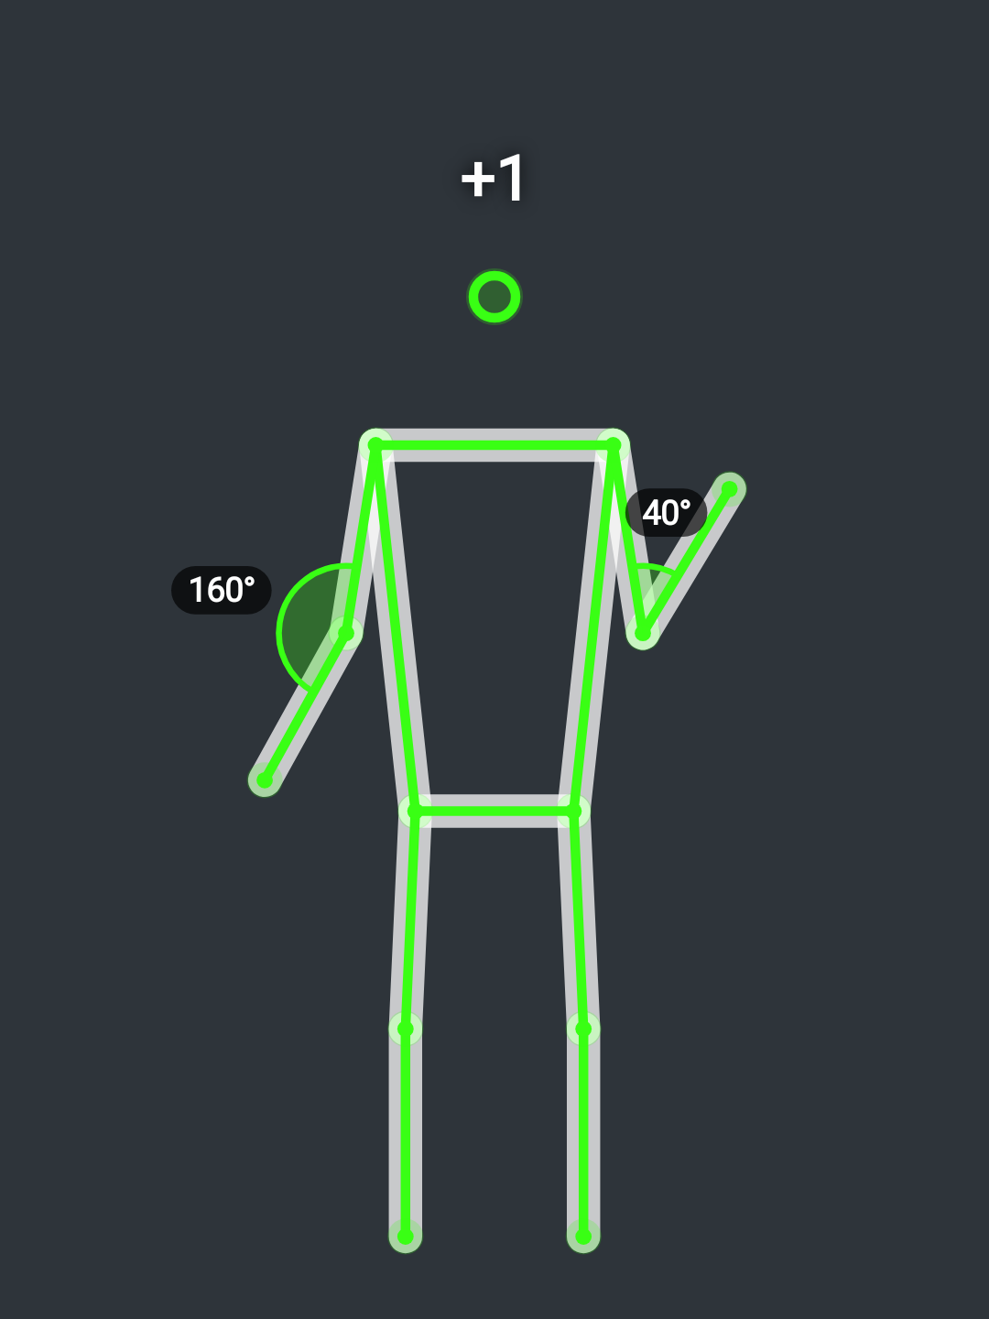  "+1" flash on a counted repetition
The live skeleton overlay as drawn by the app on the phone. The joint the exercise is counted on carries an arc between its two bones with the live angle in degrees, for each side the app can measure; left and right are never averaged. A counted repetition makes the skeleton glow and a "+1" rise from the head. An attempt that does not count turns the skeleton red and shows the reason, such as "Too fast – not counted".
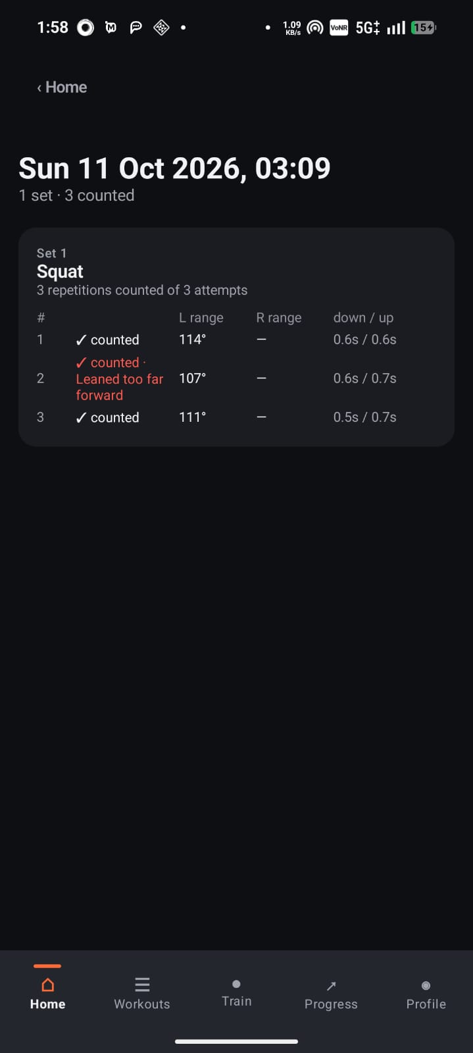  Session detail: counted and form-fault repetitions | 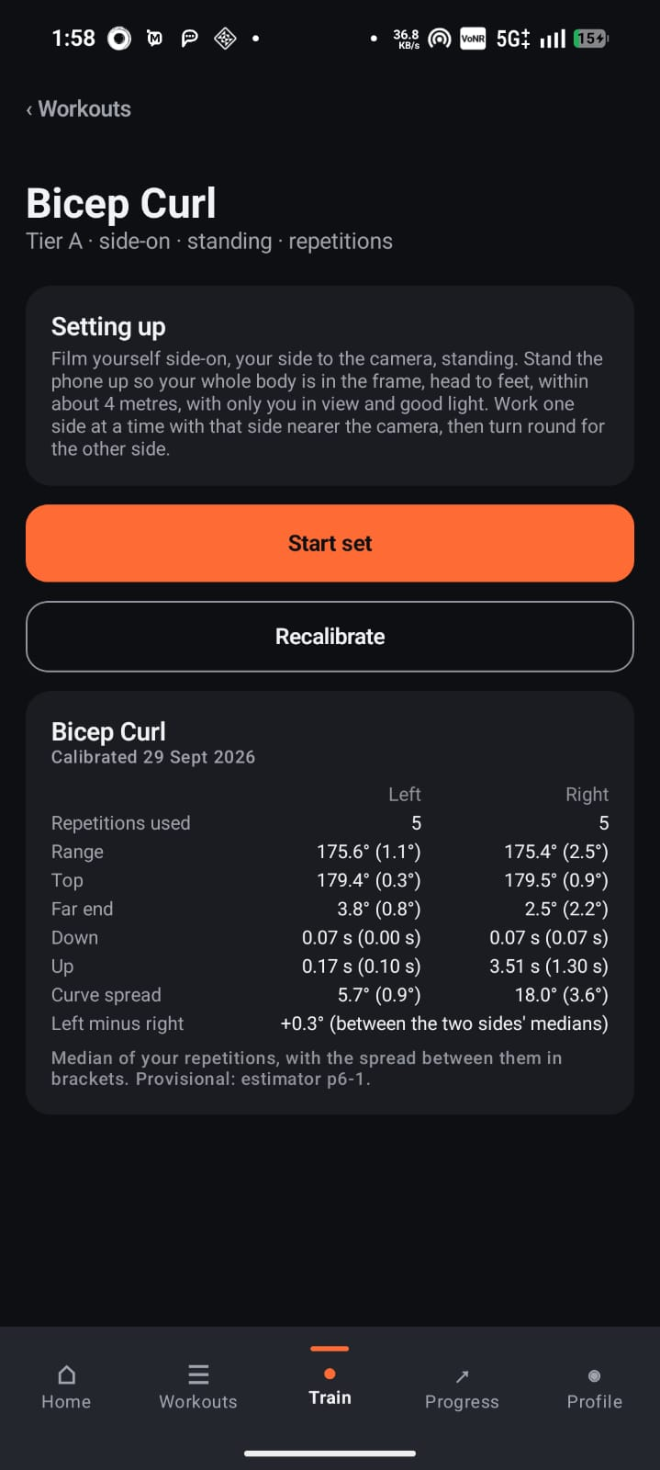  Bicep curl with personal calibration
A past session lists every attempt with its verdict and each side's range of motion and timing; here the second squat counted but is marked in red "Leaned too far forward". The bicep curl page shows the user's calibration: per side, the median of each measure with its spread.
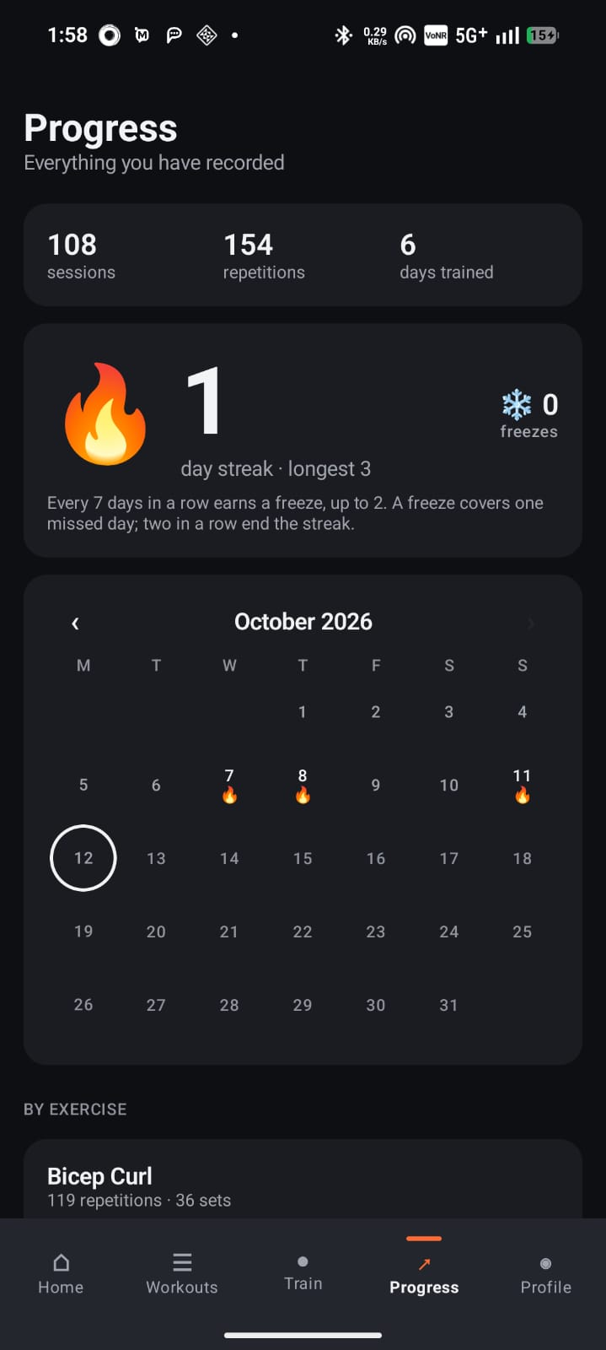  Progress: totals, streak and calendar | 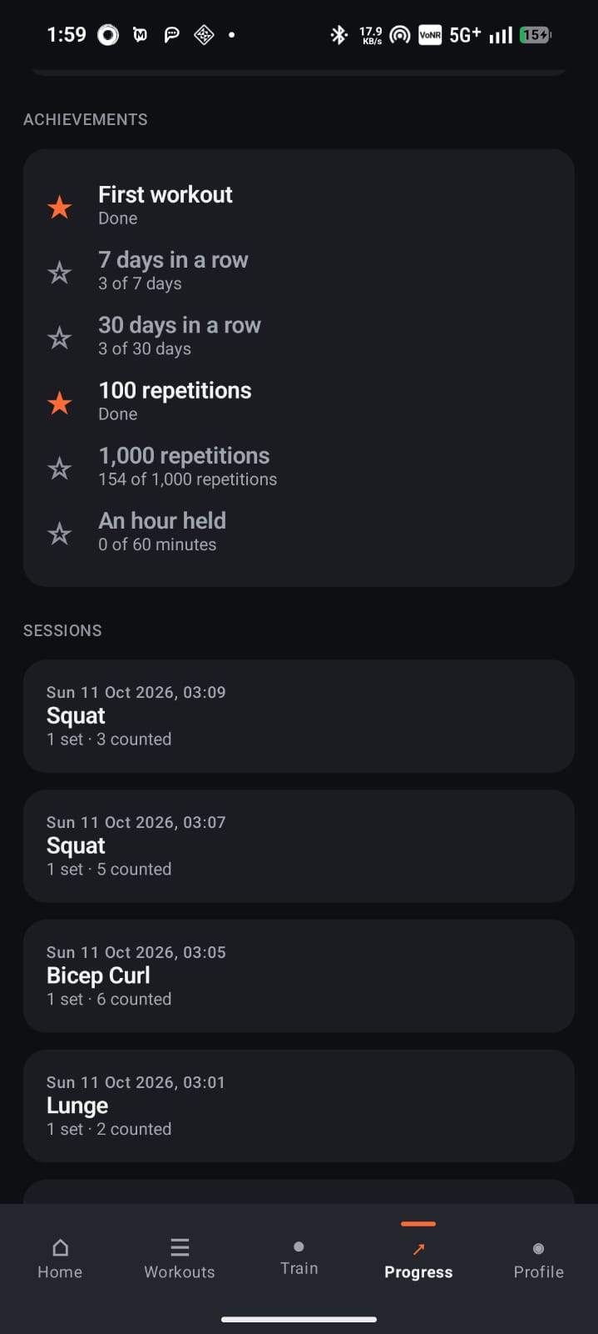  Progress: achievements and sessions
Progress shows totals, the streak and a calendar marking every training day, followed by achievements and the list of sessions.
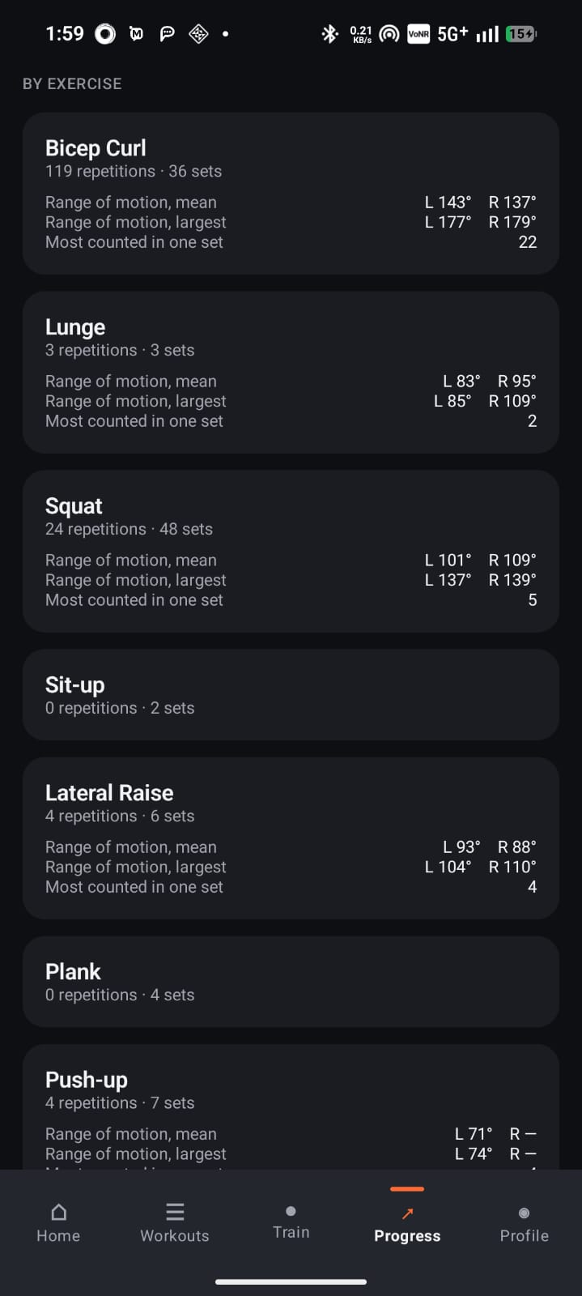  Progress: statistics by exercise | 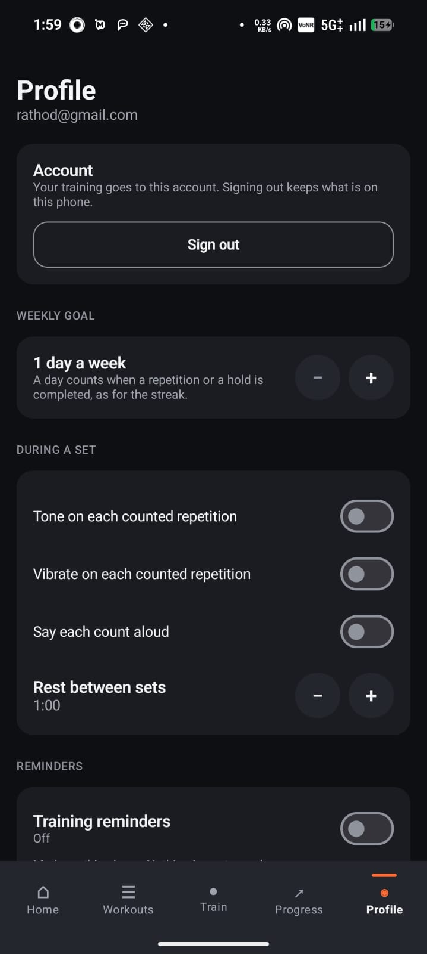  Profile: account, goal and cues
Statistics by exercise show repetitions, sets and range of motion for each side. Profile manages the account, the weekly goal, the sound, vibration and spoken-count cues and the rest between sets.
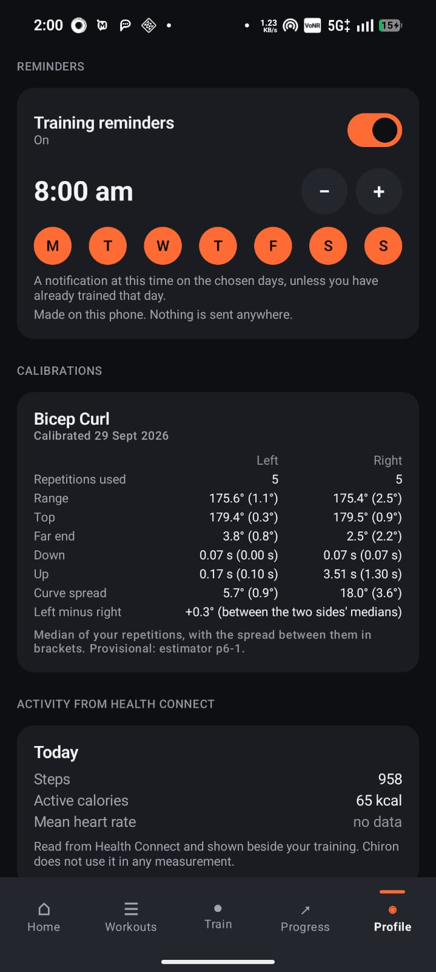  Profile: reminders, calibrations, activity | 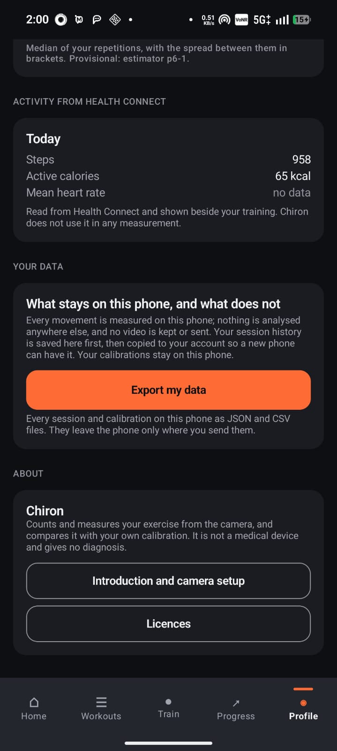  Profile: data export and about
Training reminders are scheduled for chosen days and time. Profile lists the calibrations, shows the day's activity read from Health Connect, explains what stays on the phone, and exports all data as JSON and CSV.
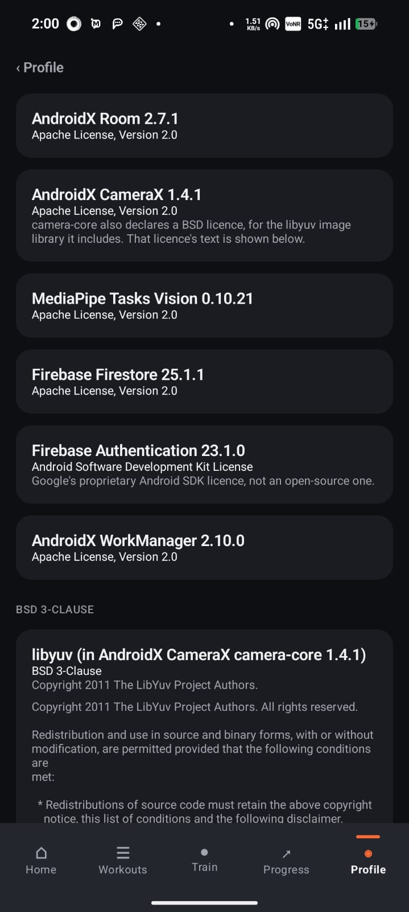  Licences: software components | 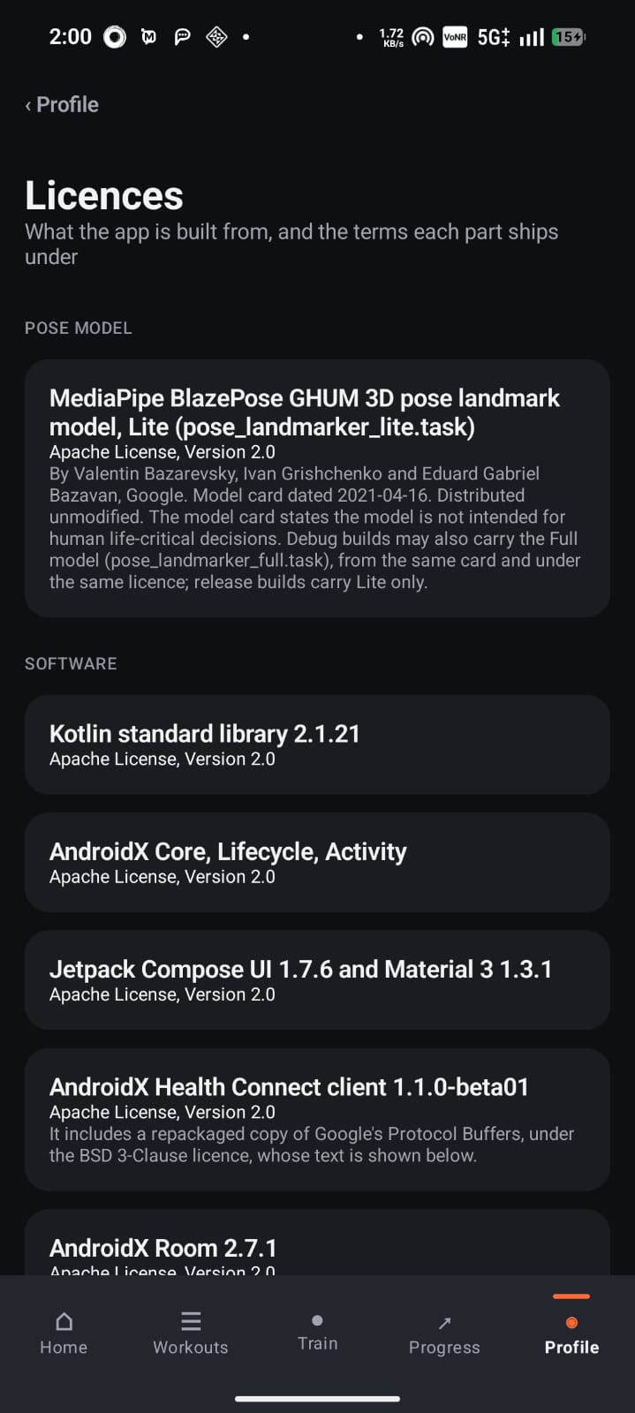  Licences: pose model
The licences page lists every component the app is built from and the terms it ships under, including the MediaPipe pose landmark model.

8. CONCLUSION
Chiron shows that an ordinary smartphone can give a person training alone measured, explainable feedback on how they move, without uploading a single image. The application estimates body pose on the device, measures every joint angle for the left and the right side separately, counts repetitions only when the full movement is completed, and tells the user why any attempt did not count. It times holds, compares the user with their own calibration, builds and guides workouts, and records progress, streaks and achievements, all offline-first with an optional synced account.
The project was built around a shared analysis engine in Kotlin Multiplatform. Because exactly the same code runs on the phone, on a PC and in JavaScript, the counting could be evaluated on a public dataset and its behaviour pinned by more than 3,300 automated test executions on every platform. On people who were never used during development, the engine counted 163 of 163 bicep curls and 146 of 150 lateral raises, and in no accepted change did it ever count more repetitions than were performed. Live features such as the angle arc, the "+1" flash and the red verdict banner make that analysis visible to the user while they train.
The work also showed the value of measuring before claiming. Several design choices were changed because the measurements contradicted them, for example a rule that would have deleted real alternating lunges, and the final system is better because of it. Chiron meets its objectives and provides a practical, private and explainable movement-analysis tool for everyday training.

9. SCOPE AND ENHANCEMENT
Scope. Chiron counts and measures 15 exercise profiles (17 library entries, with two variants) from one phone camera, compares the user with their own calibration, and applies cited technique notes to the Tier A exercises only. It is not a medical or diagnostic system. The iOS and web versions were not built. The following enhancements would extend it:
- More exercises and views: extend the profiles to more movements and to both camera views for each exercise.
- Automatic camera-view check: use the recorded camera-view measurements to stop counting automatically when the phone is placed wrongly.
- Per-side tempo history: store lowering and lifting times separately for each side in the history charts.
- Coach review: let a trainer review a user's sessions and compare the technique notes with their own judgement.
- Wear OS and tablet versions: show the live count on a watch or a larger screen.
- iOS and web versions: the shared engine already compiles to JavaScript and can be reused on other platforms.

- Validate the exercise check. Run the experimental exercise check on people it was never tuned on, set a ceiling on false warnings, and only then consider switching it on by default.
- Device evidence for every exercise. Record the real count against the application's count for each exercise on the phone, so that the counting figures rest on more than the public dataset.

10. APPENDIX

10.1 Abbreviations and Glossary
The terms and abbreviations used in this report.
Term | Meaning
Baseline | The user's usual values for an exercise, for each side, recorded from a calibration set (median and spread).
Calibration | A normal set of 10 to 15 valid repetitions a side, from which the baseline is computed.
Claim level | What a result may say: Level 1 a measurement, Level 2 a deviation from the user's own baseline, Level 3 a technique note from a published source.
DFD | Data Flow Diagram.
E-R diagram | Entity-Relationship diagram of the stored data.
Health Connect | Android's on-phone store of health data such as steps, calories and heart rate.
Hold | An exercise held still for a time, such as a plank or a wall sit, timed instead of counted.
KMP | Kotlin Multiplatform: one Kotlin code base compiled for Android, the JVM and JavaScript.
Landmark | A named point on the body, such as the left knee, found by the pose model.
MediaPipe Pose | Google's on-device pose model, which returns 33 body landmarks for each camera frame.
MM-Fit | A public dataset of people performing exercises, used to evaluate the repetition counting.
Parity | The same input giving the same output on every platform the engine compiles for.
Repetition | One complete movement from the start position to the far position and back.
ROM | Range of Motion: the difference between the largest and the smallest joint angle in a repetition.
Room / Firestore | The on-phone database, and the optional cloud database used to sync session history.
State machine | The rules that follow each side through top, lowering, bottom and lifting to decide when a repetition is complete.
Tier A, B, C | Groups of exercises; only Tier A may carry technique notes.
Verdict | The application's answer for each attempt: counted, or the reason it was not.

10.2 List of Screenshots
The screenshots of the chapter Sample Inputs and Outputs, with the page each appears on.
Screenshot | Page
Onboarding: Movement, measured | 69
Onboarding: Yours, on your phone | 69
Onboarding: Place the phone | 70
Sign in to your account | 70
Home: streak, totals, continue and weekly goal | 71
Workouts: library and workout builder | 71
Workouts: exercise library (tiers and views) | 72
Workouts: library continued | 72
Build a workout: time, focus, level, equipment | 73
Generated workout plan | 73
Train tab | 74
Exercise page: Squat setup | 74
Squat side-on: knee angle arc | 75
Curl: each elbow measured separately | 75
"+1" flash on a counted repetition | 75
Session detail: counted and form-fault repetitions | 76
Bicep curl with personal calibration | 76
Progress: totals, streak and calendar | 77
Progress: achievements and sessions | 77
Progress: statistics by exercise | 78
Profile: account, goal and cues | 78
Profile: reminders, calibrations, activity | 79
Profile: data export and about | 79
Licences: software components | 80
Licences: pose model | 80

11. BIBLIOGRAPHY
- World Wide Web Consortium, Web Content Accessibility Guidelines (WCAG) 2.1, W3C, 2018. https://www.w3.org/TR/WCAG21/
- Bazarevsky, V., Grishchenko, I., Raveendran, K., Zhu, T., Zhang, F. and Grundmann, M., BlazePose: On-device Real-time Body Pose Tracking, CVPR Workshop on Computer Vision for Augmented and Virtual Reality (arXiv:2006.10204), 2020.
- Stromback, D., Huang, S. and Radu, V., MM-Fit: Multimodal Deep Learning for Automatic Exercise Logging across Sensing Devices, Proceedings of the ACM on Interactive, Mobile, Wearable and Ubiquitous Technologies, 4(4), 2020. https://doi.org/10.1145/3432701 (dataset: https://mmfit.github.io).
- Smith, A., Teaching for Skill Acquisition in Fitness: Best Practices for Fitness Pedagogy, NSCA Coach, 7(4), National Strength and Conditioning Association, 2021.
- Online documentation, read in October 2026:
- American Council on Exercise, Exercise Library: Bodyweight Squat, Push-Ups, Hammer Curl and Lateral Raise, ACE, 2026. https://www.acefitness.org/resources/everyone/exercise-library/
- Android Developers, Jetpack Compose, CameraX, Room, WorkManager and Health Connect documentation, Google, 2026. https://developer.android.com
- Gradle Inc., Gradle Build Tool Documentation, Gradle, 2026. https://docs.gradle.org
- Google, Firebase Authentication and Cloud Firestore documentation, Google, 2026. https://firebase.google.com/docs
- Google, Pose landmark detection guide and MediaPipe Solutions, Google AI Edge, 2026. https://ai.google.dev/edge/mediapipe
- JetBrains, Kotlin Language and Kotlin Multiplatform documentation, JetBrains, 2026. https://kotlinlang.org/docs
- PlantUML, Language Reference Guide, PlantUML, 2026. https://plantuml.com

